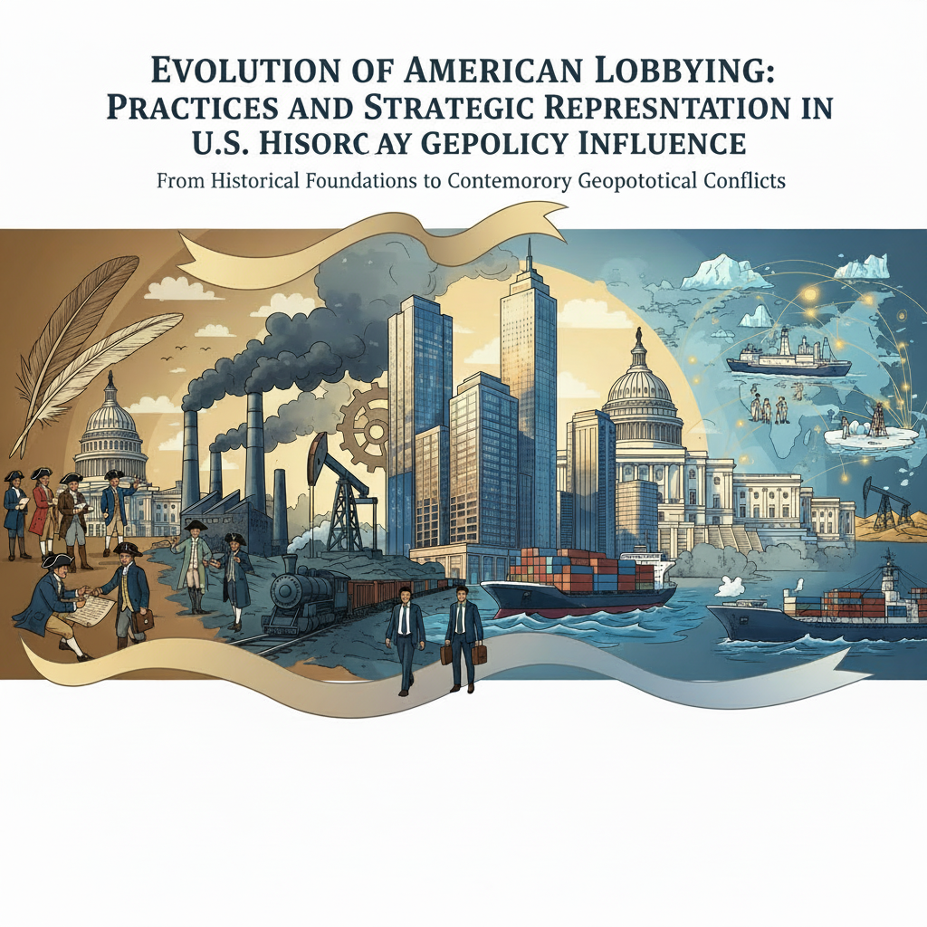

Strategic Embedding and Influence Vectors in U.S. Political and Commercial Decision-Making: Balancing Domestic Entrenchment and International Competitiveness
frankfarnel@gmail.com
Abstract
This analysis examines the strategic importance of establishing representation centers within the United States, particularly in Washington, D.C., and select state capitals, for organizations seeking to influence political and commercial outcomes. It highlights how proximity to legislative bodies, executive agencies, and regulatory authorities enhances the ability to engage effectively in federal and regional policy processes, enabling timely interventions during critical procedural windows. The study explores the interplay between political culture, regulatory frameworks, and commercial interests, emphasizing the resource trade-offs that arise from deep domestic engagement, which often limits international competitive agility. Sector-specific lobbying strategies, coordination across multiple policy domains, and integration with media narratives are discussed as essential components of sustained influence. Additionally, the work addresses the implications of transparency and compliance requirements, the role of technological innovations in advocacy, and approaches to risk management including mitigating political backlash and managing regulatory uncertainty. The analysis further considers the economic and diplomatic consequences of concentrated domestic focus, noting opportunities for external competitors in emerging markets and shifts in global market dynamics. Ultimately, it underscores the balance organizations must strike between securing durable domestic footholds and maintaining flexibility for international expansion within complex governance ecosystems.

1 Pre-introduction
Understanding the landscape of political and commercial influence in the United States requires more than superficial familiarity with legislative processes or market structures. Influence is rarely the product of isolated efforts; instead, it emerges from a confluence of regulatory engagement, sustained communication strategies, and proximity to decision-making centers. Historical patterns suggest that entities situated within Washington, D.C., whether corporate, governmental, or international, have consistently benefited from being able to respond quickly to political developments with locally calibrated messaging. Modern equivalents to earlier printed advocacy campaigns include rapid-response teams embedded directly in such offices, capable of producing tailored statements within hours of political challenges. This operational agility is enabled by personnel fluent in domestic political protocols and cultural nuances, transforming distant interests into narratives perceived as locally relevant. The establishment of a representation center in Washington is not simply a ceremonial gesture; it appears to be a functional necessity for any organization aiming to shape policy or gain commercial advantage in the U.S. By embedding activities within the domestic legislative environment, businesses reduce both temporal and logistical friction in influencing outcomes. From a scientific standpoint, proximity acts as a multiplier on influence potential: messages are communicated more efficiently to target audiences who control statutory levers. The embedded nature of these offices creates synergy between formal channels, such as congressional testimony, and informal opinion-shaping mechanisms, integrating them into cohesive campaigns that align procedural opportunities with broader strategic aims. Historical precedents during industrialization already hinted at this model’s effectiveness. Corporations at the time framed compliance with emerging regulations as voluntary contributions to national progress, often linked to improved worker safety, well before laws required such action. These preemptive positions provided leverage when negotiating over binding statutory terms. Foreign entities adopting similar strategies today may align public benefit narratives around local jobs or infrastructure development in key districts, subtly connecting international commercial objectives with domestic socio-economic priorities (1). Here the mechanics are clear: presenting an external interest through an internal lens mitigates perceptions of outsider influence and can even embed foreign aims within nationalist rhetoric. Such domestic anchoring parallels how certain nations integrate economic ambitions into bilateral relationships. For instance, the United Arab Emirates (UAE) has long sought global market penetration for state-backed companies while maintaining strong economic ties with the U.S. In recent years it has also negotiated agreements over advanced technology transfers, including semiconductor components potentially sourced from major American manufacturers (2). These arrangements suggest that positioning inside U.S. commercial discourse can facilitate access that might otherwise be hampered by geopolitical caution or competitive resource allocation elsewhere. However, allocating resources and attention toward influencing U.S. policy frequently demands trade-offs in the international arena. Once an entity commits substantial effort to defending its position within American markets or legislation, capacity available for external expansion tends to diminish. For example, maintaining an active role inside Washington often entails ongoing narrative management, preloading crisis communications, synchronizing with emergency cycles, and sustaining coalitions broad enough to disguise narrow origin points, all designed to shield proposals under favorable disclosure optics. While these tactics are effective domestically, they consume energy that could otherwise be directed toward competing globally where rivals might proceed unhindered by similar constraints. Practical considerations cement this point: defending national or regional markets often involves direct engagement with regulatory authorities and lawmakers through continuous lobbying disclosure regimes instituted throughout the 20th century (1). These measures require transparency about who is seeking legislative influence and through what means, a legal architecture developed partly due to public concern over covert operations embedded in appropriations bills. Organizations committed to influencing policy must allocate legal and compliance resources toward meeting such obligations, further binding them into domestic cycles at potential cost to their outward-looking activities. Even security-focused interactions with the U.S., as seen in bilateral partnerships or mutual defense considerations discussed among Gulf states like Kuwait (3), create commitments that root foreign actors into American regulatory and diplomatic rhythms. This anchoring deepens local investment but limits flexibility abroad; global competitors without such embedded obligations may exploit such openings for their own growth trajectory. The opportunity cost for sustained presence thus becomes measurable: while domestic market control strengthens immediate influence potential within U.S policy domains, strategic agility outside those borders can erode over time. From an analytical perspective, this prioritization reflects a broader principle observable across both corporate lobbying practices and state-level foreign relations, the necessity of situating influence efforts locally before attempting durable gains internationally (1). It is not enough simply to enter a market; entities must entrench themselves physically and narratively near decision centers if they hope to move beyond peripheral involvement into shaping outcomes directly. Yet the resource-intensive nature of this entrenchment inevitably reinforces internal focus at the expense of external ambits, a structural reality that shapes long-term competitive landscapes across multiple sectors and geopolitical theaters alike.

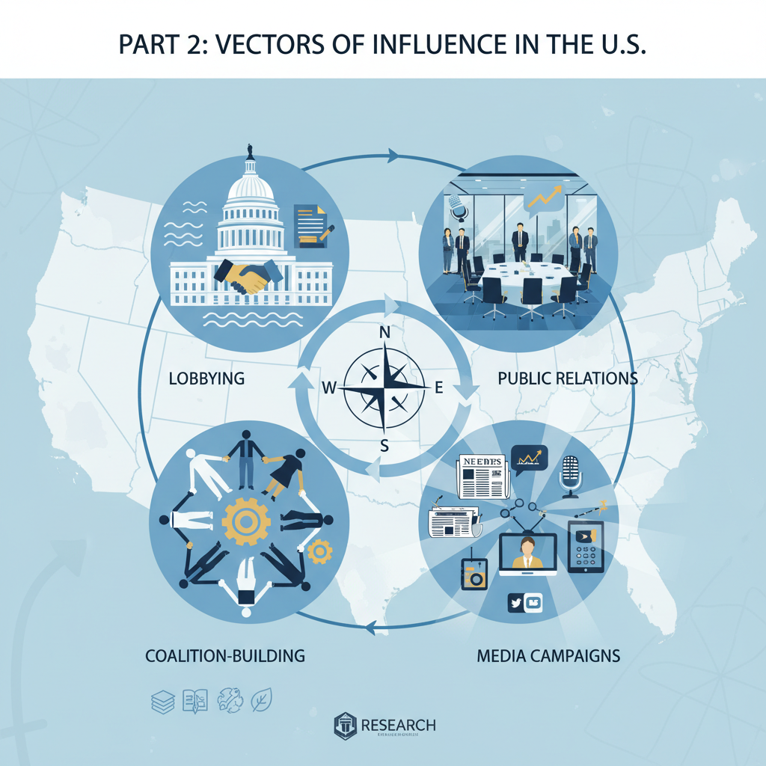Understanding Vectors of Influence in the United States

2.1 Political Influence Pathways

2.1.1 Federal Legislative Processes
Federal legislative processes in the United States present an intricate environment where influence is shaped through both formal mechanisms and peripheral activities. For organizations, whether corporate, trade-oriented, or state-affiliated, the procedural arc from committee discussions to final bill passage involves multiple stages where advocacy efforts can be embedded for maximum effect. The committees themselves are often focal points for targeted messaging. Stakeholders with dedicated representation in Washington benefit from proximity, enabling them to monitor draft legislation and anticipate amendments. This strategic positioning can facilitate rapid incorporation of favorable language before a bill advances to wider congressional debate. By aligning arguments with committee priorities, advocates can subtly recalibrate the trajectory of proposed measures long before they reach the voting floor. The process is rarely confined to immediate interpersonal lobbying; it extends into structured media and publication campaigns aimed at influencing public sentiment in ways that indirectly shape legislative behavior. Historically, printed material such as newspapers and pamphlets served this function by reframing grievances into narratives that attracted broad coalitions spanning socioeconomic boundaries. These campaigns were timed deliberately so legislators would enter debates equipped with rhetoric already embraced by their constituents, essentially adopting ready-made talking points anchored in perceived public consensus. Modern equivalents mirror these practices. Detailed position papers or sectoral reports circulated privately within congressional offices provide granular policy recommendations supported by data sets and precedent analyses. The intent is clear: create an intellectual roadmap for lawmakers that aligns legislative decision-making with the advocate’s preferred outcomes. Such precision documents often thrive under the procedural pace of federal lawmaking, where amendments may be introduced quickly in subcommittee or floor sessions without extended public discussion. Trade associations represent another form of structured engagement within federal processes, pooling resources among industry participants to project a united position on regulations and federal policy shifts (1). By embedding permanent advocacy teams in the capital, these associations ensure constant interaction with relevant committees and regulatory agencies. Members thereby gain not only visibility but also cumulative procedural knowledge, a reservoir of insight into timing, phrasing, and dossier preparation that can determine whether legislative language survives intact through multiple revisions. Legislative influence frequently requires alignment with appropriations cycles as well. Allocation decisions embedded within larger spending bills often contain clauses or funding directives shaped by prior lobbying efforts. For instance, oversight provisions regarding commercial disputes between U.S. entities and foreign governments demonstrate how appropriations text can be used as a lever to enforce diplomatic or trade objectives (3). Such insertions bypass lengthy standalone bill debates and instead ride on must-pass legislation, illustrating another layer of strategic penetration into federal processes. In defense-related procurement contexts, the necessity of a solid analytical basis before committing to large acquisitions has been emphasized repeatedly. Here the legislative interest lies not just in approving budgets but also in verifying project feasibility against strategic needs and technological readiness. Advocates wishing to secure inclusion of certain programs within defense appropriations must therefore supply comprehensive business cases, akin to what leading commercial firms use when weighing investment projects, to satisfy scrutiny during hearings and closed-door reviews (4). Inadequate justification risks delays or outright cancellation. At times, influence requires balancing direct advocacy on Capitol Hill with shaping regulatory frameworks implemented by federal agencies. Mining-related legislation offers a case study: some members of Congress have stated there is insufficient scientific information to accurately assess risks tied to deep seabed extraction, prompting introduction of measures designed to strengthen data acquisition before authorizing exploitation rights (5). Industry actors seeking favorable terms must address such concerns proactively if they hope to see supportive language codified during Congress’s legislative term. Proximity remains central because it allows stakeholders to navigate the compressed timelines often characteristic of federal processes. Legislative calendars are dense; missed opportunities might mean waiting months or years for similar policy windows to reopen. Embedding representation teams allows instantaneous engagement during key procedural events, committee markups, budget negotiations, reconciliations between House and Senate versions, which are moments where final wordings may be fixed permanently into law texts. There is an implicit trade-off here: intensifying domestic presence within these processes inevitably consumes bandwidth that might otherwise fuel international ventures. As noted previously in Section 1, defending positions embedded deep within U.S legislative structures can divert intellectual and financial resources from external expansion strategies. Foreign competitors without comparable domestic entanglements may exploit global openings while U.S.-focused actors remain engaged in continuous cycles of advocacy maintenance at home. Effective participation in federal processes thus demands a dual capacity: mastery over procedural nuance while sustaining persuasive narratives beyond formal hearings. Media influence strategies rooted historically in pamphleteering still find parallels today through white papers distributed internally to policymakers (1). Trade associations leverage pooled credibility while individual corporations use real-time monitoring enabled by local offices inside Washington’s political grid. Together these tactics form a composite pathway through which substantive change in federal outcomes becomes not merely possible but predictable, provided those executing them are situationally aware enough to adapt as political climates shift mid-session. The pattern across sectors suggests that actors who commit fully to this arena do so understanding it is both resource-intensive and strategically grounded in defending current spheres rather than exploring new ones abroad. This structural reality shapes not just how policies emerge but also how competitive balance evolves over longer arcs across industries affected by Congressional action (4).

2.1.2 Executive Branch Decision-Making
Executive branch decision-making operates in a rhythm that is distinct from legislative processes yet equally consequential for organizations seeking to influence U.S. political and commercial trajectories. The presidency wields both formal authority, through instruments such as executive orders, and informal signaling power. These actions can alter regulatory landscapes in condensed timeframes that bypass the more prolonged deliberation characteristic of Congress. For entities aiming to place their interests within federal policy, the speed and unilateral reach of these directives present opportunities, but they also impose demands for near-instantaneous strategic response. Without a permanent representation center embedded in Washington staffed by personnel trained in domestic political structures, responding to such rapid policy pivots becomes a logistical challenge, often resulting in missed openings. Executive orders are more than mere legal tools; they act as public declarations of directional change across multiple policy sectors. During the Trump administration, for example, high-profile orders related to critical minerals and energy infrastructure were simultaneously regulatory acts and strategic signals to both domestic stakeholders and foreign counterparts. This dual role meant that lobbying agendas had to adapt not only to the substantive content of the orders but also to their performative dimension, how they reframed priorities in public discourse. The velocity at which such measures were implemented frequently left organizations without entrenched local networks unable to shape downstream agency rules before they solidified into enforceable norms. For industry actors positioned inside relevant federal agencies’ orbit, executive branch initiatives could trigger coordinated advocacy efforts aimed at aligning with presidential directives. Public relations campaigns timed alongside agency briefings amplified perceptions of alignment with national interest, turning compliance into a narrative of contribution, often citing job creation or infrastructure enhancements tied directly to order themes. Such framing was particularly effective when opponents attempted to cast foreign-backed measures as conflicting with domestic priorities; well-prepared representation offices could counteract these narratives by seeding favorable interpretations across targeted regional markets before disclosure requirements exposed lobbying activities. This capacity for synchronization, media rollouts matching internal governmental timelines, relies heavily on the embedded nature of representation teams. Locally schooled operatives understand how agency-level follow-through unfolds once an executive order shifts priorities. They can anticipate which offices will draft implementing regulations and expedite engagement before opposing forces mobilize procedural or rhetorical resistance (1). This operational foresight strengthens resilience against counter-lobbying, but it comes at a cost: sustained focus on domestic executive actions consumes resources that might otherwise target external market expansions or global competitive maneuvers. In sectors linked to national defense and homeland security, executive branch programs such as the Defense Production Act (DPA) Title III initiative are central channels for investment targeting critical industrial capacities. Organizations that align themselves early with such programs stand to benefit from grants, purchase commitments, or loan guarantees aimed at reducing reliance on foreign supply chains. Success here hinges on presenting viable business cases meeting performance and quality expectations while balancing acquisition uncertainties, a process demanding intimate familiarity with agency procurement standards (4). Timing remains decisive since appropriations linked to these executive actions often integrate into broader fiscal strategies set by the administration. The emphasis on domestic capacity-building through executive initiatives spills over into commercial opportunities tied specifically to nationally sensitive resources like critical minerals extracted from offshore territories. Federal definitions identify these materials as essential based on economic and security criteria, and successive administrations have framed domestic mineral resilience as a strategic matter requiring accelerated leasing processes (5). Here again, discretionary decisions by agencies such as the Department of the Interior, opting to skip certain procedural steps, shorten windows for advocacy. Strategically placed representatives can exploit compressed timelines by advancing interests before competing claims crowd agency agendas. Foreign partnerships intertwined with executive decision-making illustrate further complexity. The UAE’s investments in artificial intelligence infrastructure and semiconductor components operate within diplomatic contexts that U.S. policymakers monitor closely due to associations with Chinese suppliers (2). Executive oversight mechanisms affecting export controls or trade agreements can quickly recalibrate permissible scopes of collaboration. Actors lacking immediacy in Washington risk delayed reactions that allow rivals within compliant jurisdictions to secure agreements first. A broader observation emerges: embedding influence near the epicenter of executive branch activity reshapes organizational priorities toward defending footholds established under presidential initiatives. This alignment can strengthen domestic presence but may limit agility in addressing international arenas where competitors move without such constraints. The same representation office deploying narratives around employment growth tied to an executive order may have fewer resources left for negotiating emerging bilateral deals abroad, providing space for others less encumbered by U.S.-centered obligations. The scientific parallel between legislative tactics outlined earlier in Section 2.1.1 and those required for executive branch engagement lies in temporal compression. Where congressional processes allow incremental adjustments through successive readings and committee markups, executive orders impose an immediacy that either locks in advantages or forecloses them entirely within days or weeks. Successfully influencing this domain depends on situational awareness sharpened by continuous proximity, physical presence inside Washington paired with cultural fluency regarding administrative rhythms. Yet this proximity operates as both an asset and an anchor: while it increases success probability inside U.S policy circuits, it binds organizations into a defensive posture over time, prioritizing maintenance of current policy gains over speculative expansion elsewhere. Competitors operating beyond this gravitational pull may capitalize on global opportunities unchallenged by actors deeply entangled within American governance cycles. Thus, mastering vectors within executive decision-making is less about sporadic lobbying spikes than about sustained readiness, a condition achievable only through entrenched institutional presence supported by adaptive media strategies and agile engagement with regulatory actors at every stage from directive issuance to rule enforcement (1).

2.1.3 Role of Regulatory Agencies
Regulatory agencies in the United States exert a distinctive form of influence, operating between the legislative and executive domains while translating both political directives and statutory mandates into binding operational frameworks. Their role is not limited to enforcement; these agencies shape policy interpretations, set procedural norms, and determine the pace at which new directives ripple through affected industries. For an organization intent on influencing U.S. political and commercial decisions, proximity to these bodies is both a strategic necessity and a logistical challenge. Without direct access, often achieved via a representation center in Washington, engagement risks being reactive rather than anticipatory, cutting away critical lead time needed to align operational goals with regulatory outputs. The interface between agencies like the Bureau of Ocean Energy Management (BOEM) and industry participants exemplifies this dynamic in the critical minerals sector. BOEM does not simply follow congressional orders; it interprets legislative intent through leasing rules, consultation protocols, and plan approval processes. This translates into real-world project timelines that can be accelerated or throttled depending on how comments from states, territories, or other stakeholders are integrated (5). Organizations positioned locally can respond quickly during public comment windows, drafting inputs that embed favorable technical clauses within generally acceptable rationales such as national energy reliability or environmental resilience (1). Missing these narrow windows often means waiting for the next regulatory cycle, a delay that could erode competitive advantage. Uncertainty in agency interpretations also warrants sustained presence. In offshore mining operations, for example, questions persist regarding whether certain seabed mining vessels qualify as dredging vessels under existing acts. This classification has direct consequences for cost structures due to domestic vessel build requirements mandated by the Jones Act and Dredge Act (5). The cost implications are compounded by interpretive changes the agency might propose based on technology shifts or operational methods. Agencies can alter enforcement landscapes without new legislation simply by issuing revised guidance or reinterpretations. Entities without embedded monitoring mechanisms inside Washington may find themselves blindsided by such changes after operational investments have been made. Timing is a recurrent theme in agency influence patterns. Policy implementation often proceeds through notices of proposed rulemaking followed by defined comment periods. Representation centers using synchronized media strategies, such as op-eds or district-level press events timed before hearings, can prime public narratives that reinforce their formal submissions (1). This synergy between public-facing communication and written regulatory input increases the likelihood of favorable framing within final rules. Regulatory staff are not immune to broader political sentiment; aligning submissions with widely circulated narratives gives them cover to adopt positions that might otherwise appear controversial. Agencies also act as gatekeepers in cross-border strategic projects where domestic concerns intersect with foreign investment interests. For instance, partnerships involving UAE investments in sectors like artificial intelligence manufacturing interact not just with trade negotiators but also with export control administrators who implement executive branch orders (2). These administrators decide licensing scopes, compliance thresholds, and whether certain technologies may proceed under contractual arrangements, all decisions made inside bureaucratic frameworks that respond to both statutory law and shifting geopolitical priorities. Beyond specific industries, agency engagement reflects broader patterns seen earlier in federal legislative and executive processes: those embedded locally gain cumulative institutional knowledge about procedural cultures, informal decision pathways, and personnel priorities. Understanding which mid-level managers draft technical annexes versus those who handle stakeholder correspondence helps tailor input precisely to decision makers’ operational contexts. Representation offices with domestically trained specialists can format documentation and technical data in ways consistent with agency styles, a subtle factor that can mean acceptance rather than rejection during final reviews (1). An additional layer exists where agencies operate under overlapping statutory regimes requiring consultation with subnational governments. Under BOEM’s framework, state governors adjacent to proposed mineral leases possess formal channels to submit objections or recommendations within fixed timeframes (5). A company leveraged within Washington can coordinate parallel outreach campaigns targeting these governors so their commentary aligns strategically with corporate goals before reaching federal reviewers. This multi-tier orchestration requires intimate familiarity with how agencies integrate state input into federal determinations, a skill cultivated through ongoing engagement rather than sporadic lobbying trips. Resource allocation toward persistent agency engagement has measurable opportunity costs at international levels. Time spent defending procedural positions domestically consumes bandwidth that could serve exploratory ventures abroad. As observed across multiple sectors discussed previously, competitors unburdened by extensive U.S.-centric commitments may channel their resources toward markets experiencing less regulatory friction, thereby expanding unopposed while American-focused actors remain locked into sustaining compliance narratives at home. This prioritization follows from agencies’ capacity to alter commercial landscapes independently of Congress once statutory authorizations permit regulatory discretion. In maritime infrastructure aligned with alliance logistics hubs, for example, standards developed at formative stages inside agencies directly influence LNG exporters supplying allied naval fuel stockpiles. Shaping those standards demands early involvement when initial drafts are still fluid, not after they solidify into codified rules resistant to alteration. The scientific analogy here mirrors earlier sections’ attention to temporal compression: just as executive orders close decision windows abruptly (Section 2.1.2), regulatory agencies define procedural timelines that reward proximity-enhanced readiness. The asymmetry between those able to insert themselves promptly during rule-making phases and those waiting for final publication magnifies over time; early movers solidify structural advantages embedded in normative frameworks long before latecomers adapt. Ultimately, engaging effectively with U.S. regulatory agencies is less about single interventions than about establishing a sustained presence capable of anticipating shifts in interpretative approaches and procedural detail before they manifest publicly. Representation centers provide this situational awareness while enabling narrative synchronization across legislative oversight hearings and rule-making comment periods alike (1). Yet the deeper an organization invests into defending its standing here, the more its attention tilts inward toward domestic compliance maintenance, leaving external opportunities open for rivals unconstrained by similar anchoring within American governance cycles.

2.1.4 Influence of Political Culture on Policy Outcomes
Political culture in the United States operates as an underlying framework shaping how legislative bodies, executive offices, and regulatory agencies interpret and act upon formal obligations. It involves a blend of norms, attitudes, and unwritten expectations that influence not only the content of policies but also the likelihood of their acceptance or rejection at various decision points. For entities seeking to shape political and commercial outcomes, understanding these cultural currents is as vital as mastering procedural lawmaking. Cultural signals determine which narratives resonate with policymakers, how much political risk they are willing to tolerate, and what framing might render a proposal viable even amid controversy. The very language used, through symbolic alignments with national interest, can decide whether an initiative advances or stalls quietly in committee. Within this environment, ideological underpinnings often intermingle with pragmatic considerations. Deep-seated beliefs about government’s role in markets or social life subtly direct the weighting of evidence presented during policy debates. In some congressional contexts, appeals rooted in principles such as states’ rights or fiscal restraint will find stronger traction than purely technocratic arguments. Likewise, references to security imperatives may override strict cost–benefit reasoning if they align with prevailing cultural anxieties over foreign dependence (3). This means advocacy must continually recalibrate its emphasis to fit shifting priorities rather than relying solely on static economic justifications. Political culture also shapes receptivity to external actors, particularly foreign-based organizations attempting to advance their interests domestically. There is a long-standing suspicion toward perceived outside influence on policymaking; however, when such influence is reframed through culturally familiar themes, local job creation, community investment, alignment with allied national security objectives, it becomes less contentious (1). Skilled representatives in Washington can anticipate which framings will align foreign aims with domestic self-image. They can also detect when heightened nationalism or sensitivity to sovereignty might necessitate quieter lobbying methods instead of high-profile public campaigns. Institutional traditions play a part in determining how quickly or slowly policies move through the system. For example, Kuwait’s publicly stated rejection of external critiques on human rights reflects a broader Gulf approach where sovereignty takes precedence over international peer pressure (3). In a U.S context, while there is greater openness to discourse on rights issues, resistance emerges when external criticism is perceived as undermining national autonomy. Understanding this reflex helps determine when to engage openly and when to channel recommendations through trusted domestic intermediaries rather than overtly foreign voices. Political protests and public unrest can exert asymmetric influence on policy formation depending on their perceived legitimacy within political culture. In settings like France, where disruptive protest action influences governmental risk calculations despite strong security capabilities, the implications for U.S. actors lie in anticipating whether similar patterns could emerge domestically under politicized conditions (6). While the U.S has different institutional guardrails, its political culture still responds strongly to mobilized public sentiment, especially when linked directly to electoral prospects for sitting members of Congress. Symbols embedded within political rituals reinforce these dynamics. Presidential visits abroad, such as those resulting in high-value commercial deals between the U.S and partners like the UAE, even if some agreements were pre-negotiated, are often narrated domestically as proof of leadership success (2). This kind of symbolic framing filters back into congressional receptivity toward related trade measures or defense cooperation agreements that follow. Organizations aiming for long-term influence track how such symbolic moments recalibrate partisan alignments and committee attitudes toward specific sectors. The interaction between political culture and bureaucracy is another layer worth noting. Regulatory agencies operate under statutory mandates but interpret them within cultural frames influenced by ongoing debates about federal authority versus state control (5). Agencies adjusting lease conditions for offshore resources may weigh state governor objections not only for legal merit but also for how those objections resonate with prevailing beliefs about environmental stewardship or economic independence. Representation centers situated locally can read these cues earlier in the process, tailoring submissions that thread technical compliance with culturally resonant narratives around sustainability or domestic capacity building. Political culture further affects transparency expectations and disclosure norms in lobbying activities. While lobbying disclosure requirements are formalized by law, their interpretation by both media and oversight bodies hinges on public sentiment about money in politics, a deeply embedded cultural concern since progressive-era reforms (1). Missteps here carry reputational costs disproportionate to their procedural gravity because they tap into entrenched cultural skepticism about undue influence. A striking feature of U.S political culture is its capacity for compartmentalization, permitting cooperative ventures with strategic competitors under narrowly defined contexts while sustaining adversarial rhetoric elsewhere. This tension creates both opportunities and hazards for influence strategies: an initiative framed within a cultural comfort zone (for example emphasizing technological leadership over dependency) may succeed even if originating from a politically sensitive partner; conversely misalignment with domestic narratives can sink deals irrespective of their economic advantages. Establishing a permanent presence inside Washington becomes essential not just for tracking procedural movement but for living inside these cultural shifts daily. Such immersion allows representatives to hear informal signals before they manifest formally, casual remarks by agency staff about “what will fly” legislatively or subtle changes in talking points among influential caucuses indicating updated priority hierarchies. Without this proximity, organizations must rely on second-hand interpretations that often miss the nuances making the difference between success and failure. However this immersive approach deepens focus on defending footholds already adapted successfully into prevailing political culture at home. The attention demanded here inevitably diverts resources from exploring more fluid environments abroad where competitors might operate unencumbered by similar domestic anchoring (3). Over time this trade-off may see domestically entrenched actors holding firm positions internally while losing ground internationally, a structural byproduct of aligning too tightly with one nation’s political culture at the expense of engaging dynamically across multiple others. The intersection of cultural adaptability and institutional presence thus defines sustainable influence capacity within the United States. Beyond knowing laws or agency procedures, it demands fluency in symbols, values, and collective memories that animate decisions across government layers, a competency reinforced through daily observation from inside the capital’s political ecosystem (1).

2.2 Commercial Influence Pathways

2.2.1 Market Regulation and Oversight
Market regulation and oversight within the United States function as critical filters for commercial ambitions, determining whether initiatives gain traction in practice or stall amid compliance hurdles. Unlike the shifting and episodic nature of legislative or executive directives discussed earlier in Section 2.1.4, these regulatory regimes operate on an ongoing basis, with entrenched procedural structures woven into the country’s institutional DNA. For businesses and state-affiliated enterprises aiming to shape outcomes in U.S. markets, understanding this domain is not optional, it defines the permissible boundaries of activity and shapes competitive positioning over extended periods. Operating at the interface between policy aspiration and market reality, regulatory oversight tends to emphasize enforcement consistency while allowing selective flexibility through interpretive guidance. Agencies supervising critical sectors, finance, energy, maritime logistics, monitor compliance using frameworks derived from federal law yet colored by their own internal cultures and priorities (1). Companies that position themselves physically close to these decision-making hubs unlock channels for real-time input into evolving interpretations. This is particularly evident in industries dependent on supply chains that span both domestic and foreign sources, such as critical mineral extraction and refining. In such contexts, oversight does not simply enforce rules, it establishes technical thresholds that can either invite new entrants or insulate incumbent players against competition. For example, requirements tied to vessel classification under maritime statutes impose direct cost structures on operators. A mining enterprise hoping to transport polymetallic nodules to a U.S.-based processing facility must contend with build requirements under the Jones Act if its vessels fall within certain categories (5). Regulatory agencies alone decide how to interpret such classifications, meaning advocacy must reach deep into operational guidance stages rather than stopping at legislative text. Representation centers embedded inside Washington monitor these definitional debates as they unfold in internal agency deliberations, a vantage point unavailable to distant actors relying solely on public summaries after decisions are finalized. Oversight also functions as a reputational gatekeeper. Financial services exemplify how corporate governance culture influences business viability under U.S. scrutiny: weak protection for minority shareholders or insufficient audit committee transparency erodes investor confidence and may prompt regulators to tighten oversight (7). This can make entry more challenging for firms seeking capital market exposure inside the United States. Effective engagement therefore requires not just technical compliance but proactive narrative-building around governance standards, using localized offices to coordinate responses before reputational risks metastasize into formal restrictions. The European banking sector provides a comparative example illustrating centralized regulatory influence (6). There, supranational bodies like the EU and ECB drive many developments while national regulators implement specific adaptations, similar in structure to how federal U.S oversight blends congressional mandates with agency-specific rulemaking cultures. For businesses organized abroad but targeting U.S markets, familiarity with this layering becomes essential; ignoring it risks misalignment between overarching statutory aims and ground-level enforcement practices. In sectors linked directly to national defense procurement processes, oversight mechanisms are closely tied to industrial base resilience programs such as those administered under Title III of the Defense Production Act (4). Regulatory auditors involved here assess whether suppliers can meet quality benchmarks aligned with homeland security priorities before granting contracts or subsidies. Firms able to demonstrate capacity enhancements supporting domestic production not only fulfill regulatory expectations but might also secure preferential positioning in successive procurement cycles, a competitive edge facilitated by timely engagement through locally-staffed representation centers attuned to oversight rhythms. Complexities increase when oversight intersects with geopolitical concerns. Trade partnerships involving sensitive technologies, for instance between American corporations and UAE-backed ventures, often trigger additional review layers related to export controls (2). Here commercial execution hinges on satisfying regulatory bodies guarding against technology transfers deemed risky amid broader diplomatic considerations. Acting within Washington allows immediate dialogue during these reviews, enabling nuanced proposals that balance political caution with market access agendas before hard limits crystallize into binding denial orders. There is also an economic calculus applied by regulators assessing systemic risk within infrastructure projects where private participation exists alongside public guarantees (4). Concerns about moral hazard, where private entities expect government bailouts if ventures fail, can lead agencies to impose stricter reporting or performance conditions that change project feasibility entirely. The ability to respond rapidly during such evaluative windows often belongs only to actors embedded domestically; without that proximity, counterarguments arrive too late or lack the institutional currency necessary to sway risk-averse administrators. An organization investing heavily in maintaining its profile inside these oversight channels inevitably tilts resource allocations toward domestic market defense at the expense of global expansion opportunities. Maintaining constant readiness for compliance questions, from environmental impact studies for offshore leases (5) to corporate anti-money laundering protocols, consumes both managerial bandwidth and strategic vision space that could otherwise address emerging markets abroad. Competitors unfettered by such commitments may use this breathing room to consolidate positions internationally while U.S-engaged actors remain bound within recurring compliance cycles dictated by federal regulators’ timetables and methodologies (7). Oversight does not remain static; agencies adjust methodologies based on shifting political winds, technological changes, or emerging societal concerns like sustainability ethics in resource exploitation (1). Early signals about such shifts often surface informally, as pilot program notices, draft evaluation criteria circulated among select stakeholders, which gives local representation teams advance positioning over distant rivals restricted to public bulletins after adoption decisions occur. These informal currents guide preparation strategies ranging from targeted media placement aligned with regulator priorities to preemptive operational trials meeting likely upcoming standards before mandates take effect. Organizational success under sustained U.S market regulation thus depends on integrating legal literacy with cultural sensitivity inside regulatory ecosystems while anticipating directional changes fueled by political context or public sentiment cycles (3). This anticipatory capacity thrives remarkably when nourished through permanent institutional footholds at the capital’s intersection of administrative power structures, a concentration enabling deep familiarity with procedural subtleties and decision-maker predispositions that define commercial viability over years rather than months. The trade-off remains constant: defending entrenched domestic standing within these frameworks strengthens internal durability but necessarily diverts energy from international adaptability where competitors may exploit openings unhindered by similar binding commitments within American regulatory spheres.



2.2.2 Trade Policy and Export Controls
Trade policy in the United States operates as both a gatekeeper to domestic markets and a geopolitical tool with direct implications for export controls. For organizations aiming to influence how trade rules are crafted, the stakes are high: these federal mechanisms determine the movement of goods, technology, and critical resources across borders, often shaping entire commercial sectors for years at a time. The structure combines statutory law, executive discretion, and agency-level implementation in a manner that demands continuous monitoring from within Washington. Absent an entrenched presence near decision-making centers, engagement risks becoming reactive to already-established policies rather than proactive during their formation. Export controls in particular represent a specialized intersection where trade, national security, and foreign policy converge. These controls restrict the transfer of goods, services, and technology deemed sensitive due to their potential strategic or military applications (2). Enforcement resides largely with federal agencies tasked with balancing economic competitiveness against security imperatives. The Department of Commerce’s Bureau of Industry and Security (BIS), for example, oversees the Export Administration Regulations (EAR), but its frameworks are directly responsive to executive orders and congressional mandates when geopolitical tensions escalate. Sudden policy shifts, such as adding a foreign entity to an export blacklist, can occur rapidly following high-level diplomatic confrontations or intelligence disclosures. Companies without representation inside Washington are often late in adjusting compliance strategies or lobbying for exemptions before such measures take binding effect. Critical resource supply chains illustrate how trade policies and export restrictions can be used strategically. The designation of minerals as “critical” based on their essentiality to economic and national security adds layers of protectionism or conditional licensing before export (5). Stakeholders positioned domestically can advocate for inclusion or exclusion of materials from restricted lists by aligning arguments with federal initiatives on industrial resilience. For example, linking offshore mineral development to domestic job creation or reducing reliance on competitors perceived as adversarial bolsters the security framing already embedded in executive rhetoric (1). When argued effectively during early drafting stages of administration strategies, such efforts can lock in favorable treatment in subsequent regulations or trade agreements. Bilateral relations cannot be ignored in this sphere; strategic partners like the UAE have engaged in negotiated exchanges involving sensitive technologies such as advanced semiconductors (2). These arrangements inherently attract scrutiny under export control regimes due to concerns over re-export or diversion toward sanctioned actors. Entities representing foreign interests must therefore work closely with both regulators and political offices, not merely to clarify transactional terms but to position them within narratives consistent with U.S. strategic alignments. This can mean months of preemptive engagement explaining safeguards against technology leakage while simultaneously cultivating supportive voices within industry coalitions that policymakers trust. Trade policy instruments also include tariffs, quotas, and retaliatory duties deployed during economic disputes or leverage negotiations. Recent examples include ad valorem duties imposed on imports from specific nations under presidential proclamation (3). Such measures may originate from purportedly narrow disputes but carry broad downstream effects on related industries, altering import costs and creating sudden demand shifts for domestic producers. Organizations embedded inside Washington gain early warning of pending tariff actions through informal briefings or participation in closed stakeholder consultations convened by agencies like the U.S. Trade Representative’s office. This temporal advantage allows for rapid adjustment in sourcing contracts or mobilization of counterarguments before decisions are finalized into law-like tariff schedules. Export controls tied explicitly to defense-related items further heighten strategic stakes under statutes like the Arms Export Control Act (AECA) and International Traffic in Arms Regulations (ITAR). Licenses here depend not just on technical classifications but also on political climate, an area where cultural sensitivity proven earlier remains vital (1). A licensing request involving dual-use maritime equipment might sail through under cooperative bilateral defense relations yet stall indefinitely if diplomatic conditions sour. Maintaining close relationships with decision-makers helps navigate these fluxes, providing opportunities to reshape licensing conditions rather than facing outright denials that could take years to revisit administratively. Engagement around these controls is deeply procedural at the agency level yet politically charged at higher echelons; advocates must manage both realms concurrently (5). BOEM’s leasing decisions for offshore mineral extraction may intersect with Department of Defense concerns about controlling supply chains for naval applications, a convergence point where trade flows meet military readiness objectives (4). Embedding representation teams locally enables real-time triangulation between agencies with divergent mandates but overlapping influence over outcomes. The underlying dynamic creates a double bind: defending positions within U.S. trade and export regimes requires sustained domestic investment that can draw focus away from overseas expansion opportunities. Maintaining compliance infrastructure for EAR amendments or adapting quickly to shifting commodity-specific tariffs keeps organizations anchored inside American regulatory cycles. As noted in previous contexts involving market oversight strategies, this concentration affords unparalleled access to influential actors but ties resources into protecting established footholds instead of seizing emerging global openings where rivals without similar encumbrances may act more freely. Moreover, trade policy debates increasingly intertwine with multi-country frameworks where concessions in one area, such as relaxing certain tariffs, may be linked implicitly to unrelated commitments like enhanced security cooperation or reciprocal environmental enforcement clauses (3). Representation offices familiar with congressional committee inclinations and executive branch negotiating styles can identify when these linkages provide openings for inserting sector-specific advantages into otherwise broad agreements. The tempo at which these policies evolve is rarely uniform: some changes grind through multi-year negotiations while others crystallize overnight via emergency determinations tied to geopolitical flashpoints (2). Embedded operatives thus need parallel readiness structures: long-term lobbying campaigns aimed at shaping statutory baselines alongside rapid-reaction teams capable of responding within days to emergent control measures. From an analytical perspective, trade policy and export control influence hinges on three intertwined capabilities: constant situational awareness fostered by physical proximity; narrative alignment coupling organizational goals with prevailing political sentiments; and procedural literacy across multiple implementing agencies whose jurisdictions overlap unpredictably depending on issue framing (1). For entities willing to dedicate sustained attention here, gains can be decisive, but so too are the opportunity costs incurred by remaining tethered closely enough to anticipate each shift before it hardens into enforceable regulation or binding international commitment. This structural reality forces strategic choice: deepen entrenchment domestically within the intricate gears of U.S trade governance or free resources for broader pursuits where the immediate competitive terrain may differ radically yet offer growth without equivalent bureaucratic constraints back home.

2.2.3 Sector-Specific Lobbying Strategies
Sector-specific lobbying strategies require precise tailoring to the operational context of each industry. While overarching principles of influence apply across sectors, the tactical execution must reflect the regulatory environment, political sensitivities, and commercial priorities unique to that field. Organizations embedded in Washington, D.C., can translate such sectoral nuances into lobbying campaigns that synchronize with both formal decision-making calendars and informal networks of influence. These campaigns depend heavily on timing and proximity, factors that consistently determine whether advocacy efforts shape outcomes during critical formative stages or slip into reactive positions after opportunity windows close (1). In defense-related industries, lobbying strategies often pivot around long procurement timelines and complex supply chain dependencies. Here, establishing credibility involves not just policy arguments but demonstrations of technical capacity to meet domestic resilience goals set by initiatives like Title III of the Defense Production Act (4). A defense manufacturer’s Washington presence allows for active monitoring of appropriations subcommittees and agency procurement schedules, identifying alignment points where project proposals can secure federal backing. These projects benefit from strategic coupling with narratives about safeguarding U.S. industrial sovereignty, an appeal that resonates in hearings and briefings when national security overrides pure market logic. Without proximity to key actors in agencies or on the Hill, overseas competitors might exploit delays in domestic engagement to capture contracts through allied procurement networks. Commercial lobbying in energy resource sectors introduces a different matrix of considerations: definitions within regulatory statutes directly dictate investment viability. For offshore mineral development, classification debates over whether certain vessels are subject to Jones Act build requirements have direct cost implications (5). Sector-specific lobbying here involves injecting technical clarifications into agency deliberations before they produce binding interpretations. Representational offices situated locally enable rapid engineering-to-policy translation, ensuring regulators can adopt favorable categorization backed by technical evidence while opponents remain outside immediate conversation loops. Linking such technical advocacy with employment or infrastructure gains reinforces commercial arguments under a cultural framing acceptable to political gatekeepers (1). In high-technology markets, semiconductor production, advanced materials, artificial intelligence, the sector’s lobbying strategies intersect acutely with export control regimes. Deals involving partners like UAE-backed ventures attract dual scrutiny from trade officials and national security advisors (2). Effective sector-focused lobbying integrates compliance assurances directly into promotional narratives while maintaining open channels with licensing authorities who administer EAR or ITAR frameworks. A Washington-based presence facilitates nuanced engagement: simultaneous preparation of industry coalition support letters alongside targeted agency meetings ensures proposed terms satisfy both statutory conditions and informal partner confidence thresholds. This dual-front effort is logistically difficult without entrenched local stations capable of mediating between commercial aims and evolving diplomatic alignments. Financial services present yet another distinct arena for narrowly focused lobbying approaches. Regulatory oversight emphasizes governance standards and investor protections; lapses in transparency or audit rigor trigger heightened regulator watchfulness (7). Lobbying efforts in this sector often revolve around shaping the tone of oversight, not dismantling it outright, by supplying policy case studies demonstrating improved market stability under certain corporate governance models. Officers working inside D.C.’s financial policy circles can distribute tailored statistical analyses that fit ongoing regulator concerns, aligning corporate interests with entrenched oversight cultures while holding back more intrusive requirements that would otherwise dilute competitive positions. Defense sector lobbying also exhibits strong cross-sector interactions: submarine-industrial base programs rely on workforce availability concentrated in specific states (4). Advocates might pressure Congressional delegations from these states to support funding for training centers aligned with company expansion plans. Embedding this within appropriations debates transforms a corporate need into a regional economic proposal shielding the request from being viewed as narrow self-interest, a tactic refined through deep familiarity with committee-level politics gained only via permanent representation structures. The oil and gas export sector likewise depends on early influence during leasing rule developments overseen by agencies like BOEM (5). Lobbyists stationed domestically can synchronize public relations events timed ahead of comment deadlines, leveraging regional business coalitions to submit aligned feedback reinforcing desired procedural clauses. Absent this orchestration capability, competitors may present more cohesive bids during lease allocations simply because their representations were able to pre-shape rule contours before finalization. Aerospace industries operating under defense cooperation agreements face linked vulnerabilities: shifts in executive branch attitudes towards allied technology sharing can abruptly alter permissible trade flows (2). Sector-specific lobby strategies here balance technical presentations highlighting cooperative mission outcomes against quiet reassurance campaigns aimed at alleviating perceived risks of capability transfer to third-party adversaries. Representation centers serve as nerve points where such twin-track tactics are deployed swiftly when geopolitical pressures evolve mid-negotiation. Patterns emerge across these disparate sectors indicating that precision matters far more than general advocacy rhetoric. In all cases, local positioning allows integration of industry-specific data into policymaker contexts quickly enough to influence early drafts, whether those drafts are appropriations riders for submarine workforce funding (4), vessel classification criteria affecting mineral shipping economics (5), or export licensing stipulations modulating semiconductor trade viability under bilateral deals (2). However, immersing deeply into one sector’s influence architecture does increase the likelihood of resource concentration inwardly toward defending domestic baselines rather than proactively seeking global openings. For instance, a mining firm dedicating its Washington office entirely to navigating BOEM processes may lack bandwidth to pursue Latin American exploration concessions before rivals establish local dominance there. This mirrors earlier observations about opportunity costs linked to heavy domestic engagement: sustained presence enriches tactical leverage locally at expense of international agility. When calibrated correctly though, sector-focused lobbying produces disproportionate payoff: shaping definitional boundaries within regulations or positioning supply chains inside federally protected zones tends to lock structural advantages for years at a time. Competitors operating without this level of embeddedness struggle not only for access but also for interpretive alignment with agencies whose operational cultures evolve continuously inside localized political currents (1). A parallel can be observed internationally: South Korea’s long-term investment in its domestic defense technology base, including the use of offset agreements with U.S. firms, has cultivated an industrial posture able to compete globally while aligning national capability objectives with allied procurement opportunities (8). This underscores how sustained policy coordination between industry actors and government decision-makers may secure not just immediate transactional wins but enduring structural advantages in sensitive markets where both technological credibility and geopolitical trust carry weight beyond contract pricing alone.

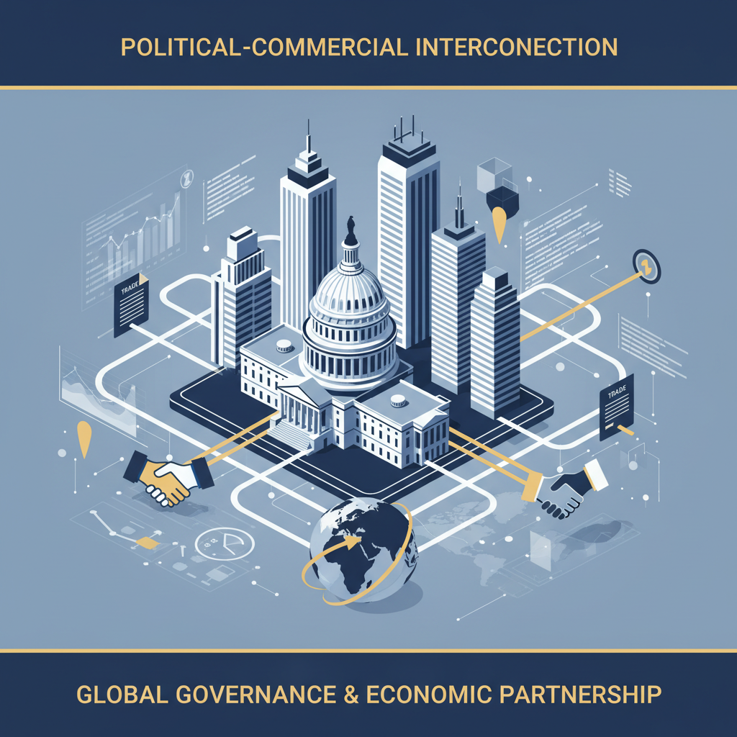

2.3 Interconnection Between Political and Commercial Spheres

2.3.1 Policy Shifts Driven by Economic Interests
Policy shifts in the United States frequently emerge from intersections between economic imperatives and existing political agendas, where governmental bodies recalibrate priorities to sustain domestic markets, protect strategic industries, or respond to competitive pressures from abroad. Economic interests, whether originating from private enterprise coalitions or state-linked sectors, exert a framing influence that directs how legislation is crafted, executive orders are issued, and regulatory rules are designed. These shifts often carry downstream effects extending beyond the immediate industry in focus, altering wider trade flows, investment climates, and the distribution of resources between domestic defense and international expansion efforts. Economic pressure points can trigger swift policy redirection in high-value sectors such as energy infrastructure, defense manufacturing, and maritime resource extraction. Congressional interest in industrial base resilience offers a clear illustration: submarine construction programs involving firms like General Dynamics Electric Boat and Huntington Ingalls Industries are not simply procurement matters, they signal a national commitment to retain complex manufacturing capabilities that have atrophied since the post-Cold War shift toward a services economy. By tying budgetary allocations directly to industrial revival narratives, these decisions become less about isolated contracts and more about systemic capacity-building. This interdependence between economic rationale and political endorsement means that lobbying campaigns targeting appropriations committees must embed commercial needs into broader national interest discourses if they hope to shape allocation outcomes effectively. Executive branch actions further demonstrate the speed with which economic triggers can reshape policy orientation. Measures under the Defense Production Act Title III are deployed precisely to address fragilities in critical supply chains, offering grants or purchase commitments when domestic capacity is judged insufficient for strategic needs (4). This tool reflects an intent to pull economic levers for political ends, reinforcing national self-sufficiency while constraining reliance on imports from states seen as geopolitical competitors. Actors embedded within Washington gain procedural advantage here: anticipating which sectors may be flagged for intervention allows them to prepare proposals that fit administrative criteria before funding windows open, often locking in precedence over rivals. Similarly, resource-driven policy evolution occurs around offshore mineral development as agencies like BOEM map areas with potential reserves (5). Identification of high-value deposits, whether rare earths or other critical minerals, can spur accelerated leasing decisions framed in terms of economic security. The narrative tie-in between job creation and strategic independence strengthens political viability for such leases even amid environmental debate. For organizations situated locally, early engagement during mapping or comment periods provides a decisive edge in embedding favorable extraction terms into procedural frameworks before opposition mobilizes. Trade dynamics compound these processes by layering foreign policy considerations atop domestic economic goals. Sanctions regimes illustrate this hybridization sharply: restrictions placed on entities involved with Russia’s Arctic LNG 2 project were justified partly on geopolitical grounds but carried direct commercial implications for global gas supply routes (9). These measures recalibrated energy market flows, creating openings for alternative suppliers already positioned within compliant jurisdictions. Companies with Washington-based representation could better navigate sanction environments by aligning product offerings with administration-endorsed diversification strategies aimed at displacing sanctioned goods. Bilateral engagements, involving nations like the UAE investing in semiconductor infrastructure, also show how economic interests provoke policy scrutiny under export control statutes (2). Domestic actors opposing such ventures frame them through risk narratives tied to technology leakage; supportive lobbying campaigns conversely highlight reciprocal benefits like domestic capacity expansion and allied cooperation compliance assurances. Success depends on detailed familiarity with agency review cultures, enabling timely counterarguments within acceptable security frames before restrictive clauses are formalized. The interplay between economic drive and political culture shapes how these shifts manifest. Calls for protecting domestic labor markets resonate differently depending on prevailing public sentiment about globalization (3). When skepticism toward foreign dependency peaks, as during heightened interstate tensions, economic arguments for reshoring production find greater legislative traction. Regulatory interpretations follow suit: vessel classification changes under maritime law may align more readily with protectionist frames when public discourse favors national build requirements over global supply chain efficiency (5). Representation centers in Washington function as nerve nodes translating sector-specific data into politically resonant objectives within these shifting contexts (1). Their proximity ensures not only rapid adaptation to unfolding priorities but also pre-emptive positioning during formative stages of policy realignment. This embedded vigilance is essential because opportunities tied to economic triggers often vanish once final rules or funding allocations are set; late entrants face procedural inertia that resists reversal without new legislative or executive impetus. However, sustained focus on influencing U.S.-centered policy shifts inevitably tilts organizational attention inward. Energy spent defending and augmenting positions secured through alignment with domestic economic priorities limits capacity for exploratory activity abroad (3). Competitors unconstrained by intensive American market commitments may exploit openings in developing regions or sectors undergoing liberalization while U.S.-anchored entities remain bound within cyclical domestic advocacy loops. Defense-linked industries provide a case study of this concentration effect: substantial advocacy work invested into securing naval shipyard modernization funds reinforces local manufacturing capacity but leaves fewer resources available to pursue parallel procurement opportunities arising from allied fleet expansions elsewhere (4). Likewise, mining enterprises expending effort on securing advantageous offshore leasing terms domestically may miss timely bidding windows on comparable concessions in foreign waters where regulatory environments pose fewer compliance burdens. Policy shifts instigated by economic interests thus operate as both catalysts for growth and anchors tying organizations tightly to one governance sphere. The gains achievable through early influence inside Washington’s decision frameworks, inserting clauses into appropriations bills, shaping agency interpretations before codification, are substantial for protecting domestic footholds. Yet those same engagements consume strategic oxygen that might enable diversification across different geopolitical landscapes absent similar procedural complexity. From an analytical perspective, the pattern reflects structural reciprocity between economics and politics: material needs justify legislative action; enacted policies reinforce market structures that perpetuate those needs; organizations embedded locally adapt continuously within this feedback loop (1). Breaking out requires either radical reallocation of lobbying bandwidth toward external arenas or acceptance that domestic entrenchment will define competitive boundaries going forward, a choice each actor must weigh against both immediate market security and longer-term global positioning potentials.

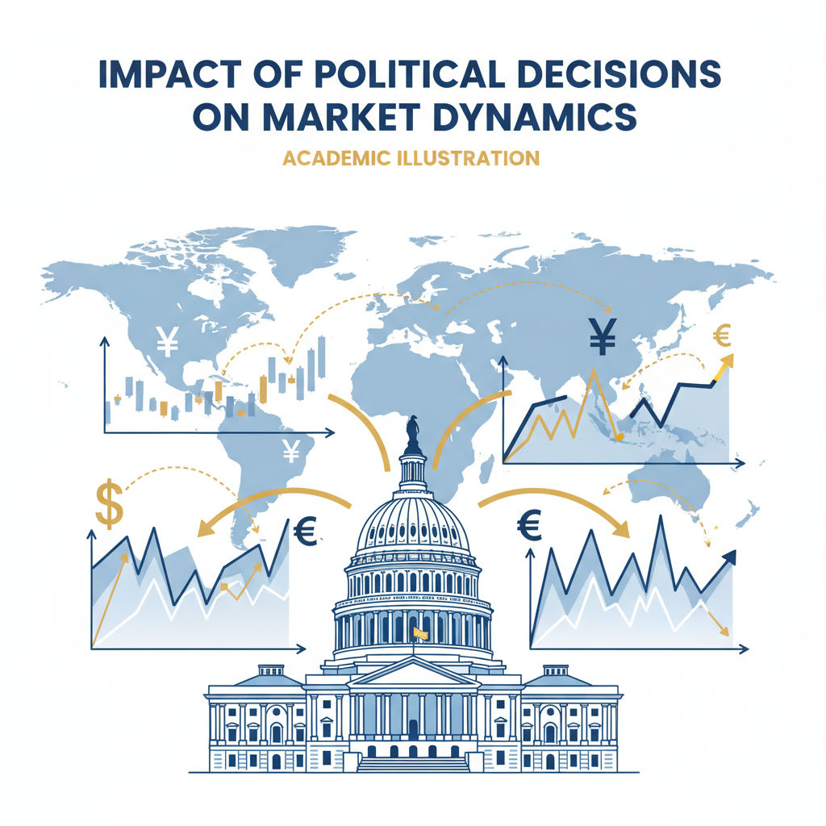2.3.2 Impact of Political Decisions on Market Dynamics
Political decisions in the United States often ripple through market systems with a force that can reshape competitive landscapes, altering trajectories for domestic operators and foreign entrants alike. These decisions range from overt legislative acts to subtler executive signaling, filtered ultimately through regulatory interpretations that define the permissible scope of commercial activity. Markets tend to respond less to abstract political discourse than to binding actions embedded in appropriations clauses, executive orders, or enforceable agency rules, all of which can tilt investment flows and adjust supply chain architectures within compressed timeframes. Firms operating within U.S. borders experience these shifts not merely as regulatory compliance questions but as direct economic recalibrations with downstream consequences for pricing strategies, capital allocation, and long-term positioning. One vivid illustration appears in defense procurement programming, where congressional appropriations earmarked for naval shipbuilding or submarine manufacturing do more than allocate funds; they send a stability signal to associated industries dependent on multi-year contracts and specialized labor pools (4). That signal can trigger ancillary investment in upstream suppliers, metallurgical plants, electronics firms, and secure retention of skilled workforces in targeted regions. Conversely, if political decisions deprioritize a certain defense sector due to shifting strategic needs or fiscal pressures, the resulting contraction ripples into local economies tied tightly to that sector’s survival. The ability to anticipate such pivot points depends heavily on embedded observation of legislative currents before formal announcements are made. In energy and resource extraction markets, political alignment around offshore mineral leasing can accelerate development cycles when framed under national security imperatives (5). A decision by BOEM to open specific tracts for exploration shifts not only operational planning for miners but also collateral ventures such as port infrastructure upgrades or regional logistics expansions. These compilations of micro-decisions, lease boundary definitions, vessel classification interpretations, aggregate into decisive market reshaping forces. Companies without early insertion into the dialogue risk confronting hardened regulatory conditions after competitors have tailored their operations to favorable rulings negotiated during formative phases. Trade policy measures likewise demonstrate how political choice drives real-time market adjustments. Tariffs introduced under executive direction in response to geopolitical tensions alter cost structures overnight, pushing import-reliant industries toward sudden sourcing diversification or passing price changes onto consumers (3). When such tariffs target specific commodity categories critical to manufacturing inputs, steel grades for defense production, rare earths for electronics, the impact feeds directly into strategic calculations over capacity utilization and international supplier negotiations. Actors with persistent Washington presence can seek exclusions or reduced rates proactively by presenting targeted economic impact analyses timed ahead of tariff list finalization. Export control regimes extend these dynamics by constraining outbound technology flows based on national security determinations (2). Restrictions targeting precision-manufacturing equipment or semiconductor technologies directly influence global competitiveness in these sectors. Domestic producers may benefit short-term if restrictions limit foreign rivals’ access; however international expansion plans suffer when outbound licensing slows due to heightened scrutiny. Market actors aware of impending control shifts through close regulatory engagement can adjust production schedules and customer commitments in anticipation, an advantage lost entirely for those outside immediate policy loops. As observed previously in Section 2.3.1, economic triggers often spark political recalibrations that cascade through market mechanisms quickly enough to overwhelm slower-moving strategic plans. For instance, a sudden reclassification under maritime statutes deciding whether foreign-built vessels may operate domestically reorders competitive advantage between incumbent fleets and potential new entrants (5). Costs associated with complying, retrofits, domestic rebuild mandates, shift investment flows toward compliant operators already positioned within the rulemaking dialogue. These interactions underscore the necessity of establishing a permanent representation center within Washington’s orbit (1). It is this embedded presence that enables extensive preemptive shaping of decisions while simultaneously reading informal cues emanating from committees, sub-agencies, and caucuses about policy directions yet unreleased publicly. Without it, businesses confront markets shaped by political forces they did not influence and cannot easily reverse post-implementation. Political decision-making also interacts intimately with cultural narratives surrounding national autonomy and industrial sovereignty (3). Policies touted as protecting domestic industry tend toward higher public acceptance even at potential efficiency costs; markets adapt accordingly by contracting supply options internationally while deepening dependence on local production ecosystems. Strategic foresight here hinges on recognizing when such narratives crest within policymaking bodies so as to align bids or proposals with prevailing sentiment before budgetary or regulatory locks occur. Moreover, defensive postures adopted in response to political determinations reverberate into resource allocation decisions at corporate governance levels. Time invested in sustaining current compliance advantageousness under shifting oversight regimes naturally diverts attention from exploratory ventures abroad (7). This results in asymmetrical opportunity distribution where competitors unbound by U.S.-centric obligations advance unchallenged into liberalizing regions while domestically entangled firms expend cycles maintaining entrenched advantages against evolving local laws. Defense cooperation decisions with foreign partners further exemplify how intertwined political approvals are with market potential (2). Agreements opening joint research paths or technology-sharing channels catalyze investment surges into aligned industries; revocations or hesitations freeze pipelines instantly. Market actors lodged inside the evaluative venues guiding these agreements can modulate terms toward sustained viability despite geopolitical flux, a capability rarely available without deep institutional proximity. In effect, the structural interplay between U.S. political decisions and market outcomes creates a loop wherein policy formation stages become battlegrounds for shaping competitive futures. Representation centers serve as both listening posts and staging grounds for interventions calibrated to secure advantageous market alignments before codification occurs. Yet every gain acquired internally entails an implicit narrowing of outward focus: resources locked into domestic influence maintenance cannot simultaneously drive equivalent engagement across diverse global theaters (1). Over years this trade-off molds organizational geography itself, dense concentration around American regulatory hubs paired with leaner projections elsewhere, not due only to preference but as an adaptive response to the velocity and magnitude at which U.S. political choices reshape domestic markets from their very foundations.

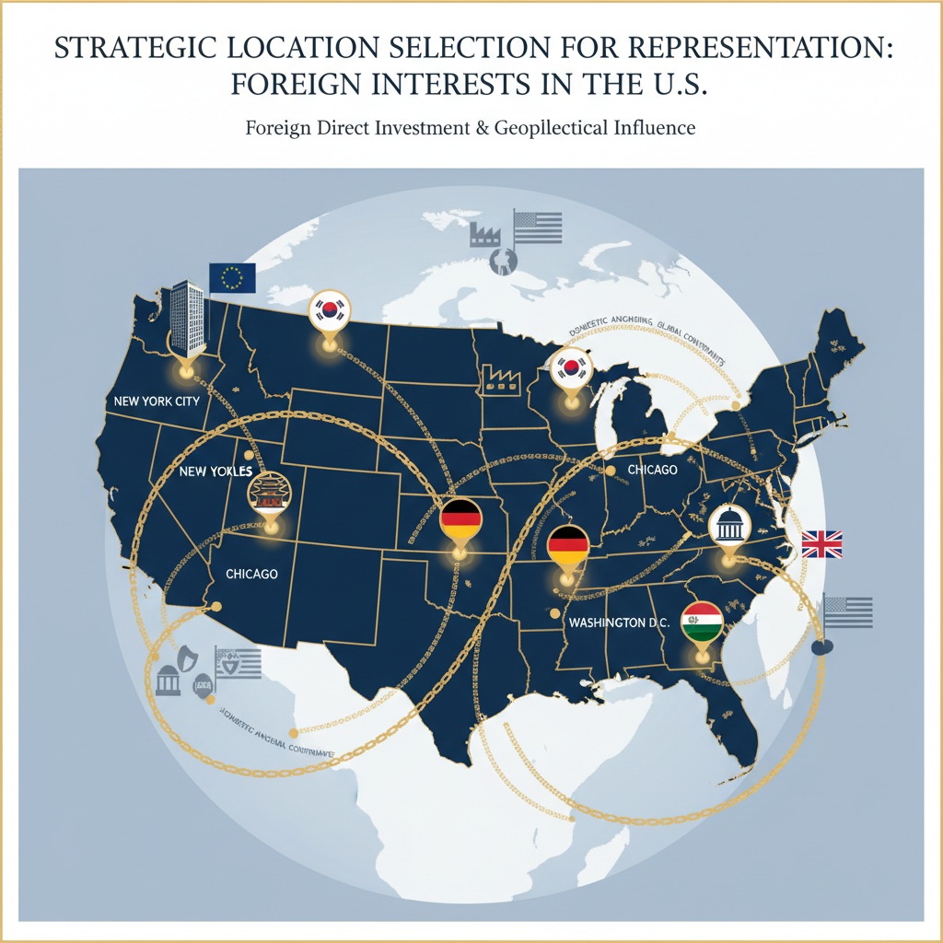

3 Strategic Location Selection for Representation

3.1 Washington D.C. as a Federal Hub

3.1.1 Access to Congress and Legislative Bodies
Direct access to Congress and its legislative machinery provides a distinctive channel through which organizations can influence statutory outcomes before they mature into binding law. Physical proximity inside Washington, D.C., ensures that representatives can monitor committee deliberations, subcommittee hearings, and procedural markups in real time, significantly increasing the chance of embedding favorable language into bills during their formative stages (1). Organizations without such presence are typically confined to reacting after measures have already gained structural momentum, at which point altering provisions becomes substantially more difficult due to entrenched coalition support around existing text. The legislative calendar is dense with overlapping decision points, appropriations cycles, policy review periods, conference committee reconciliations, that occur on timelines too compressed for remote actors to engage effectively. Representation centers situated within the capital can place staff directly into informal briefing networks among aides and committee clerks, accessing draft proposals and amendment frameworks before they reach public distribution. This early insight allows strategic preparation of policy briefs or statistical supplements tailored to the chairpersons’ or caucus leaders’ known priorities, increasing receptivity when advocacy materials arrive during moments of procedural openness. Congress as a target for influence is multi-layered: beyond the visible floor debates lie substructures where much of the substantive shaping occurs. Standing committees on energy, defense, or commerce hold closed sessions gathering expert testimony that often frames later bill provisions. Advocates embedded locally stand ready to supplement these inputs with their own analyses aligned to members’ policy philosophies and electoral considerations. For example, in sectors involving offshore mineral development, representatives can leverage live BOEM mapping results (5) to demonstrate both critical resource potential and localized economic benefits, a combination that tends to resonate well with committees balancing national security rhetoric against economic opportunity creation. Legislative bodies are also the arena in which spending appropriations merge technical project detail with political culture alignment. Securing inclusion in must-pass financial legislation provides resilience against targeted opposition; earmarking funds for industrial base preservation under naval procurement contracts illustrates how commercial requests are recast as strategic necessities (4). In such cases, advocacy teams positioned near Congress cultivate alliances across district lines by reframing benefits toward regional labor impacts, the same investment framed differently depending on local electoral narratives. This ability to adapt messaging swiftly relies entirely on accessibility to legislative offices where staffers articulate those very narratives during internal discussions. Access further enables tactical engagement with oversight mechanisms through hearings designed to inquire into program efficacy or regulatory adherence. Representatives who anticipate oversight themes can prepare coordinated responses supporting agency interpretations favorable to their goals. If vessel classification disputes threaten operational economics (5), an advocate aligned with both committee leadership and sympathetic member blocs may influence how technical criteria are presented publicly, possibly steering follow-up legislation toward more flexible compliance thresholds. Without an office inside Washington’s corridors, such coordination would be diluted by delays inherent in remote consultation chains. The mechanics of lobbying within Congress require not only access but persistent visibility: short bursts of engagement tend to fade from legislative memory amid continuous influxes of competing agendas. Maintaining a representation center ensures recurring contact with key members and their aides through formal testimony offers or informal caucus briefings that preserve organizational priorities at the forefront of consideration lists. These sessions often serve dual purposes, informing legislators while embedding talking points into their public communications portfolio so that external criticism is countered by arguments sourced directly from the advocacy entity’s materials. It is important also to acknowledge the trade-offs embedded in maintaining this proximity-centric strategy. The continuous defense of U.S.-anchored market positions pulls organizational resources toward domestic agenda maintenance at the expense of international ventures (3). Parliamentary allies abroad may observe diminished engagement levels as Washington-based teams focus intently on preserving gains secured through close congressional interaction, leaving strategic vacuums for competitors operating outside these constraints to pursue expansion plans unimpeded. Committee engagement extends into shaping not just content but sequencing: knowing when a bill will move from markup to floor debate allows backchannel persuasion aimed at modifying whip counts or adjusting amendment sponsorships before final tallies lock in legislative fate. This intelligence cannot be replicated reliably from outside; it flows within tightly knit networks cultivated through daily presence (1). Where geopolitical pressure influences trade restrictions or defense cooperation clauses (2), real-time advisory capacity can reposition proposed measures within compromise zones acceptable both domestically and internationally before binary vote scenarios drive polarizing outcomes. Moreover, congressional accessibility enhances alignment across multiple policy layers: synchronizing narrative framing between House committees dealing separately with commerce and defense creates pathways for multi-sector initiatives that would otherwise be siloed administratively. Crafting unified support packages weaving together mineral lease expansions and defense manufacturing funding requires intimate awareness of programme pacing inside disparate committees, a task feasible only through sustained personal interface with legislative architects responsible for bridging such divides. The long-term impact of this access reveals itself in structural positioning within national markets: early involvement during statute formation cements operational advantages into legal frameworks resistant to displacement by subsequent entrants lacking originating influence credits. Yet this consolidation inside one governance sphere inherently reduces fluidity for pivoting toward external opportunities, opportunities often seized by actors less entangled in American political rhythms because their strategies remain shaped by broader global responsiveness rather than constant adaptation within a single federal system (3). The decision calculus here revolves around securing enduring domestic predominance despite foreseeable contraction of external projection capabilities over time, a balance struck differently depending on each entity’s appetite for bounded versus diversified growth trajectories.

3.1.2 Proximity to Executive Agencies
The operational closeness to executive agencies in Washington, D.C. creates a spectrum of influence opportunities that differ in tempo and scope from those associated with legislative bodies, yet often intertwine with them to define final policy orientations. Executive agencies take presidential directives, statutory mandates, and budgetary allocations and translate them into concrete administrative actions, guidance documents, licensing decisions, and enforcement priorities. For organizations seeking to impact U.S. political or commercial decisions via these pathways, sustained proximity is more than a convenience, it functions as an early-warning and active-shaping capability. Within the federal apparatus, departments such as Commerce, Defense, Interior, and sub-agencies like the Bureau of Ocean Energy Management (BOEM) or the Bureau of Industry and Security (BIS) wield considerable discretion when interpreting broad policy objectives (5). These interpretations occur in fluid procedural environments where political context and technical argument converge. For example, BOEM’s mapping of offshore mineral deposits not only informs leasing availability but also frames inter-agency conversations around critical mineral classification, a designation that can increase protectionist measures or trigger accelerated exploitation timelines under national security premises (1). Being physically close enables stakeholders to contribute data sets or environmental assessments directly into these formative dialogues before they coalesce into official policy statements or regulatory codifications. Executive agency processes often operate on compressed timelines following high-level decisions from the White House. An executive order targeting industrial base resilience through Defense Production Act Title III authorities may set off a chain reaction within the Department of Defense to identify candidate sectors for investment (4). Those sectors compete internally for finite budgets based on readiness assessments presented by agency analysts. Organizations with locally embedded teams can input tailored capacity demonstrations during these window moments, well before priority lists reach public disclosure, thus influencing which industries or facilities secure advantageous procurement commitments or grant funding. Proximity also facilitates integration into intra-agency consultation cultures. Departments frequently prefer stakeholder submissions formatted according to their internal style guides and analytical conventions; non-conforming inputs risk being sidelined regardless of substantive merit (1). Representation centers populated by specialists familiar with each agency’s operational rhythm can align proposals accordingly while maintaining ongoing rapport with mid-level officials who draft technical appendices or decision memos. This relational capital operates subtly: when tight deadlines emerge on adjustments to vessel classification criteria under maritime law (5), trusted contacts inside agencies may give informal heads-up calls enabling advocates to prepare evidence packages preemptively. There is a notable synergy between proximity-driven engagement at executive agencies and earlier discussions regarding congressional access (Section 3.1.1). Agency staff frequently liaise with congressional committees during budget justification cycles; aligning narratives across both spheres can ensure continuity from statutory intent through administrative practice. For instance, if defense appropriations secure funds for submarine workforce training (4), consistent support within Navy acquisition offices reinforces execution aligned with advocacy plans rather than permitting divergence due to shifting internal priorities. However, localization has resource consequences. Maintaining continuous presence for monitoring swift-moving export control changes, for example involving sensitive semiconductor technologies negotiated alongside UAE partnerships (2), draws organizational attention inward toward defending domestic compliance structures. International expansion agendas may stall as personnel remain focused on adjusting license applications or negotiating technical provisos under EAR or ITAR frameworks before adverse determinations crystallize. Agency engagement is not purely reactive but requires anticipatory structuring of influence campaigns. Draft notices of proposed rulemaking (NPRM) often precede formal policy changes by months yet circulate initially among select stakeholders likely to respond constructively (1). Representation centers within Washington are strategically positioned to acquire these drafts early enough to orchestrate multi-pronged responses: technical clarifications filed formally, complemented by district-level economic impact stories distributed in parallel media channels priming public sentiment in favor of the advocated position. The overlapping jurisdictional landscape further heightens the importance of physical access. A leasing decision by BOEM could intersect with Department of Defense logistics planning if extracted minerals have naval applications (4). Bridging such agency mandates requires nuanced relationship management across bureaucratic boundaries, a skill cultivated most effectively through consistent face-to-face interface in headquarters’ corridors rather than occasional teleconferences that miss informal cross-department exchanges shaping consensus outcomes. Moreover, executive agencies play gatekeeping roles in bilateral agreements involving technology sharing or strategic resource trade (2). Their determinations about licensing scope or compliance conditions directly influence whether deals survive geopolitical scrutiny. Without immediate access for clarification meetings or submission of supplemental assurances during review processes, foreign-linked ventures risk entanglement in extended delays, often fatal for time-sensitive competitive positioning against rivals already operating within approved channels. Over time proximity becomes both an asset and a constraint; it amplifies situational awareness and accelerates tactical responsiveness internally but ties commitment strongly to one governance sphere’s cycles (3). Opportunities in other jurisdictions can be missed while resources remain absorbed by continual adaptation to domestic administrative dynamics, from environmental compliance stipulations for offshore projects (5) to evolving best-practice guidelines in cybersecurity policy affecting technology exports (6). This inertia can be exploited by competitors abroad who move into liberalizing markets unencumbered by entrenched obligations inside American regulatory frameworks. Thus engagement with executive agencies benefits from a blend of technical competence matched precisely to agency culture and early-stage intervention timed at procedural inception points. Representation centers situated inside Washington serve dual functions: harvesting embedded intelligence about impending shifts while shaping implementation details that carry decisive commercial implications downstream. Yet actors investing deeply here must accept that their strategic bandwidth will tilt toward sustaining domestic market advantages rather than pursuing diversified growth elsewhere, a structural trade-off integral to the calculus behind federal hub location choice (1).

3.1.3 Networking Opportunities with Policymakers
Establishing and cultivating networking opportunities with policymakers in Washington, D.C. is not a peripheral benefit of maintaining a representation center there, it is one of its primary operational advantages. These opportunities involve structured, semi-structured, and informal interactions that collectively shape the policy environment in ways rarely accessible to those at a distance. By positioning organizational representatives within close physical and social proximity to decision-makers, both elected and appointed, an entity gains rare access to the underlying currents guiding legislative drafting, executive agency directives, and regulatory interpretations. The value here lies in immediacy: face-to-face exchanges in Capitol offices, side conversations during committee recesses, and attendance at policy roundtables hosted by agencies allow for timely interventions before positions harden into non-negotiable stances (1). Unlike direct lobbying meetings alone, networking often entails building familiarity over time through recurring presence at hearings, receptions, working groups, and sector-specific summits. Each interaction contributes to an incremental trust-building process in which policymakers begin to regard a representative as a reliable source for domain-specific information. This position can translate into early requests for technical input on upcoming bills or regulatory proposals, for instance, supplying vessel classification data during discussions with BOEM staff when offshore mineral leasing rules are contemplated (5). Those already embedded in the capital are positioned to provide nuanced interpretations instantly when policymakers need them most. Networking also enables entry into overlapping influence channels. Policy officers within executive agencies frequently coordinate with congressional staff during appropriations cycles or while seeking statutory authority adjustments (4). An organization that maintains relationships on both sides can act as an informal bridge, helping ensure legislative language aligns well enough with agency implementation realities to avoid delays or operational conflicts after passage. Such dual-channel engagement is impractical without constant local presence because it depends on sustained interpersonal rapport cultivated through repeated low-profile contact rather than occasional formal briefings. These relationships extend beyond formal political actors to include industry coalition leaders and think tank analysts who shape the informational diet of policymakers. Networking here involves participating in closed forums where legislative aides vet policy ideas before introducing them publicly. For example, in contexts involving export controls tied to sensitive technologies like advanced semiconductors linked with UAE partnerships (2), trusted coalition members may tip off allied policymakers about how forthcoming restrictions could be framed to preserve allied cooperation while mitigating perceived security risks. Representation offices inside Washington can respond immediately with adjusted messaging or technical safeguards that keep deals viable within shifting regulatory boundaries. Proximity-driven networking excels when political calendars compress decision windows, such as when sudden geopolitical developments trigger emergency rulemakings or sanctions announcements (3). Informal connections enable rapid information flow: a phone call from a committee aide who attended last week’s industry luncheon can alert an embedded representative to pending tariff measures targeting critical minerals (5). That advance notice allows preparation of counterarguments or economic impact briefs timed to arrive before final determinations emerge publicly. There is an adaptive quality to these networks: they evolve as political priorities shift across administrations and congressional sessions. Relationships cultivated under narratives of industrial self-reliance, seen in Defense Production Act Title III initiatives aimed at bolstering domestic manufacturing resilience (4), may need recalibration when cultural emphasis shifts toward fiscal restraint or environmental stewardship. Local representation centers can sense these pivots early through casual exchanges at subcommittee luncheons or inter-agency working groups discussing cross-jurisdictional projects like offshore exploration zones tied to naval supply chains. This embeddedness generates tactical redundancy: should one channel falter due to electoral turnover or politically motivated distancing from certain industries, alternative routes remain via remaining personal contacts elsewhere in the policymaking ecosystem. For example, loss of favor with a House committee chair might be mitigated if executive branch agency officials continue to respect the representative’s data delivery capabilities under regulatory frameworks (1). Maintaining regular attendance at mixed public-private working sessions ensures visibility across different factions regardless of partisan dynamics. However, investing deeply in these domestic networking channels reinforces inward focus at operational levels. Time spent reinforcing trust among U.S.-based policymakers inevitably reduces bandwidth available for developing similar relations abroad, a dynamic noted consistently where actors heavily engaged in American governance cycles see diminished agility internationally (3). Competitors not bound by such local commitments may allocate those resources toward markets undergoing liberalization or sectors opening under trade reforms beyond U.S jurisdiction. Another dimension involves alignment between networking content and prevailing political culture; informal contacts are most productive when exchanges acknowledge the values and symbolic language important to the U.S policymaker audience (1). Representatives who adjust their conversational framing, emphasizing national job creation alongside technical precision, find more receptive hearings during social interactions that serve as precursors to formal lobbying efforts. These cultural cues often surface outside official sessions: an offhand remark after a breakfast briefing about public sentiment toward foreign supply chains can signal how best to pitch related policy proposals inside committees later that week. Overlapping networks also allow cross-sector leverage; defense advocates might introduce energy-sector lobbyists to procurement-focused legislators if they perceive mutual reinforcement between narratives, for instance linking naval base infrastructure upgrades funded under defense allocations with regional port expansions justified by mineral export revenue streams (4). Representation centers functioning as nexus points for such introductions amplify influence by weaving separate industry threads into composite agendas appealing directly to multifaceted policymaker interests. In practice, rich networking landscapes materialize through deliberate cultivation of presence across formal hearings, semi-formal receptions, private briefings, agency-hosted consultations, and co-sponsored forums blending governmental stakeholders with industry technocrats. Each setting plays distinct roles: hearings provide official records useful for later citation; receptions offer unstructured dialogue conducive to message testing; private briefings allow targeted persuasion away from media glare; agency consultations deliver technical validation shaping rulemaking nuances; multi-stakeholder forums embed corporate perspectives into broader strategic debates before specific legislative vehicles are chosen. Ultimately these multifaceted interactions turn proximity into procedural leverage, the ability not only to react swiftly but also to pre-align organizational objectives with converging currents from legislative chambers, executive offices, regulatory agencies, and informal advisory circles before they crystallize into binding action (1). In exchange for this advantage comes the strategic cost of reduced international mobility: dominant focus on nurturing domestic decision networks will inevitably draw attention from global expansion possibilities where rivals less constrained by American political rhythms may move faster into new arenas.

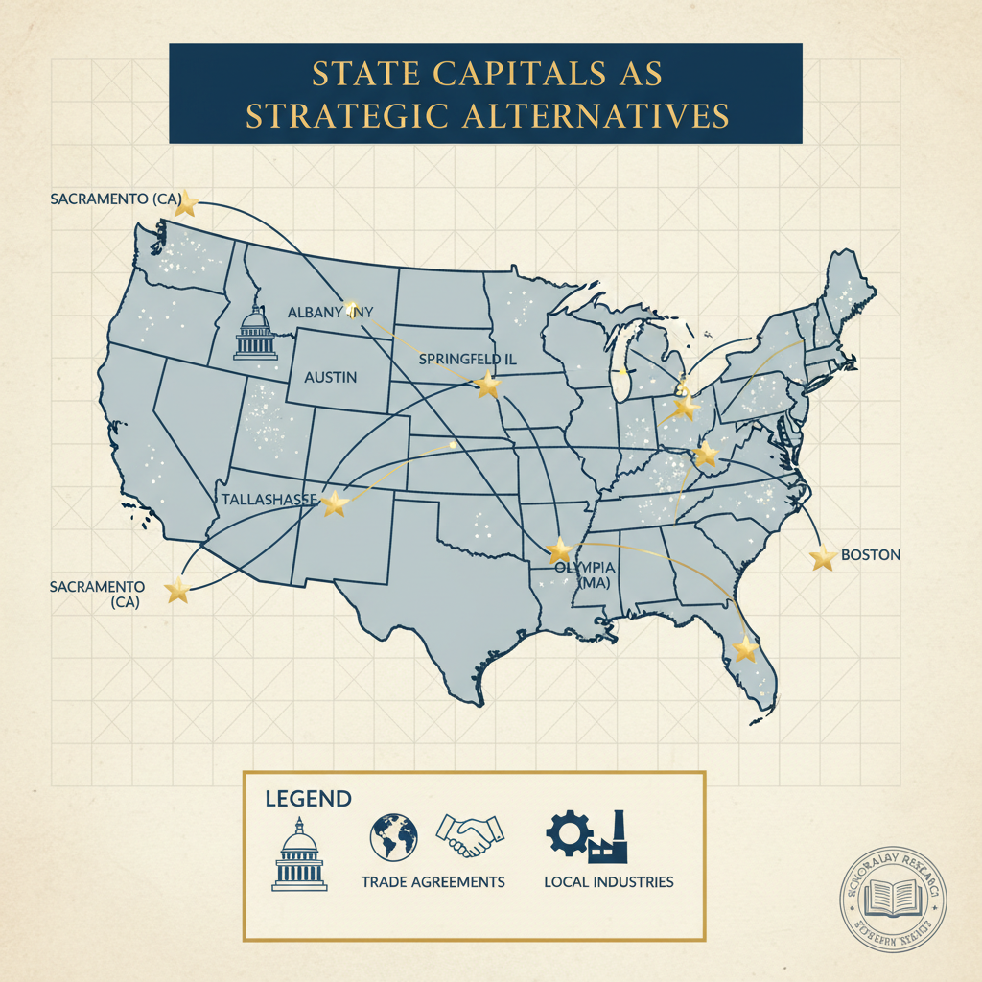

3.2 State Capitals as Strategic Alternatives

3.2.1 Influence in Regional Markets
Influence in regional markets within the United States operates on a scale and tempo distinct from federal engagement, yet it follows many of the same structural principles outlined earlier for proximity-based advocacy. State capitals offer alternative hubs where organizations can embed their presence to drive outcomes more aligned with local priorities, regulatory landscapes, and political cultures specific to each jurisdiction. While Washington, D.C., remains the nexus for national policy setting, state-level influence often determines how federal directives are interpreted and applied in practice, particularly in industries where substantial autonomy resides in state agencies or legislatures (1). This means that an organization aiming for resilient market positioning must recognize that shaping statutes or regulations at the state level can yield durable advantages, sometimes bypassing contentious federal venues entirely. Regional influence starts with understanding the localized economic narratives that dominate legislative discussions. Many state capitals place emphasis on sectoral strengths embedded in their geographic and industrial identity, oil and gas in Texas, maritime logistics in Louisiana, defense manufacturing clusters in Virginia. Embedding representation inside these contexts allows advocates to align proposals with entrenched policy objectives already embraced by local leaders. For example, offshore mineral leasing processes discussed federally through BOEM often intersect directly with coastal state decision-making (5). Governors and legislative committees adjacent to proposed operations control formal objections or recommendations that carry significant weight when rules are finalized. Local offices situated near these decision centers can coordinate outreach ensuring such commentary aligns constructively with corporate goals before submission to federal authorities. Trade flows at the regional level also link tightly to local infrastructure development priorities. Port expansions justified under energy export demands often require state legislature authorization for bond measures or environmental clearances. An embedded advocate can couple technical impact assessments with employment growth estimates designed to appeal directly to district-focused legislators whose electoral prospects depend on visible economic benefits (1). This mirroring of arguments between technical feasibility and cultural-economic resonance strengthens adoption likelihood while pre-empting opposition rooted purely in environmental or fiscal caution. State-level regulatory bodies frequently exercise substantial discretion over industries highly sensitive to oversight culture. In sectors like financial services, banking commissions establish operational transparency standards that can either smooth market entry or create reputational hurdles (7). Organizations present within these capitals can supply evidence of governance models meeting or exceeding existing norms before stricter conditions crystallize under public pressure. The advantage lies in timing: such submissions carry greater weight during drafting phases of rule adjustments than after rules are promulgated. Defense-linked industry networks provide another rich vein for regional influence efforts. Where shipbuilding contracts benefit coastal economies through naval base support facilities, state congressional delegations coordinate closely with local policymakers to ensure workforce training programs align with anticipated procurement cycles (4). A representation center operating from a relevant capital can integrate seamlessly into these efforts, framing commercial needs as instruments for preserving or expanding skilled labor pools, an argument that resonates culturally due to its coupling with community stability narratives. Regional markets also reflect political cultures every bit as impactful as those encountered federally. Some states emphasize sovereignty-like control over strategic resources, reminiscent of Gulf states’ prioritization of autonomy noted elsewhere (3). In such environments, resistance to perceived external imposition requires careful reframing of proposals into locally owned initiatives supported by outside partnerships rather than directed by them. Offices embedded regionally acquire the informal intelligence necessary to detect shifts toward protectionist sentiment early, shifts which may affect both licensing decisions and procurement preferences. One marked advantage of locating advocacy resources within state capitals is access to multi-sector networking opportunities less encumbered by crowded federal schedules (1). Policy forums convened regionally tend to be smaller and more focused on actionable project timelines pertinent to the area’s dominant industries. This tight focus enables substantive conversations where technical changes, such as vessel classification implications for regional shipping, can be discussed in detail without dilution against national-scale agendas (5). Building rapport inside these forums fosters relationships across municipal government layers, trade associations, and academic research bodies contributing essential data into policymaking channels. Yet as with Washington-focused strategies, heavy investment into one sphere carries resource trade-offs. Organizations dedicating personnel extensively at the regional level inevitably commit substantial energy toward defending market share locally, time and attention that might otherwise be directed toward international expansion (3). Competitors unconstrained by such obligations may seize openings abroad while regionally entrenched actors cycle continuously through maintenance of domestic regulatory compliance and legislative alignment routines. Networking at the regional scale is often more personal than transactional; repeated engagement across town halls, industry-specific committee hearings, and cooperative pilot projects generates trust capable of shifting both legislative language and administrative interpretations before they become fixed (1). For foreign-linked ventures this trust-building demands careful cultural integration into local priorities so that joint projects emphasizing community benefits are viewed favorably even amid heightened sensitivity toward outsider motives. Aligning with local educational initiatives tied directly into workforce pipelines, for example partnerships between technology suppliers and vocational schools, serves both commercial needs and demonstrates tangible social investment. Critical infrastructure debates provide fertile ground for sustained influence within regional markets. Projects like LNG export terminal development hinge on both state environmental agency permits and legislative funding approvals tied to transportation upgrades. Representation centers sited locally can synchronize regulatory filings with public relations campaigns highlighting job creation numbers alongside compliance benchmarks, blending economic rationale with assurances tailored precisely for local political consumption (5). An integrated strategy across multiple regional hubs may complement Washington-based lobbying by securing distributed pockets of influence feeding indirectly into federal processes via coordinated governor or attorney general statements supporting aligned policy positions. These signals often impact committee determinations more than distant corporate briefs because they arrive bearing local consensus grounded in prominent constituent interests (1). Ultimately influencing regional markets requires immersion within unique socio-economic fabrics and political rhythms distinct from but connected to national ones. Proximity converts knowledge into timing advantage: understanding when a state committee will revisit critical mineral lease policy or a maritime board will redefine vessel categories allows targeted interventions shaping outcomes favorable over long horizons (5). The strategic balance then becomes one of determining how far resource allocation toward defending these enclaves should tilt against pursuing competitive footholds internationally, a calculus complicated but enriched by the embeddedness that proximity affords inside American governance cycles across its diverse political geographies.

3.2.2 Integration with State-Level Policy Agendas
Integration with state-level policy agendas requires organizations to adapt their influence strategies to the specific priorities, political culture, and administrative processes of each jurisdiction. This is not simply a matter of replicating federal-level lobbying techniques in miniature; state governments often have distinct legislative rhythms, regulatory frameworks, and economic focus areas that demand a tailored approach. Where federal engagement seeks to align with national strategic narratives, state-level integration hinges on embedding proposals into localized policymaking environments so they appear as natural extensions of existing economic or societal objectives (1). Organizations positioning themselves within state capitals must first map the institutional landscape, identifying key committees, regulatory boards, and advisory bodies most relevant to their sector. For example, in states with significant offshore mineral potential, integration with the governor’s energy agenda and the legislature’s infrastructure priorities can shape how formal recommendations to federal agencies like BOEM are framed. When these recommendations bolster both local job creation narratives and perceived national security interests, they exert disproportionate influence during federal rule-making phases. An embedded local presence allows advocates to participate in drafting or endorsing these recommendations at the source rather than reacting after submission. Economic development initiatives at the state level offer further points of entry for influence strategies. Legislators and governors frequently champion targeted investments, industrial parks, port upgrades, renewable energy clusters, that align with both regional growth goals and partial execution of federal objectives. Integrating organizational priorities into such initiatives can deliver dual benefits: securing state funding or policy incentives while laying groundwork for parallel advocacy in Washington that references strong subnational support. For energy exporters or mining firms, this might mean presenting environmental compliance plans synchronized with state sustainability benchmarks alongside projections of employment impacts in port communities handling increased output (5). Sector-specific agendas also vary widely between states. In defense manufacturing hubs like Connecticut or Virginia, workforce training provisions tied to anticipated naval contracts are often embedded in economic policy bills (4). Integrating into these agendas involves working closely with vocational institutions, industry alliances, and legislative sponsors to ensure funding allocations specify skill sets aligned with corporate supply chain needs. Timely intervention in such state-level allocations creates a documented track record of local benefit that can be leveraged later in federal appropriations debates when competing for inclusion in broader defense spending packages. Regulatory cultures at the state level can diverge sharply from federal norms. Financial services businesses seeking entry into New York’s markets face exacting transparency and governance standards administered by state commissions (7). Here integration means engaging early with oversight staff to provide governance models exceeding minimum requirements before high-profile enforcement actions drive legislators toward stricter rules. Doing so positions the organization not as a compliance risk but as an exemplary actor whose operations may be shielded from more punitive measures aimed at less engaged firms. The same anticipatory method applies to sectors facing technology export scrutiny where geopolitical factors trigger rapid adjustments; even if licensing rests federally under EAR or ITAR regimes (2), alignment with supportive resolutions or economic strategy statements passed by influential states can help establish domestic legitimacy before federal reviews commence. The opportunity for alignment extends beyond direct economic propositions into areas shaped by political culture sensitivities noted earlier in regional contexts. Some states adopt strong autonomy stances over natural resource management reminiscent of sovereignty-focused Gulf economies (3). Effective integration here involves reframing external investment as locally driven initiatives bolstered by outside expertise rather than externally dictated projects. A representation office embedded within such a capital can sense subtle shifts toward protectionist sentiment before they manifest legislatively, adjusting partnership terms or public messaging accordingly so as not to trigger reflexive opposition rooted in cultural values. Inter-agency cooperation at the state level offers additional leverage points that become accessible only through localized presence. Infrastructure expansions connected to energy exports might require simultaneous input from environmental quality departments, transportation agencies, and economic development boards, all functioning under separate mandates but ultimately contributing to project feasibility assessments. Close proximity enables ongoing coordination across these fragmented structures so that messaging remains coherent from one department’s review cycle to another’s implementation timeline. Without this integration work on the ground, discrepancies between agency interpretations can delay or derail projects despite legislative intent having been secured earlier. Networking remains essential for continuous integration once initial relationships are established. Attendance at regional forums, such as maritime business roundtables where vessel classification changes are debated, and regular participation in task forces linked to sectoral development plans help maintain visibility among policymakers balancing competing constituent demands (5). Since these gatherings often precede formal legislative activity by months, they serve as incubators where ideas take shape informally before codification; organizations absent from such spaces lose their chance to steer discourse trajectories toward beneficial outcomes. Proximity thus transforms networking into procedural foresight: sensing when employment-focused language should be added to infrastructure bills or when environmental compliance clauses ought to be softened without sacrificing public trust metrics important to local administrations. Embedding deeply within a state’s policy agenda also enables strategic synchronization between subnational priorities and broader national objectives. Governors’ joint letters to Congress supporting specific industry expansions carry weight precisely because they convey consensus anchored in local stakeholder benefit rather than distant corporate interest (1). By participating directly in shaping such communications, through supplying data sets or drafting narrative elements emphasizing community gains, organizations prepare favorable framing ready for insertion into federal hearings or agency evaluations later on. This dual-path advocacy increases chances that subnational support will be echoed during decision stages farther up the governance chain. However, devoting extensive resources toward integrating with one or several state-level agendas inevitably deepens domestic market entrenchment at the expense of international mobility (3). Organizations focusing heavily on reinforcing ties inside U.S subnational systems commit themselves to constant cycles of legislative monitoring, regulatory consultation, and cultural adaptation within those jurisdictions; less time remains for pursuing openings abroad where competitive conditions might currently favor expansion unimpeded by intricate compliance frameworks embedded into American governance structures. Competitors operating without such constraints may move faster into liberalizing foreign markets while regionally anchored actors safeguard positions already secured domestically, a strategic trade-off requiring calculated foresight regarding long-term growth priorities versus immediate stability inside one country’s multifaceted political geography. State-level integration therefore functions as both an amplifier and a limiter: it amplifies influence within targeted regions by embedding organizational objectives directly into prevailing economic policies and regulatory processes; it limits agility globally due to the sustained commitment required to maintain alignment amid ever-shifting local political currents (1). An entity choosing this route must weigh whether the durable foothold achievable through deeply ingrained regional partnerships outweighs opportunities foregone elsewhere, a choice informed not just by near-term commercial returns but also by structural realities inherent in aligning too closely with any singular governance sphere over diversified global positioning possibilities.

3.2.3 Leveraging Local Political Structures
Leveraging local political structures within state capitals requires a level of strategic embeddedness that enables organizations to navigate decision-making processes unique to each jurisdiction. Unlike the federal apparatus, where committees and agencies follow nationally standardized protocols, local structures often involve a web of formally legislated powers intertwined with informal influence channels running through municipal governments, business councils, and regional advocacy alliances. The capacity to act effectively here depends on blending procedural fluency with situational awareness of how local policy priorities intersect with broader federal agendas (1). Local councils, boards, and commissions frequently exert considerable weight over projects that eventually link into federal frameworks. For instance, a port authority’s decision to expand terminal capacity for mineral exports may dictate whether a state legislature supports energy infrastructure upgrades that feed into BOEM’s offshore development strategies (5). An organization positioned physically near these decision centers can build relationships with officials who shepherd such proposals through varied committee stages at the municipal or county level before they arrive for state-level ratification. Engagement at this early juncture allows advocates to infuse narratives tying project viability to community benefits, employment growth, improved logistics resilience, which resonate strongly in local forums and make later opposition less likely. The operative value of leveraging these local structures lies in their capacity to create bottom-up influence vectors feeding upward into state legislatures and even federal committees. Governors often rely on aggregated inputs from regional boards when framing formal positions toward federal policies; alignment between those local reports and an organization’s objectives can indirectly embed its priorities into gubernatorial communications with Washington (1). This dynamic functions particularly well in sectors where state leaders emphasize autonomy, mirroring sovereignty-focused political cultures observed internationally (3). Here reframing externally sourced investment as a co-owned local initiative shifts perception away from foreign control toward collaborative enhancement of regional capacity. Defense-related industries offer a concrete example of this cascading influence model. Naval base expansions hinge on coordinated support between state defense committees and local training institutions tasked with producing specialized labor pools (4). A representation office embedded within proximity not just to the capital but also to these municipal training hubs can facilitate synchrony between workforce planning decisions and appropriations requests moving through state assemblies. By engineering concordance across such structural layers, lobbyists ensure their project proposals arrive at legislative hearings carrying both technical validation and community backing, critical assets when budget competition is intense. Local economic development agencies provide another vector for influence. These bodies typically operate under mandates to attract investment aligned with sectoral strengths, whether that be mineral extraction along coastal states or advanced manufacturing clusters inland. Negotiating frameworks within these agencies often precede legislative authorization for incentives like tax abatements or public bond measures supporting infrastructure builds. Organizations physically present in these locales can engage in iterative dialogue with agency staff during program design phases, ensuring that incentive structures are tuned to operational realities while still framed in terms appealing to policymakers’ cultural expectations of economic stewardship (1). In financial services markets, leveraging state-level commissions becomes essential where governance standards set locally impose additional criteria beyond federal requirements (7). Chairs of such commissions often entertain proposals informed by multi-stakeholder networks including local industry associations and consumer advocacy groups. Building rapport across these groups strengthens the credibility of corporate compliance narratives put forth before commissioners decide whether heightened oversight is warranted. Timely presence inside such deliberations ensures organizations pre-empt reputational challenges by offering demonstrable transparency enhancements before adverse rulings mature under public pressure. Export-sensitive sectors likewise benefit from engaging municipal business councils capable of organizing interstate trade delegations or reciprocal investment visits linked into broader trade policy discussions (2). While licensing under EAR or ITAR remains federally controlled, support letters from recognized local entities ease pathway approvals by establishing legitimacy within domestic political culture prior to national review stages. Such groundwork is near impossible without continuous interaction inside localized networks where trust grows incrementally through consistent attendance at events ranging from chamber breakfasts to special project steering committee sessions. The operational rhythm in local political environments differs significantly from annualized federal cycles; smaller bodies meet more frequently, enabling faster tactical corrections but demanding consistent attention from advocates tied deeply into those timelines (1). This frequency compounds resource demands: representation teams must remain engaged across numerous overlapping venues, city councils debating zoning changes for industrial expansion sites, county boards adjusting environmental compliance ordinances relevant to energy operations, all while monitoring statehouse activity that will codify broader enabling legislation later on. Proximity becomes indispensable here since decision-making speed outpaces what remote actors can credibly respond to without risking missed openings entirely. Yet embedding deeply into these structures intensifies inward focus on defending existing market footholds regionally rather than scouting international opportunities, a trade-off echoing patterns seen in broader domestic engagement strategies (3). Competing firms free from such commitments may channel resources toward emerging overseas markets or industries undergoing deregulation abroad while locally entrenched actors devote cycles toward managing perpetual compliance alignment and nurturing municipal relationships that secure incremental gains inside the United States. Over years this shapes organizational strategy geography itself: dense clusters around key capitals balanced against leaner footprints globally, not always by choice but as an adaptive necessity tied to operational embedding within U.S governance layers. Leveraging local political structures therefore encompasses an ability to maneuver within municipal councils, county commissions, regional development agencies, and allied community boards so that organizational objectives are woven seamlessly into the decision matrices guiding resource allocation and regulatory framing at the subnational level (1). Doing so transforms early-stage participation into downstream advantages at both statehouses and Washington committees via cultivated consensus rooted firmly in constituent interests, an outcome rare for distant actors without localized representation capable of sustaining nuanced relationship management over time.

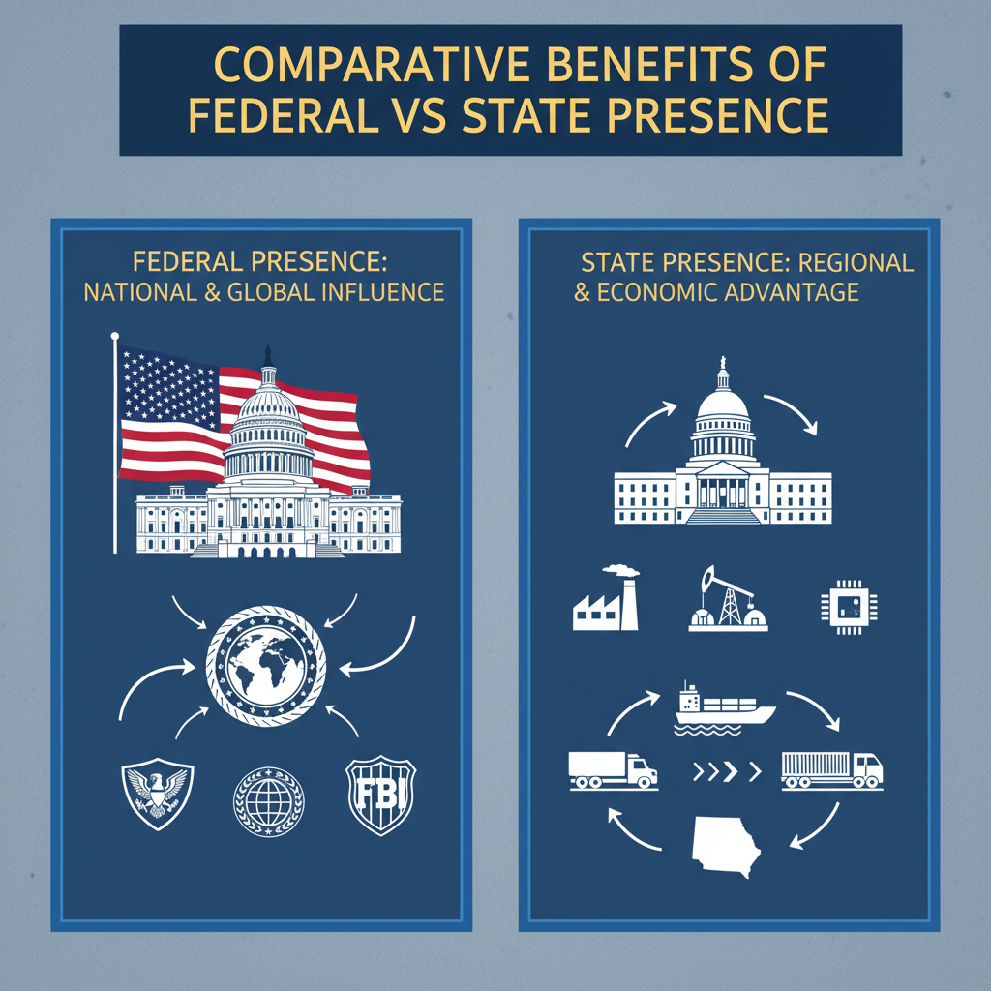

3.3 Comparative Benefits of Federal vs. State Presence

3.3.1 Cost-Benefit Analysis of Location Choice
Evaluating the cost-benefit profile of establishing a representation center in Washington, D.C., versus positioning influence operations within state capitals requires granular examination of both tangible and intangible returns. At first glance, the federal hub offers unparalleled centrality, physically proximate to Congress, executive agencies, and regulatory bodies with national jurisdiction, but the concentration of resources there produces structural trade-offs that extend beyond immediate budgeting considerations (1). The benefits at the federal level center on immediacy of engagement: staff embedded locally can react within hours to legislative markups or sudden executive directives affecting critical industries. This speed yields influence leverage during moments when policy is still malleable. For instance, timely input during BOEM’s mapping and lease planning for offshore minerals can embed commercial-friendly technical clauses directly into administrative drafts before they solidify (5). Early-stage intervention here is worth considerable strategic capital because reversing unfavorable language after codification often demands prolonged lobbying campaigns with uncertain success probability. Embedding in Washington also facilitates synchronized advocacy across multiple agencies whose mandates intersect unexpectedly, such as Department of Defense logistical requirements meeting Department of Interior mineral classifications (4). Organizations able to triangulate arguments between these bodies can ensure continuity from statutory design through operational execution, curbing risks where internal agency interpretation might otherwise diverge from the legislative intent originally negotiated. The financial value of such continuity is difficult to quantify precisely but manifests as operational predictability, lowering compliance costs over time through avoidance of contradictory rulings across jurisdictions. Yet these advantages are paired with steep resource commitments. Maintaining high-functioning representation inside Washington demands continuous investment in personnel trained for procedural fluency, cultural alignment, and network cultivation across political factions (1). This internal focus can saturate attention spans, the bandwidth needed for defending hard-won domestic policy positions consumes capacity that could advance global expansion agendas. Competitors without entrenched U.S. obligations retain agility to exploit liberalizing markets elsewhere while domestically anchored actors cycle through endless compliance upkeep and relationship management inside American governance loops (3). State-level presence rebalances that equation by trading breadth for depth. While state capitals lack the omnichannel reach of Washington’s institutional cluster, they offer direct access to policymakers whose decisions exert substantial influence over how federal directives play out locally. Regional decision-making power is particularly pronounced in resource sectors; coastal governors can sway BOEM lease terms by lodging support or objection impressions grounded in local economic priorities (5). Securing endorsements from these jurisdictions prior to final federal determinations delivers influence indirectly into national processes without absorbing the full costs of constant federal engagement. This pathway carries an attractive efficiency: displacement risk from competitors is mitigated through cultivated alignment with localized industrial agendas, maritime infrastructure upgrades, workforce training for defense contracts, that make policy shifts favor continuation over disruption (4). Operational expenses at the state level generally run lower than maintaining an equivalent footprint in Washington due to less competitive lobbying ecosystems and reduced need for multi-agency monitoring teams. Furthermore, regional settings permit more personalized networking; smaller political arenas tend toward closer interpersonal connections between industry advocates and legislators or commission chairs (1). These relationships serve as accelerators for state incentive programs, tax abatements, bond-funded infrastructure projects, that can lock in market advantages parallel to those pursued federally. However, cost savings come with narrower scope of impact. State-focused settings may limit visibility into emergent federal decisions until they have already entered implementation phases, reducing opportunities to shape foundational statute language or initial regulatory framing. In industries subject to rapid geopolitical condition changes, technology exports under EAR or ITAR constraints involving sensitive partners like UAE-backed ventures, missing early signals from federal licensing authorities can impose costly compliance retrofits or exclude an organization from bidding cycles entirely (2). Thus while a state presence offers nimbleness within its jurisdictional scope, it must often defer to federated authority on ultimate rule setting, making supplementary coordination channels toward Washington indispensable if complete influence coverage is desired. Strategic cost-benefit calculations must also weigh opportunity timing against budgetary cycles endemic to each jurisdiction’s governance rhythm. Federal appropriations open annual windows tied to defense manufacturing budgets or industrial base resilience funding (4); missing these due to absent proximity forfeits high-value program inclusion that a Washington station could secure by aligning proposals directly with key committees during markup periods. State budgets may operate on different fiscal schedules, enabling staggered advocacy campaigns across multiple capitals without overloading organizational capacity, but this only benefits actors capable of running parallel tracks effectively. Cultural adaptation costs vary between scales too. In Washington’s policy culture, aligning external interests with broadly accepted national narratives, security independence, domestic supply chain resilience, is essential to bypass skepticism toward perceived foreign influence (1). This adaptation workload is intensive yet necessary for accessing core decision points nationwide. In contrast, state-level adaptation focuses on integrating into region-specific socio-economic frameworks; here reframing outside participation as locally led initiatives backed by external expertise aligns better with autonomy-sensitive climates similar to Gulf states’ economic sovereignty emphasis (3). These localized adaptations demand fewer thematic shifts once trust networks are established but require sustained community integration efforts that divert global-facing momentum just as much as their federal counterparts. From a scientific standpoint comparing location options involves quantifying both immediate transactional gains and long-run opportunity costs inherent in each model. A Washington base maximizes touchpoints per dollar spent on lobbying but commits the organization heavily into defending domestic footholds against evolving regulatory landscapes; a state capital footprint reduces overhead while embedding deeply into regional decision pathways but narrows upstream access to national policy shaping moments. Hybrid approaches may mitigate trade-offs by distributing representation resources, a lean federal office tracking macro-level developments complemented by specialized state desks cultivating stronghold markets aligned with corporate sector strengths like defense manufacturing clusters or energy export corridors (5). Ultimately the calculus hinges on resource elasticity: entities able to fund concurrent presences without cannibalizing functional depth gain combined advantages; those forced into choosing one sphere must balance whether enduring domestic predominance under tighter procedural control offsets lost agility internationally where unconstrained rivals may capitalize on openings unobserved or unaddressed due to inward orientation (3). The decision thus intertwines budget mathematics with strategic foresight, measuring dollars spent not just against influence captured today but against potential future positioning forfeited when geography dictates political engagement scope irreversibly over time (1).

3.3.2 Balancing National and Regional Strategies
Balancing national and regional strategies involves a layered decision-making process where organizations must reconcile the high-impact immediacy of federal engagement with the tailored, locally resonant advantages of state-level operations. The challenge is not simply logistical but strategic: maintaining active influence in Washington demands continuous immersion in policy cycles, whereas regional capitals offer more sustained yet narrower pipelines into decision-making that shapes how national mandates translate into localized execution (1). This duality requires careful calibration of resource distribution, message framing, and procedural timing to ensure that neither sphere becomes neglected to the point of forfeiting competitive ground. The difficulty arises from the asymmetric nature of opportunities in these two domains. Federal-level activity offers broad policy reach, affecting statutes, agency rules, and multi-sector funding streams, but at the cost of intensive commitment to defending domestic footholds amid dense advocacy competition (3). A representation center in Washington can directly access committees shaping appropriations vital for defense manufacturing supply chains (4), or influence classification debates within BOEM over offshore mineral vessels impacting compliance costs. These early interventions yield outsized influence on national market structures. Yet every hour spent monitoring subcommittee markups or attending agency consultations diminishes time available for fostering opportunities abroad where rivals less tethered to American governance cycles may act decisively. Conversely, state-level engagement enables deeper integration with local economic agendas, such as port expansions linked to energy exports or workforce programs tied to naval contracts, but its scope is circumscribed by federal oversight ceilings. Coastal governors can lodge formal support for mineral leases that later shape federal determinations (5), while state commissions on financial services set governance standards affecting market entry viability (7). These victories are regionally potent but may not translate automatically into nationwide advantage without a bridge to federal advocacy channels. Balancing these arenas calls for synchronized operational rhythms. Organizations with presence in both spheres can feed local endorsements upstream into congressional hearings, leveraging state-level political capital to bolster credibility during federal negotiations (1). For instance, support statements coordinated among multiple governors favoring industrial base resilience initiatives can strengthen the case for Defense Production Act Title III investments at the national level (4). Such cross-sphere echoing amplifies impact without duplicating effort. The key lies in message harmonization: technical data used to convince a regional maritime board about vessel classifications must be adaptable into legislative talking points framed around national security independence when presented in Washington. Resource allocation emerges as a pivotal constraint in this balancing act. Maintaining skilled staff embedded at both levels entails parallel investment in procedural expertise and cultural literacy specific to each environment. In Washington, operatives must navigate complex coalition dynamics between congressional committees and executive agencies on issues like export controls involving sensitive semiconductor technologies tied to UAE partnerships (2). At the state level, advocates must cultivate municipal and industry networks capable of reinforcing policy proposals through community benefit narratives that resonate with autonomy-focused political cultures. Deciding how much capacity each location warrants depends on anticipated legislative timetables and regulatory changes; misjudgments risk either losing visibility during critical policy formation moments federally or failing to secure crucial regional precedence before federal rules lock in. Timing also complicates balance. Federal cycles often peak with annual appropriations markups or rapid-response executive directives, requiring intense short bursts of attention. State cycles might operate continuously across staggered sessions or commission reviews, allowing more predictable planning but necessitating constant presence to maintain relationship currency. A hybrid model may schedule surges into Washington during high-stakes windows, such as BOEM lease finalizations or defense budget reconciliations, while sustaining steady-state engagement regionally to reinforce localized alignment with national aims. Interdependence between spheres further blurs strategic lines. Federal trade measures like tariffs on critical minerals can accelerate legislative interest in state infrastructure projects designed to replace restricted imports with domestic production (3). Representation centers capable of intercepting such shifts immediately can deploy coordinators across target states whose industries stand to benefit, ensuring rapid mobilization behind synchronized narratives emphasizing job creation and economic stability within both local and national contexts (1). Cultural fit is another determinant, narratives effective at the national level do not always resonate regionally without adaptation. Security-first rhetoric championed federally may require reframing toward direct community gains at the state level; protectionist attitudes prevalent in certain states mirror sovereignty positions found internationally and require framing external participation as locally driven initiatives backed by outside expertise rather than imposed projects (3). Embedded offices facilitate these pivots instantly; remote actors often fail due to lag between sentiment change detection and message retooling. Strategic balance also implies calculated acceptance of trade-offs. Prioritizing Washington maximizes potential reach but embeds the organization deeply into defending existing advantages from regulatory reinterpretations or shifts in appropriations focus, such as changes in submarine industrial base funding requirements (4), thus constraining agility abroad. Prioritizing state capitals strengthens entrenched positions within key markets but limits capacity to inject influence upstream before laws and regulations set binding parameters nationally. Actors attempting simultaneous deep engagement risk dilution unless resources are sufficient for maintaining full operational depth in both spheres. In practice, organizations tend toward hybridized dominance: anchoring decisive statutory influence federally while cultivating select regional strongholds tied directly into their sector’s economic lifeblood, for example, pairing D.C.-based advocacy over BOEM leasing rules with entrenched relationships along Gulf Coast energy export corridors (5). The science here lies in optimizing cross-pollination: using federal intelligence on pending regulations or funding streams to prime supportive action through regional stakeholders whose input will be considered during finalization stages nationally. Over time this balancing requires iterative reassessment as political priorities shift across administrations and local governments adapt their agendas accordingly. Export control tightening amid geopolitical tensions might necessitate heavier Washington focus temporarily; conversely, an extended lull federally could be leveraged for consolidating multiple state-level bases ahead of anticipated nationwide policy expansion (2). Flexibility rests on continuous situational awareness fed by footprints embedded securely inside both strategic landscapes, a condition achievable only through deliberate resource structuring acknowledging opportunity costs inherent in deepening ties within U.S-centric governance layers while competitors operate freely across faster-moving international theaters (1).

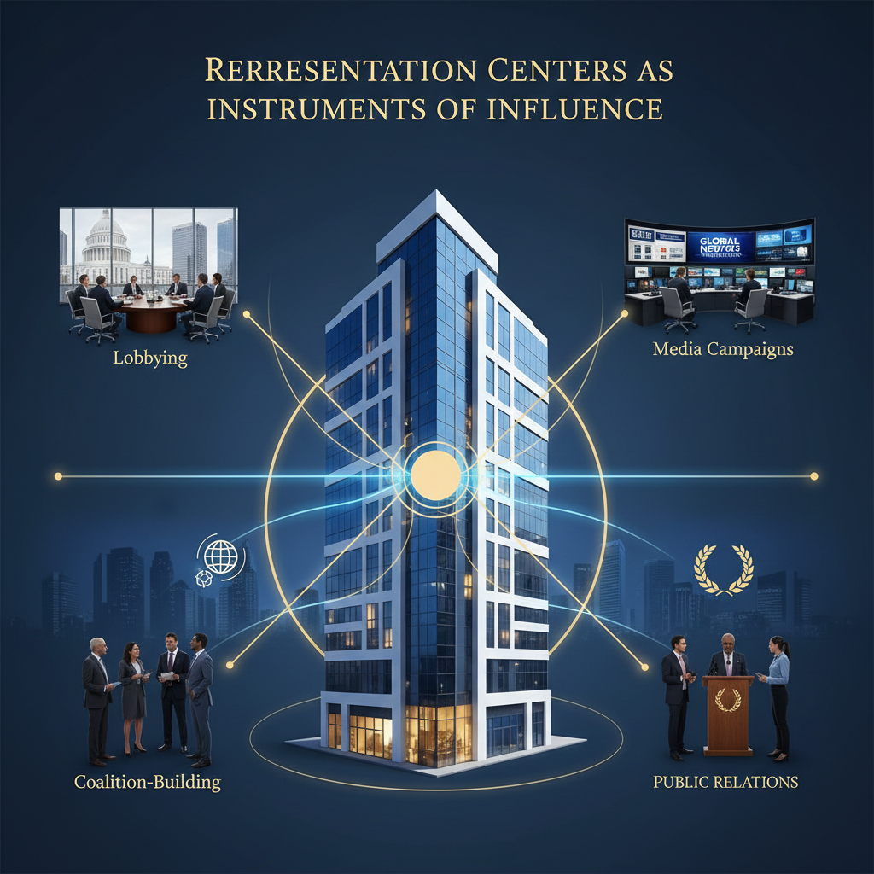

4 Representation Centers as Instruments of Influence

4.1 Organizational Structure and Staffing

4.1.1 Domestic Cultural and Procedural Fluency
Domestic cultural and procedural fluency functions as a critical substrate for any representation center aiming to exercise sustained influence over political and commercial decisions within the United States. This fluency goes beyond knowing statutory text or formal regulatory timelines; it requires immersion in the unwritten codes, interpersonal dynamics, and interpretive preferences that guide decision-making from congressional offices to executive agencies and state-level commissions. Without an adaptive grasp of these cultural elements, even technically sound proposals risk rejection or dilution during translation into legislative language, agency rule-making, or subnational policy frameworks (1). An effective representation center must embed personnel with both domestic cultural literacy, understanding prevailing political narratives, symbolic framing devices, and regional sensitivities, and procedural competence in navigating federal and state governance rhythms. Staff conversant with America’s political culture can sense early shifts in sentiment that affect legislative receptivity. For instance, advocacy pitched purely on economic efficiency might falter during periods of heightened nationalism unless reframed to emphasize domestic job creation and supply chain resilience (3). Recognizing when environmental stewardship gains salience across party lines enables recalibration of resource development proposals to include sustainability clauses that preserve political acceptability without ceding core operational goals (5). Procedural fluency integrates this cultural awareness into practice by ensuring engagement occurs at opportune points where influence yields maximum return. Legislative processes operate through committee hearings, appropriations markups, and conference reconciliations where insertion of tailored language can lock in advantages (4). A culturally fluent representative understands which members respond to district-level narratives about workforce impacts versus those driven by national security framing. The procedural expert knows precisely when that member’s staff is preparing briefings internally so advocacy materials can arrive aligned with their format expectations, avoiding the risk of being sidelined due to nonconforming presentation. At the executive agency level, such fluency allows for productive participation before formal announcements crystallize policy direction. Knowledge of internal consultation patterns at bodies like BOEM positions representatives to submit technical data supporting desired vessel classifications while concurrently aligning public messaging with themes under discussion among mid-level decision-makers (5). Cultural alignment here involves understanding the agency’s self-image, whether it prioritizes environmental stewardship, rapid industrial deployment under security imperatives, or balanced trade-offs between the two, and threading advocacy arguments accordingly. Operational staffing design must reflect this dual competency ethos. Appointing personnel solely for technical mastery risks disconnect from the political rhythms shaping how and when such mastery is valued. Conversely, staffing oriented entirely toward relationship management without sufficient procedural grounding can leave representation centers adept at “being in the room” but ineffective in securing actual policy gains. Ideally teams blend both attributes within each key role rather than siloing them, enabling a single operative to hold informal rapport-building conversations with a House aide about constituent benefits while also preparing draft amendment language formatted to committee requirements. Networking acumen feeds directly into this model: repeated informal engagements across hearings, receptions, working groups, and closed-door consultations build trust reservoirs that yield early access to draft documents or insights into evolving priority lists (2). Procedural fluency ensures these opportunities are leveraged effectively, knowing which consultation phases permit external input without triggering procedural objections or delaying cycles tied to statutory deadlines is crucial for sustaining influence momentum. Integration with state-level structures adds another layer requiring adaptation. Cultural fluency here means adopting regional identity narratives; what convinces a coastal legislative committee may differ sharply from inland energy boards focused on overland logistics hubs (7). Procedurally fluent representatives understand that state commissions’ decision calendars may not map neatly onto federal cycles but can be strategically harnessed so local endorsements arrive in Washington just as related bills enter markup (5). Coordinating this timing demands intimate familiarity with disparate procedural environments, the very skill set cultivated only through sustained presence close enough to absorb local idiosyncrasies firsthand. The payoff for mastering domestic cultural and procedural fluency shows most clearly during high-compression decision windows triggered by geopolitical developments or sudden executive orders. When export control regulations tighten around sensitive technology transfers involving strategic partners such as UAE-backed ventures (2), reaction time dictates whether deals survive review intact or collapse under new compliance burdens. Representation staff operating with full cultural context can recast technical safeguards as contributions to national capacity-building, a frame more palatable under tense diplomatic conditions, while their procedural literacy ensures license modifications reach the correct review bodies before final determinations are locked in. Sustaining this level of embedded presence exacts an inevitable strategic cost: resources committed continually to interpreting and acting within U.S.-centric governance cycles diminish those available for exploratory initiatives abroad (3). Cultural context must be refreshed constantly as political atmospheres shift, incumbents lose seats, public sentiment swings on trade dependency, forcing representation centers into perpetual recalibration mode for both narrative emphasis and tactical sequencing. Competitors free from such obligations can redirect comparable investments toward high-growth foreign markets where governance engagement demands are lighter. In designing staffing models under these constraints, organizations may opt for hybrid roles capable of pivoting between federal and state priorities without losing coherence in underlying advocacy themes. Such versatility depends on training regimes explicitly pairing cultural familiarization with procedural rehearsal: simulations of committee testimony incorporating symbolic language effective for American audiences; mock NPRM comment drafting exercises replicating agency stylistic norms; case study analyses on how past initiatives integrated smoothly into both national statutes and state policy agendas. Critically, domestic cultural and procedural fluency is not static capital; it degrades without ongoing input from real-time situational awareness networks inside Washington’s corridors and across key state capitals (1). Representation centers must institutionalize feedback loops translating soft signals, offhand remarks, informal coalition reshuffles, into actionable adjustments before those signals manifest formally in votes or rules. This continual refresh sustains relevance against policy volatility while reinforcing embedded trust relationships essential for early-stage access ahead of broader stakeholder engagement phases. Thus organizational readiness in this domain requires deliberate curation of personnel experienced enough to interpret latent cues yet disciplined enough to navigate complex procedure without misstep. The blend becomes a core capability enabling representation centers not just to occupy space within domestic governance geographies but to actively shape outcomes therein, all while accepting that this inward-facing vigilance comes at the expense of equivalent agility across other global theaters where absence may mean ceded opportunities ripe for exploitation by less domestically tethered rivals.

4.1.2 Skillsets Required for Effective Advocacy
Effective advocacy within the United States requires a composite skillset that blends technical acumen, political literacy, interpersonal agility, and procedural mastery. Without this integrated profile in the personnel of a representation center, it becomes extremely difficult for organizations to position themselves effectively for influence in both political and commercial vectors. The demands are amplified by the speed at which decision-making in Washington and other capitals can shift, as well as by the layered complexity of governance structures discussed previously in Section 4.1.1. A primary competency is deep procedural knowledge of legislative, executive, and regulatory processes. Advocates must understand not only statutory requirements but also internal workflows within committees, subcommittees, and agencies, identifying points where external input is permissible and most likely to have decisive effect. For example, knowledge of when BOEM circulates pre-publication drafts on offshore mineral classifications allows an advocate to submit supporting data aligned with the agency’s interpretive style before these rules reach full codification (5). Procedural missteps here can see otherwise viable proposals excluded due to missed deadlines or non-compatible formatting standards (1). Coupled with process expertise is the ability to interpret and adapt to prevailing political culture. This cultural literacy involves knowing how narratives about national sovereignty, economic security, or environmental stewardship resonate differently across decision-making venues. An advocate who understands that a workforce initiative tied to naval shipyard expansion may be more persuasive when framed under industrial base resilience goals (4), rather than efficiency metrics alone, will be able to tailor persuasion strategies more effectively. This extends into bilateral contexts as well; technology export arrangements involving sensitive partners like UAE entities require aligning compliance assurances with U.S security narratives while preserving commercial viability (2). Advanced networking skills are another indispensable asset. Advocacy often succeeds on the strength of sustained interpersonal ties cultivated through consistent presence at hearings, roundtables, working groups, and even informal policy events (1). The role here is not mere social engagement, it is strategic relationship management that builds reservoirs of trust enabling early access to draft policy proposals or regulatory notices before wider stakeholder distribution. This is decisive in environments such as high-speed tariff implementations targeting critical minerals; advance warning from connected contacts can enable rapid preparation of economic impact statements influencing final determinations (3). Technical domain expertise specific to the sector an organization operates in anchors credibility within content-heavy discussions. Defense sector advocates must demonstrate grasp over procurement pathways and readiness standards that align with domestic manufacturing goals under programs like Title III of the Defense Production Act (4). Energy industry representatives require fluency in maritime logistics regulations and vessel classification criteria linked to cost structures under acts such as the Jones Act (5). Financial services lobbying benefits from intimate understanding of governance standards expected by commissions concerned with investor protection and transparency (7). A skillset grounded in these sector-specific technicalities ensures that advocacy materials presented at any venue move beyond rhetorical assertion into operationally viable proposals. Media strategy integration is increasingly important, knowing how to synchronize public-facing narratives with internal policy engagement cycles can magnify influence outcomes. Advocates must be able to prepare op-eds or targeted press releases timed alongside state governor comments or congressional hearings so that public discourse reinforces private lobbying positions rather than diluting them. Such timing requires skills both in strategic communications planning and in reading procedural calendars across multiple levels of governance. In addition, legal compliance literacy ensures sustained access within U.S advocacy channels. Lobbying disclosure regimes impose strict rules on reporting activity; inadvertent violations erode credibility and weaken long-term relationships with policymakers who value transparency (1). Mastery over compliance protocols for foreign investment reviews or export licensing protects against sudden disqualification from negotiations involving sensitive technologies under EAR or ITAR constraints (2). In markets tied closely to geopolitical risk assessments, critical mineral exports or LNG infrastructure supporting NATO allies, the capacity to present legally secure operational frameworks is often a prerequisite for further discussion at policymaking tables. Analytical forecasting ability rounds out the effective advocate’s toolkit, using data-driven models to anticipate shifts in legislative interest based on economic triggers such as industrial capacity shortfalls or trade disputes. Employing scenario analysis enables proactive positioning; if congressional trends indicate rising appetite for reshoring supply chains amid protectionist sentiment, advocates can pre-package proposals highlighting domestic job creation aligned with those currents before formal calls emerge (3). This foresight not only cements relevance but primes stakeholders for immediate collaboration once policy windows open. The integration between federal-level skill application and regional-level specialization cannot be overstated. At the state capital scale, interpersonal agility includes adapting overarching organizational aims into local idioms, crafting investment propositions as community-led projects rather than external takeovers in autonomy-sensitive environments (7). Procedural adaptation accounts for varying budget cycles between jurisdictions so endorsements from governors or commissions can be timed for maximal influence upstream during congressional debates on related sectors (1). An advocate cross-trained in both spheres minimizes friction between national objectives and regional market defenses, a balance critical given resource constraints described earlier where heavy domestic commitments often reduce scope for international projection (3). Finally, resilience under compressed timelines defines advocacy efficacy in volatile conditions. When sudden executive orders alter export control regimes affecting semiconductor components bound for allied markets (2), an effective advocate mobilizes quickly, coordinating inter-agency clarification meetings while simultaneously initiating public narrative defenses anchored in national benefit framing. Adaptive strategy execution under pressure draws on every preceding skill cluster: procedural mastery for navigating emergency regulatory changes; cultural literacy for framing affected transactions within acceptable political rhetoric; networking reach for securing crucial audiences; technical precision ensuring solutions withstand substantive scrutiny; media agility aligning public sentiment with private negotiation goals; compliance competence maintaining lawful standing; and analytic foresight anticipating ripple effects into related markets like defense manufacturing supply chains or offshore mineral transport logistics (5). These combined capabilities allow representation centers not merely to participate but to push decisively at nodes where influence vectors converge, transforming proximity into actionable leverage throughout U.S governance architectures while accepting that intense inward focus inevitably shapes long-term competitive boundaries relative to globally mobile rivals unbound by equivalent domestic entrenchments (1).

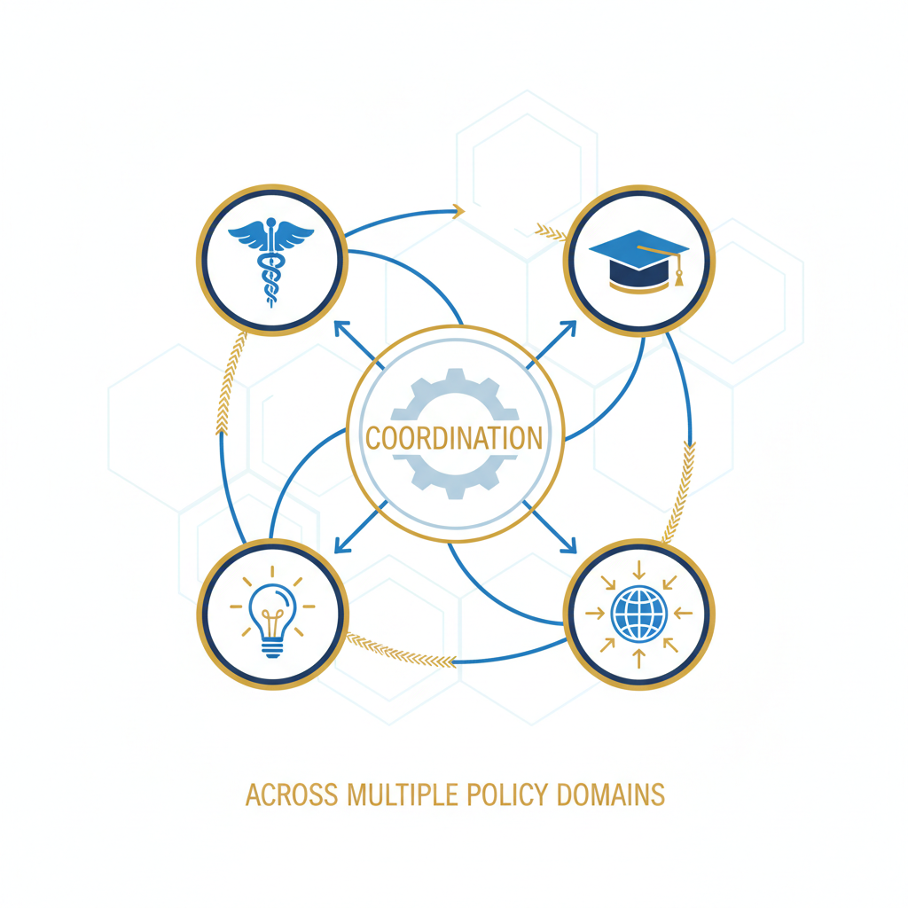4.1.3 Coordination Across Multiple Policy Domains
Coordination across multiple policy domains within the United States requires a representation center to act not only as a physical base for lobbying but also as a nerve center integrating influence strategies across legislative, executive, regulatory, and regional layers. The operational complexity emerges from the fact that decisions taken in one domain frequently ripple into others; therefore, an organization seeking meaningful impact must synchronize efforts so that advocacy conducted in one arena reinforces objectives pursued elsewhere (1). Personnel must maintain active situational awareness across interconnected channels. A leasing classification determined by BOEM for offshore mineral transport, for instance, does not exist in isolation, it influences trade policy debate if domestic vessel builds are mandated under maritime law, alters export projections subject to Department of Commerce oversight, and potentially triggers appropriations shifts when naval supply chains recalibrate around new sourcing patterns (5). Successfully navigating this chain requires coordinated engagement with agency technical staff drafting the initial classification language, congressional committees overseeing maritime law implementation, and trade policy teams evaluating downstream tariff implications (3). The representation center becomes the link ensuring all parties receive consistent messaging adapted for their decision-making context. Cross-domain coordination also applies heavily in defense procurement contexts. Appropriations for shipbuilding or submarine manufacturing pass through congressional processes (4), yet implementation occurs within Navy acquisition offices following executive branch guidance. Here, influence efforts in Congress, particularly embedding resilience narratives into spending bills, must align with discussions inside the Department of Defense where readiness requirements are vetted against industrial capacity data provided by stakeholders. A representation team monitoring both spheres can prevent divergence where legislative allocations might otherwise fund capabilities unsuited to actual operational priorities, a mismatch that could lead to budget inefficiencies or delayed contracting timelines. In trade and export control regimes, domain overlap is even sharper. A bilateral technology deal involving semiconductors linked to UAE partners requires alignment between Department of Commerce licensing (EAR frameworks), legislative voices concerned with national security implications (2), and potentially state-level economic development boards promoting local fabrication facilities. Coordinated advocacy across these points ensures that compliance safeguards presented to regulators match job creation metrics emphasized to legislators while still aligning with regional growth agendas. Without synchronization, a compliance concession made in regulatory discussion could inadvertently weaken political support at the legislative stage if it appears economically disadvantageous to domestic constituencies. Timing is central to coordination efficacy. Legislative calendars open critical windows during committee markups; executive agencies operate on rulemaking cycles punctuated by comment periods; regulatory commissions issue notices of proposed changes on their own schedules; state governments layer independent fiscal years and session timetables into the workflow (7). Representation centers embedded in Washington must integrate these disparate clocks into a master influence calendar so that messaging flows sequentially through each domain at precisely the right moment, allowing early regional endorsements to amplify congressional hearings or agency consultations before final decisions crystallize. The need for cross-domain integration ties directly back to resource allocation challenges noted earlier. Organizations heavily engaged within U.S. governance architectures often find their strategic bandwidth tilted inward toward sustaining domestic gains rather than pursuing opportunities abroad (3). The demand of tracking multi-layer interactions, such as connecting BOEM lease terms with Defense Production Act Title III priorities (4), absorbs analytical capacity that could be applied to scouting foreign markets or negotiating international agreements unaffected by U.S.-centric procedural constraints. This narrowing effect grants an advantage to competitors without such embedded obligations: they can allocate freed resources toward agile expansion into liberalizing sectors while domestically anchored actors remain cycling through U.S. policy maintenance loops. Cultural sensitivity across domains adds further nuance to coordination tasks. Lobbyists adept inside Congress must adjust narrative tone when presenting identical technical proposals to regulatory agencies whose interpretive cultures differ markedly; what resonates as national protectionism in committee testimony may need reframing into technical compliance language for agency dockets (1). At state-level institutions, messages may shift again toward community benefit emphasis or regional identity preservation using autonomy-sensitive framing observed previously in certain political climates similar to Gulf states’ sovereignty positions (3). Representation staff capable of instant linguistic and thematic pivoting ensure consistency in objectives without eroding trust via perceived opportunistic rhetoric changes. Cross-sector alliances are powerful tools when deployed deliberately across domains. For example, bringing energy exporters into dialogue with defense procurement advocates under joint infrastructure narratives leverages multiple policy streams simultaneously: port expansions justified for mineral exports become dual-use assets supporting naval resupply missions (5). A representation center orchestrating this coalition aligns its advocacy materials so that each participant’s sector benefits are visible across legislative briefs, agency funding requests, and state economic plans, thereby embedding a unified proposal more deeply within overlapping governance layers. Risk management runs parallel to opportunity capture in multi-domain work. An adverse ruling or policy reversal in one area can cascade unexpectedly: tightening export controls may alter defense production timelines dependent on imported components (2); reclassification under environmental rules might delay infrastructure projects whose funding is tied to federal defense budgets. A well-coordinated representation office uses its overview position to prepare contingency narratives and alternative arrangements before such changes destabilize broader strategy execution. The intricate interplay between different policy domains demands institutional memory within the representation center, recording how previous cross-domain initiatives succeeded or faltered informs future synchronization efforts under evolving political conditions. These records track which congressional committees proved most receptive after aligned state endorsements were submitted, or which agency interpretations shifted positively following joint advocacy campaigns spanning commercial and defense sectors (4). This historical insight prevents redundancy and sharpens predictive capability when new proposals begin crossing domain boundaries. Ultimately coordination across multiple policy domains moves beyond mere information-sharing between separate teams; it is about weaving influence operations into a continuous fabric where every thread supports others despite operating within distinct procedural worlds (1). Such integration maximizes the conversion rate between opportunity identification and realized market or regulatory advantage, but it amplifies inward focus on maintaining these complex domestic alignments at the expense of immediate responsiveness abroad. For organizations willing to accept this trade-off, mastering cross-domain coordination yields durable positioning inside U.S markets resistant to disruption by rivals entering from less entrenched vectors. Conversely those seeking balanced global agility may need hybridized approaches that limit depth per domain domestically while preserving mobility internationally, a compromise dependent on precise understanding of how each policy realm interlocks with others under real-world American governance rhythms.

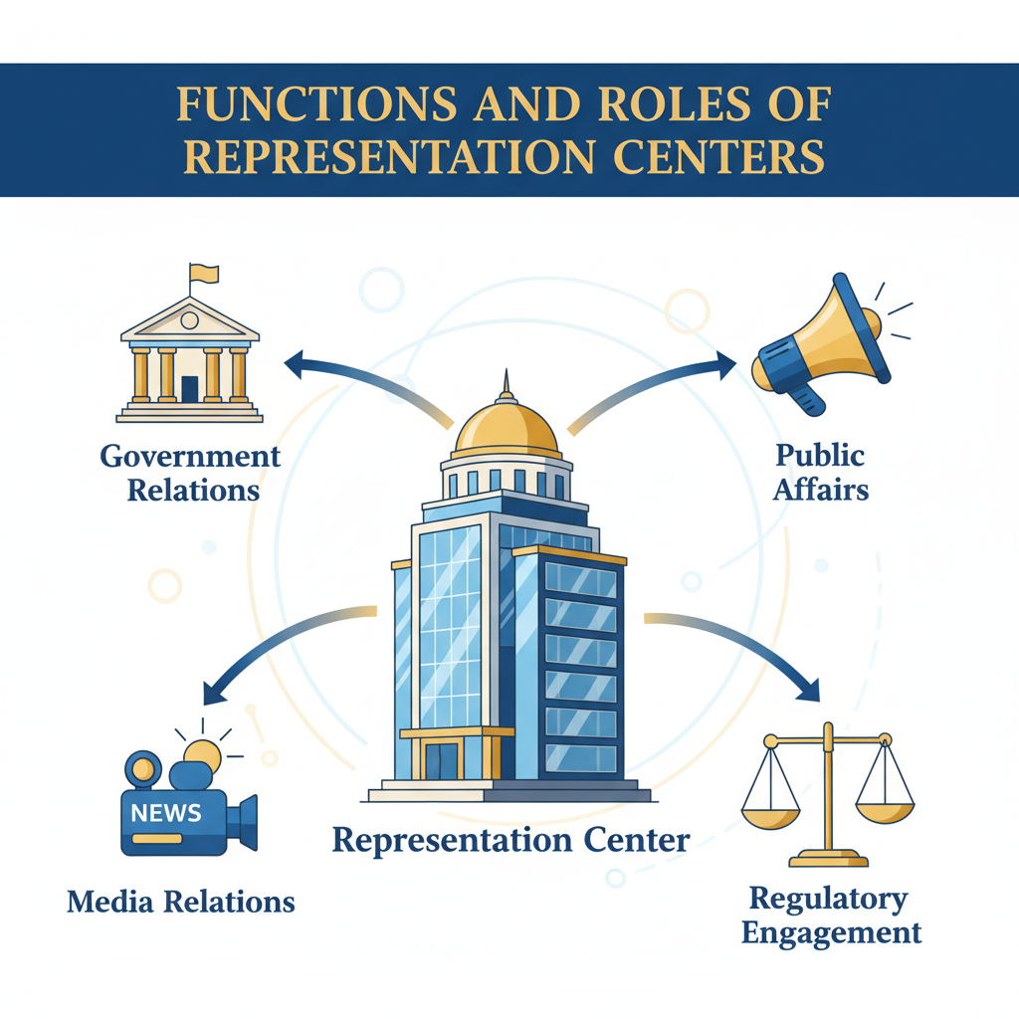4.2 Functions and Roles of Representation Centers

4.2.1 Government Relations
Government relations within the United States encompasses a strategic continuum in which representation centers serve as embedded operational points, translating organizational goals into actionable influence across legislative, executive, and regulatory channels. For companies and organizations intent on moving beyond passive observation toward actively shaping political and commercial decision-making, the capacity to absorb, interpret, and respond to governmental stimuli in real time is indispensable. Proximity to those stimuli, particularly within Washington, D.C., constitutes the core advantage because it allows immediate engagement with policymakers whose decisions ripple outward into statutory frameworks, administrative rules, and enforcement priorities (1). At its most basic level, government relations work inside a representation center means cultivating sustained interaction with congressional offices, executive agencies, and state-level counterparts whose inputs collectively determine national policy shape. The legislative dimension involves persistent tracking of committee agendas to forecast when relevant bills will enter markup or conference reconciliation phases. Teams must be prepared to inject tailored language into drafts before coalitions solidify around existing provisions, a task that requires anticipating priorities among key members and packaging arguments to match those priorities. For example, in mineral resource sectors impacted by BOEM classifications of offshore vessel types (5), government relations personnel positioned near congressional staff can circulate technical briefs demonstrating local economic gains alongside compliance rationales framed to align with prevailing political narratives on energy independence (3). Such alignment increases the likelihood that proposals are not only considered but survive intact through legislative iterations. Executive branch integration is equally vital in this continuum; directives issued via executive orders or specific agency programs like Defense Production Act Title III reshape industrial landscapes swiftly (4). Representation centers engaged in government relations monitor these shifts closely, feeding timely data into agency consultations during window periods when program scope has not yet ossified. This might entail demonstrating readiness metrics for domestic manufacturing capacity improvements tied directly to security imperatives, a linkage more persuasive when administrative actors are balancing technical feasibility against the urgency conveyed by presidential signals. Coordinating narrative framing between what agencies require operationally and what legislators seek fiscally ensures coherence across domains prone to divergence without such alignment. The regulatory tier forms another pillar where government relations functions exert influence. Agencies such as the Bureau of Industry and Security weigh both statutory constraints and geopolitical contexts when defining export control measures (2). Involving oneself early in these processes demands maintaining rapport with mid-level decision makers responsible for drafting compliance guidelines, relationships cultivated over extended cycles of consultation rather than sporadic contact. A representation office with embedded staff converts proximity into predictive capacity: they detect subtleties like evolving preferences for license application formats or heightened sensitivity toward supply chain transparency due to recent enforcement cases (7). This foresight allows advocacy materials to arrive harmonized with procedural expectations that increase acceptance probability across regulatory reviews. Effective government relations also require an ability to cross-link efforts vertically from state capitals into federal arenas. Governors’ formal statements on issues like offshore leasing can have disproportionate sway over federal determinations when framed as consolidated regional endorsements (5). A well-positioned representation center coordinates lobbying so that these subnational inputs complement congressional committee testimony or agency docket submissions made concurrently, presenting a unified message reinforcing the organization’s objective across multiple policymaking levels. The strength of this multi-tiered orchestration often lies in cultural fluency: knowing how regional identity narratives influence local attitudes towards federal policy adoption enables reframing external investment as locally originated benefit rather than imported directive (3). Networking constitutes the connective tissue underpinning all these activities. In practical terms it is through ongoing interpersonal exchanges, hallway conversations post-hearing, side meetings at policy luncheons, that raw intelligence emerges about where potential openings might surface in otherwise closed deliberative environments (1). Government relations specialists use this intelligence to initiate supporting actions ahead of formal announcements: mobilizing coalition letters timed just before tariff schedules are finalized (3), seeding job creation stories aligned with impending defense budget markups (4), or adjusting export proposal safeguards prior to licensing determinations under EAR regimes involving sensitive technologies (2). Each tactical move benefits from proximity-enforced relationships delivering trust capital unavailable through remote lobbying channels alone. Embedding deeply within U.S. decision ecosystems compels organizations toward sustained defensive strategies protecting domestic market advantages gained through such effort. This defensive posture can consume disproportionate resources relative to exploratory initiatives abroad (3). American-based companies securing favorable clauses in appropriations bills may find their teams locked into cyclic oversight hearings ensuring continued compliance with original intent, limiting agility for competing globally while foreign rivals advance unimpeded into liberalizing sectors elsewhere. Government relations thus operates within a dual paradigm: it anchors influence domestically while potentially anchoring organizational focus inward beyond optimal proportions for maintaining international competitiveness. Operationally, staffing and structure must be designed to capture synergies between information gathering, narrative framing, procedural execution, and relationship maintenance across all governance layers simultaneously. Specialists trained in congressional procedure work alongside those fluent in agency cultures; regional outreach coordinators interface back into federal strategy windows; media strategy teams synchronize public communications with confidential briefings so that external perception reinforces internal persuasion campaigns. By binding these functions together under one representation center’s purview, an organization maximizes its leverage at nodes where lawmaking authority meets administrative discretion, transforming proximity into sustained capacity for reshaping outcomes across America’s influential governance circuits (1). Yet sustaining that reach comes at measurable opportunity cost: every cycle spent nurturing domestic government relations is a cycle diverted from potentially transformative engagements across less procedurally burdensome international arenas, a structural equation each actor must reconcile within its broader growth calculus.

4.2.2 Regulatory Engagement
Regulatory engagement represents a sustained and strategically sensitive activity for any representation center operating within the United States, where agency-level decision-making often moves in parallel to, and sometimes independently from, legislative or executive policy directives. The essence of such engagement lies in establishing durable channels of communication with those federal bodies that translate broad statutory mandates into operational rules, technical requirements, and enforcement protocols directly shaping commercial viability. Agencies such as the Bureau of Ocean Energy Management (BOEM), the Bureau of Industry and Security (BIS), the Department of Commerce, and others exercise considerable discretion in interpreting laws and adapting them to evolving economic or geopolitical conditions (5). A well-situated presence in Washington allows an organization to contribute to these interpretations at an early stage, aligning regulatory language with its operational objectives before final codification makes adjustments costly or politically impractical (1). The process typically begins when an agency issues notices of proposed rulemaking (NPRMs) or similar early-stage discussion drafts. These moments mark pivotal openings for influence: stakeholders who can respond promptly with technically credible and procedurally compliant submissions position themselves to shape the framing of key definitions, compliance thresholds, or procedural timelines. For example, in disputes over vessel classifications under maritime law, which carry direct cost implications due to domestic build requirements under statutes like the Jones Act, access to agency deliberations before rules are finalized can result in substantial cost savings over an entire project lifecycle (5). Representation centers embedded in Washington are uniquely positioned to monitor these developments daily and mobilize technical, legal, and public relations teams to synchronize responses both for formal dockets and for informal briefings that influence internal staff positions before official comment windows close (1). Effective regulatory engagement also requires careful adaptation to the internal culture of each agency. While legislative audiences might prioritize district-level job creation or national security symbolism (3), technical reviewers inside agencies expect precise documentation formatted according to their procedural norms. Submissions misaligned with these conventions may be marginalized regardless of substantive merit. Local operatives familiar with each agency’s drafting style, from environmental impact assessments at BOEM (5) to export license applications subject to EAR protocols within BIS (2), can pre-empt rejection by tailoring language and evidence presentation accordingly. This type of adaptive capability is difficult to replicate without permanent representation capable of face-to-face interaction with policy analysts and program managers responsible for text that will become binding guidance once adopted. Engagement often extends beyond a single department’s remit; overlapping jurisdiction is common. A regulation governing offshore mineral leasing might intersect with U.S. Navy logistics planning if those minerals support naval fuel production or advanced weapons systems (4). In such cases, influence efforts must bridge departmental silos so that interpretations made by one body do not undermine programs in another. Proximity enables rapid convening of inter-agency discussions where aligned advocacy can prevent contradictory rulings, protecting operational predictability while ensuring statutory intent remains intact across administrative boundaries (1). At times regulatory processes serve as battlegrounds for balancing foreign partnership opportunities against national security safeguards. Deals involving advanced technology exports, semiconductors with potential dual-use applications, often attract intensified scrutiny guided by export control regimes administered through agencies like BIS (2). Gaining approval in these contexts demands early dialogue that addresses potential diversion risks while framing projects within broader U.S.-aligned strategic goals. Representation staff on-site can iterate safeguards quickly as reviewer concerns evolve mid-assessment, rather than risking fatal delays awaiting communications relayed through distant channels prone to bureaucratic lag. Synchronizing regulatory engagement with accompanying public narratives can magnify its effectiveness. Agencies are not immune to political sentiment; widespread perception of a proposal as economically advantageous or environmentally responsible can ease adoption even where technical considerations dominate dockets (1). Local representatives can coordinate timed media placements, editorials extolling economic benefits released just ahead of relevant hearings, to prime receptivity among agency staff without overtly politicizing their review process. This coordination underscores how representation centers function not merely as petitioners but as orchestrators aligning external discourse with internal administrative momentum. State-federal interplay adds another layer requiring attention within regulatory actions. Many federal statutes require agency consultation with governors or state agencies before finalizing certain resource-related decisions (5). For organizations active regionally as well as nationally, ensuring that state-level recommendations submitted during such consultations reflect corporate aims is essential; federal reviewers weigh this input seriously when closing rulemaking records. Representation centers act here as coordinators between local offices cultivating state relations and federal advocates translating those endorsements into persuasive collateral during meetings with regulators in Washington (1). However, sustaining this depth of engagement exacts strategic trade-offs similar to those seen elsewhere in domestic-focused operations. Continuous monitoring of multiple docket activities across agencies absorbs significant managerial capacity; specialized staff must track shifting compliance metrics for areas as varied as maritime safety protocols, financing transparency standards (7), industrial base readiness measures under defense procurement frameworks (4), and technology transfer safeguards under export controls (2). As focus narrows onto defending established advantages within U.S frameworks, bandwidth available for pursuing entirely new opportunities abroad contracts correspondingly (3). Foreign competitors operating outside these procedural intensities retain comparatively freer rein to build market share internationally while U.S.-embedded actors remain occupied by cyclical compliance alignments at home. The temporal aspect compounds this constraint: many regulatory processes allow only narrow entry points for meaningful intervention, public comment periods measured in weeks, such that absence during these intervals forfeits influence until the next review cycle, which may be years later depending on statutory mandates (5). Embedding a presence capable of immediate detection and mobilization when such windows open is thus central to maintaining strategic advantage domestically. Yet it reinforces dependence on, and entanglement with, the rhythms of American governance cycles at the expense of global agility. In practice, successful regulatory engagement entails embedding technically adept, procedurally literate personnel within a physical proximity close enough for constant informal interaction with agency decision-makers, whether over scheduled briefings or spontaneous corridor conversations, that reveal subtle directional shifts well before they enter official registers (1). From refining definitional language in mineral leasing rules to securing export licenses adjusted precisely for security-acceptable end-uses, this embedded positioning transforms reactive lobbying into proactive co-authorship of regulatory frameworks themselves. Those gains come tethered tightly to domestic defense priorities, not simply military but broader “defense” of established market share, anchoring institutions firmly inside U.S policy architectures even as potential global plays proceed apace for competitors less committed internally.

4.2.3 Public Affairs and Media Relations
Public affairs and media relations within the operational sphere of a representation center in the United States serve as an indispensable amplification arm for influence strategies that otherwise occur within legislative, executive, regulatory, or regional policy engagement. The central aim of this function is to synchronize public-facing narratives with internal policy objectives so that external perception reinforces the positions advanced through direct governmental interaction. This synchronization is particularly effective for organizations embedded physically in Washington, D.C., where the immediacy of political decision-making can be matched in tempo by rapid communications deployment (1). Embedding public affairs capacity alongside government relations ensures that message framing remains coherent across all nodes of influence. For example, when technical proposals are under review by executive agencies such as BOEM regarding offshore mineral classification (5), the concurrent release of op-eds highlighting job creation and economic security benefits primes both public sentiment and internal stakeholders toward favorable reception. Legislative staffers or agency analysts encountering a proposal contextualized positively in widely circulated media find themselves insulated against potential backlash from opposing coalitions because they can reference already-public narratives consistent with their own adoption of those measures. The proximity to policymaking venues allows representation centers to time their media outputs with unique precision. Announcements or publications can be aligned to coincide immediately before committee hearings, tariff schedule finalizations, or comment period deadlines. This timing competence is crucial during compressed political manoeuvres such as emergency export control changes involving sensitive technologies under EAR frameworks connected to international partners like UAE-based ventures (2). In those scenarios, even a few hours’ advantage in controlling initial public discourse can alter the tenor of both press coverage and policymaker reaction, especially when geopolitical stakes render interpretations volatile. Public affairs operations also serve as conduits for cultural alignment within narrative construction. Messages tailored for domestic audiences often require embedding themes such as industrial base resilience, self-reliance in critical minerals production, or local workforce development (3). Media teams working hand-in-hand with policy advocates ensure that these themes pervade op-eds, press kits, digital briefings, and televised interviews connected to organisational engagements on Capitol Hill or at federal agency headquarters. Such integration between content creation and policy positioning increases the probability that both formal testimony and informal lobbying draw legitimacy from prevailing national conversations rather than appearing discordant. Coordination between public affairs and state-level advocacy yields additional leverage when subnational endorsements play into federal determinations. Governors’ supportive letters on strategic energy infrastructure projects carry heightened weight if they echo narratives already circulating in regional press outlets seeded by representation center media activities (5). Localised coverage portraying projects as community-driven economic successes helps cultivate constituent pressure on federal decision-makers whose districts may stand to benefit indirectly. The representation center thus acts not merely as a messenger but as an architect aligning thematic consistency from regional reportage up into national policy channels. Crisis communications capabilities embedded in public affairs functions are essential for defending established market positions against sudden reputational risks. When regulatory bodies tighten oversight over sectors prone to governance criticisms, such as financial services transparency requirements administered by state commissions (7), rapid deployment of counter-narratives can limit damaging perception drift among policymakers who might otherwise respond harshly under public pressure. By issuing fact sheets demonstrating exemplary compliance records or proactive improvement programs tied directly into district benefit frames, organisations blunt momentum toward restrictive measures before they fully crystallise legislatively or administratively. Integration with coalition-building strategies further strengthens media relations impact. By assisting industry associations in coordinating joint statements across multiple sectors, defense manufacturing allies combining messaging on workforce investments with energy exporters advocating port expansions, the representation center weaves multi-sector benefits into composite media presentations timed for maximum exposure during decision windows (4). This cohesion mirrors advocacy approaches discussed within cross-domain coordination settings: media narratives resonate more powerfully with policymakers when their industry alliances appear unified not only procedurally but also in the court of public opinion. Managing ongoing visibility poses additional operational challenges. In competitive information environments like Washington’s policy ecosystem, absence from public discourse leads quickly to diminished relevance among both officials and journalists accustomed to continuous content streams from active stakeholders (1). Representation centers must therefore sustain output without saturating audiences, to remain newsworthy while avoiding perceptions of opportunistic overreach. Achieving this balance requires editorial selection attuned to procedural calendars: high-profile stories aligned with major bill debates contrasted against lower-key feature pieces maintaining steady narrative presence between bursts of legislative activity. Media relations capability also enhances defensive stability when allied trade measures attract scrutiny inside Congress or the executive branch. For instance, protective tariffs justified under national security premises may face opposition framed around consumer cost increases; representation centers can counteract by spotlighting downstream employment gains within targeted districts. This reorientation shifts focus from cost critique toward human-interest angles favourable to sustaining political support for policies advantageous to the organisation’s strategic objectives. The structural resource demands inherent in running an effective public affairs apparatus within U.S.-centric influence operations compound existing opportunity costs outlined earlier. Continuous messaging aimed at defending local footholds diverts attention from building parallel influence abroad; each press cycle requires investment in research, drafting, editing, distribution, and monitoring, all bound tightly to domestic governance rhythms (3). Foreign competitors unbound by these cycles retain greater agility to engage emerging markets internationally while domestically entrenched actors remain absorbed in perpetual narrative maintenance required to hold their position. In practical workflow terms, public affairs teams inside representation centers operate on synchronized schedules alongside government relations units: identifying upcoming procedural milestones (committee votes, rulemaking closings), crafting content tailored for media publication just ahead of those milestones, deploying coordinated outreach through insider networks (briefing friendly journalists or influencers), tracking reception metrics across target audiences (constituent feedback loops), and adjusting subsequent communications based on measured impact. This cyclical approach transforms media presence from passive publicity generation into a responsive element directly reinforcing ongoing policy engagement efforts, closing the loop between external persuasion through mass communication and internal influence exerted within official decision-making corridors (1). Sustaining this integrated operation delivers tangible legislative and regulatory advantages but roots organisations deeper into domestic market defence strategies, a consequence structurally similar to other proximity-dependent influence tactics within American governance ecosystems. Over extended timelines this inward pull shapes organisational trajectories not merely by choice but through adaptive necessity given resource constraints, a reality each actor must weigh carefully against long-term ambitions beyond U.S domains where competitors continue advancing without such procedural anchoring.

4.3 Operational Strategies

4.3.1 Monitoring Legislative and Regulatory Timelines
Monitoring legislative and regulatory timelines is one of the most operationally demanding functions for any representation center intent on shaping outcomes within the United States. The pace and distribution of these timelines, spanning congressional calendars, executive agency rule-making cycles, statutory comment periods, and state-level decision sequences, introduce layers of complexity that require continuous situational awareness. Missing a single procedural window can mean forfeiting influence not only for the current cycle but potentially for several years, particularly where statutory frameworks or long-term appropriations lock in conditions until a new legislative opening arises (1). This temporal vigilance hinges heavily on proximity; without a presence embedded in Washington, D.C., and connected into informal briefing networks among congressional staff, agency analysts, and regulatory commission clerks, organizations are forced into reactive postures, responding after critical phases have already closed. Legislative timelines run on overlapping tracks. For example, committee markups may occur months before a bill reaches floor debate, yet content solidified at markup is far less malleable later. Appropriations decision points tied to defense procurement, such as allocations for submarine construction or industrial base training, involve subcommittee hearings where data-rich narratives must be ready when invited testimony is solicited (4). Representation personnel adept at cross-referencing committee schedules with internal readiness can ensure sector-specific language makes it into early drafts. This synchronization is especially vital where legislative riders attach industry-benefiting clauses to must-pass funding bills, enabling outcomes that bypass prolonged standalone debates (3). Keeping these moving parts aligned requires precise mapping of each chamber’s calendar while maintaining flexible messaging capable of insertion during unexpected amendment opportunities. Regulatory processes demand an equally meticulous timetable management approach. Agencies like BOEM open defined comment periods following notices of proposed rulemaking; these might last only 30–60 days and will dictate technical parameters affecting whole industries (5). In offshore mineral leasing contexts, classification decisions regarding vessels carry direct cost implications under maritime statutes. The opportunity to contest or support such definitions exists solely during narrow procedural phases; once final rules are published in the Federal Register, reversal becomes an uphill battle requiring fresh legislation or successful litigation. Representation offices in Washington can field technical teams to deliver compliant submissions well before deadlines while simultaneously aligning public affairs outputs to create a favorable narrative climate around their stance (1). The interaction between legislative and regulatory clocks often complicates advocacy planning. Statutory provisions adopted by Congress may trigger subsequent agency rulemaking, each with its own timeline, but delays or accelerations in one arena ripple quickly into the other. A sudden executive order prioritizing domestic production under Defense Production Act Title III authorities compresses agency implementation timetables; stakeholders must adapt instantly to meet tightened grant application deadlines or demonstrate readiness metrics before competing claims absorb available funds (4). This requires pre-emptive scenario mapping: knowing which programmatic signals inside agencies will follow presidential directives allows representation centers to mobilize resource documentation before official calls are announced. Monitoring also extends to trade policy developments entwined with export controls. Changes to EAR licensing affecting sensitive sectors, particularly advanced semiconductor transactions involving strategic partners such as UAE-backed ventures, can occur rapidly when geopolitical conditions shift (2). BIS may publish immediate updates adding entities to control lists or modifying permissible end-use conditions; without constant alert systems feeding into advocacy plans, affected organizations risk non-compliance or missed opportunities to argue for exemptions during confidential review stages. Since these changes often follow foreign policy events rather than fixed domestic legislative schedules, monitoring teams must integrate intelligence feeds outside traditional congressional tracking into their operational timeline management. State-level proceedings add further complexity. Governors adjacent to proposed offshore mineral operations hold formal avenues to submit recommendations during BOEM’s consultation windows (5); state agencies regulating financial services may adjust transparency standards based on commission meetings occurring outside federal awareness channels (7). Representation offices maintaining parallel watch functions across selected state capitals can channel supportive resolutions or technical endorsements upstream into federal processes precisely when they will provide supplementary persuasive force in committee hearings or agency docket reviews (1). This requires building integrated calendars combining federal statutory events with subnational fiscal and session schedules so that both streams reinforce one another. Strategically, monitoring these timelines demands staffing configurations able to parse varied procedural sources: congressional bulletins detailing markup notices; inter-agency memos hinting at forthcoming NPRMs; governor’s office agendas signposting upcoming policy statements relevant to federal consultation records; media briefings acting as indirect signals of pending political pivots in committee priorities (3). Each data point feeds into an influence map updated dynamically for positioning advocacy materials exactly where procedural openness intersects with substantive relevance. Proximity again emerges as determinant. Embedded representatives can catch soft signals unavailable through public channels, casual remarks from aides about debating vessel classifications next quarter can prompt pre-emptive drafting of compliance arguments supported by regional employment data well before formal scheduling notices are issued (5). Similarly, informal warnings from agency contacts about shifting license review criteria under technology export regimes allow immediate recalibration before those shifts become binding policy hurdles (2). These micro-advantages compound over time into structural market positioning difficult for remote actors, who typically receive information only after decisions have hardened. Nevertheless, the operational emphasis this monitoring requires inevitably diverts resources toward defending entrenched domestic gains rather than exploring new international ventures. Teams consumed by tracking every docket closure and committee schedule lose bandwidth for overseas expansion planning, leaving rivals unbound by U.S.-centric governance loops freer to pursue growth plays abroad. The opportunity cost is amplified by cyclical repetition: annual appropriations debates pull experts back into defending familiar clauses in defense budgets or mineral lease renewals rather than innovating externally focused strategies. To manage this dichotomy effectively, leading representation centers deploy layered monitoring systems blending human network intelligence with analytical tools flagging dependencies between legislative events and regulatory milestones. Technical expertise embedded across issue areas filters raw input into actionable sequences, for instance correlating expected tariff announcements under trade measures with upcoming port infrastructure bond authorizations at state level so messages can be synchronized across both fronts without redundancy (3). This sophisticated orchestration transforms passive tracking into active timeline shaping, ensuring advocacy actions are not merely timely but strategically anchored within broader influence campaigns coordinated across political and administrative arenas alike (1).

4.3.2 Aligning Messaging with Local Priorities
Aligning messaging with local priorities requires an organization to translate its strategic objectives into narratives that resonate directly with the cultural, economic, and political environments in which influence is sought. This adaptation process is not superficial; it integrates a nuanced understanding of the contextual factors shaping receptivity at both national and subnational levels. As discussed in Section 4.3.1, monitoring decision-making rhythms provides the temporal framework for advocacy, but messaging alignment is what determines whether opportunities identified within those timelines convert into tangible policy or market gains. Organizations lacking this adaptive layer may arrive procedurally on time yet fail to achieve meaningful penetration because their communications do not correspond to the values or priorities of decision-makers and constituents. Proximity inside Washington allows representatives to absorb localised sentiment shifts almost immediately, using them to adjust language before it enters formal discourse (1). Within congressional contexts, aligning with local priorities begins by reconciling broad organizational aims with district-specific interests that motivate members’ support. If a bill’s passage hinges on balancing energy independence rhetoric with environmental protection mandates, advocates must weave technical proposals, such as BOEM vessel classification outcomes, into employment figures or sustainability benchmarks familiar to targeted legislators’ constituencies (5). The framing here ensures that stakeholders perceive the proposal not as an externally imposed measure but as advancing local welfare while fulfilling federal objectives. At the executive agency level, tailoring messages involves matching operational data to prevailing internal narratives. Agencies interpreting presidential directives under frameworks like Title III of the Defense Production Act respond more positively when capacity-building evidence is presented in terms complementing their current thematic focus, for instance resilience of domestic manufacturing for security-critical supply chains (4). Representation centers embedded in Washington can detect these themes early through ongoing liaison meetings, then modify submissions so they integrate seamlessly into briefing materials prepared for senior officials. This adaptation avoids cognitive dissonance between incoming advocacy messages and decision-makers’ entrenched program metrics. State-level engagement magnifies the importance of aligning messaging with regional political culture and economic focus. In sovereignty-sensitive climates reminiscent of certain international contexts (3), proposals linked to foreign-backed investment demand reframing as locally driven initiatives augmenting regional capacity. A port expansion project supporting mineral exports might be positioned publicly as a community-led enterprise securing long-term employment rather than a corporate extraction agenda, even if the underlying commercial objective remains unchanged. Embedded offices at state capitals can test such reframed narratives informally with legislative aides before public rollout, ensuring resonance without compromising operational substance (1). In regulated industries like financial services, alignment hinges largely on demonstrating exemplary adherence to oversight cultures (7). Commission chairs and regulatory staff consider both technical compliance and how well firms embody governance norms considered integral by local political leadership. Messaging here often involves case studies showing how transparency measures augment investor protections, bridging hard regulatory criteria with softer reputational elements valued in that jurisdiction. The outcome is twofold: regulators feel affirmed in their mandates while policymakers gain material they can promote to constituents as evidence of strong governance safeguarding economic stability. Trade and export control policy discussions further illustrate the necessity of fine-tuning narrative modulation across venues. A technology transaction involving UAE-linked entities may face scrutiny under EAR provisions due to dual-use risks (2). Here, alignment means pre-emptively addressing security concerns within storylines emphasizing allied cooperation and domestic capacity expansion, content structured differently depending on whether it targets agency licensers, congressional committees, or state development boards seeking industrial growth tie-ins. Proximity enables rapid pivoting between these tailored modes when geopolitical developments accelerate review schedules unexpectedly. Integrating localized cultural cues also extends into coalition-building tactics. Partnerships between defense sector manufacturers and energy exporters can be advocated under composite narratives about integrated infrastructure benefits, a port improved for mineral shipment doubling as strategic naval resupply capability (5). Such multi-sector storylines must be adapted for each audience: regional actors may prioritise job creation and logistics efficiency; federal committees might emphasize national security redundancy; agencies could focus on compliance feasibility given environmental stipulations. Representation centers orchestrate these alignments so no stakeholder hears conflicting frames that erode trust or create procedural friction. Aligning messaging with local priorities presupposes continuous intelligence collection alongside technical evidence preparation. Informal remarks from policymakers about constituent reactions often indicate impending shifts in acceptable framing even before official polling or media coverage reflect them (1). Acting on such signals demands personnel embedded deeply enough to interpret subtle changes without misreading ephemeral commentary as substantive policy direction, skill sets reinforced by repeated low-profile engagements across committee rooms, agency offices, and community forums alike. The structural consequence of sustaining finely tuned messaging domestically mirrors trade-offs described throughout U.S.-centric influence operations: resources committed to constant narrative calibration within American governance cycles inevitably reduce available bandwidth for global ventures (3). Competitors operating without such inward anchoring may introduce generic but globally portable campaigns abroad unimpeded by domestic recalibration demands tied tightly to rapidly shifting political currents in Washington or state capitals. Ultimately, aligning messaging with local priorities transforms procedural readiness into persuasive potency, ensuring advocates arrive not only at the right time but speaking in registers that decision-makers accept as advancing their constituents’ core interests. Across legislative agendas shaped by district economics, executive programs steered by thematic imperatives, regulatory bodies guided by compliance ethos, and state governments grounded in regional identity politics, this alignment amplifies proximity’s inherent advantages while consolidating domestic position against market displacement. Yet it carries an implicit narrowing of outward vision: every successful adaptation deepens entrenchment within one governance sphere’s language and values at the expense of cultivating equivalent fluency elsewhere, a balance organizations must weigh carefully given long-term competitive positioning goals (1).

5 Impact on U.S. Domestic and International Engagement

5.1 Shifts in Domestic Focus

5.1.1 Resource Allocation to National and Regional Markets
The distribution of resources toward national and regional markets within the United States fundamentally shapes how organizations position themselves for influence. Once a representation center has been established, particularly in Washington, D.C., but also in strategic state capitals, the gravitational pull of domestic engagement naturally intensifies. This manifests as sustained investment in staffing, procedural expertise, narrative calibration, and compliance infrastructure devoted primarily to safeguarding and expanding market share inside U.S. governance boundaries (1). The effect is compounded by the structural demands of active legislative, executive, and regulatory participation: cycles of congressional appropriations, agency rulemakings, and court challenges tie operational attention inwardly and leave less strategic bandwidth for exploring opportunities beyond national borders. Resource allocation decisions within this context often reflect prioritization based on perceived return on influence rather than immediate profit margins. For example, an energy exporter involved in offshore mineral development may allocate significant internal capacity to monitoring BOEM’s leasing consultations (5), preparing technical evidence aligned with both agency criteria and congressional district narratives. While these efforts secure favorable lease terms domestically, potentially locking in cost advantages under vessel classification rules, they represent capital that is unavailable for competitive bidding on foreign concessions with looser compliance regimes. The trade-off becomes a question of endurance: the assurance of domestic operational security versus the agility to pursue higher-risk/high-reward ventures abroad. National-level engagement frequently commands the largest resource share because success in federal arenas can recalibrate market conditions across all states. Defense sector involvement illustrates this concentration effect clearly. Maintaining eligibility for procurement contracts tied to submarine industrial base expansions requires ongoing advocacy before appropriations committees (4), synchronization with Navy acquisition offices, and continuous demonstration of capacity under Defense Production Act Title III readiness metrics. These defence-linked activities may employ sizable analytical teams whose specialised output is only relevant within U.S. frameworks, further constraining redeployment toward international contracting opportunities in allied nations where competing manufacturers operate without equivalent domestic obligations. Regional allocations tend to be more targeted but no less demanding over time. A representation presence in state capitals allows organizations to connect directly with policy agendas tailored to local economic identities, be that port infrastructure development linked to mineral export corridors or vocational training pipelines for defence manufacturing labour pools (1). However, sustaining such influence requires embedding into local political cultures and maintaining visibility across municipal hearings, commission reviews, and community forums. The emphasis here falls on adapting proposals so they appear as locally originating initiatives rather than externally imposed projects (3). The dialogic process consumes personnel hours and logistical expenditure equal to those required federally, albeit concentrated regionally; duplication across multiple states magnifies overall costs. From a purely economic standpoint, resource allocation to these domestic spheres carries an inherent opportunity cost measurable not only in forgone foreign expansion but also in reduced flexibility when global conditions shift unexpectedly. An organization heavily invested in lobbying against restrictive export controls on sensitive technologies involving UAE-linked partnerships (2) may find itself constrained if diplomatic conditions change rapidly, resources are locked into maintaining existing licensing pathways rather than scouting alternative trading partners outside EAR or ITAR jurisdiction. Similarly, mining firms bound into defending current Jones Act vessel classifications domestically are slower to pivot toward offshore projects situated within jurisdictions offering lower transport cost bases due to relaxed build requirements (5). The practical mechanics of such allocations demand constant balancing between macro-level federal positioning and micro-level regional entrenchment. Federal investment ensures access to cross-sector leverage points, aligning defence industrial base funding streams with energy export policy, but requires concurrent alignment at state levels where governors’ endorsements can sway congressional committees during final reconciliations (1). Coordination between these layers involves duplicative preparation: economic impact studies for federal hearings mirrored in locally contextualised versions for state legislative sessions or commission deliberations. This redundancy absorbs budget that might otherwise fuel international outreach campaigns or exploratory partnerships abroad. Operational actors embedded nationally tend toward a model where legislative monitoring systems, agency liaison teams, public affairs divisions, and compliance specialists form a dense domestic apparatus designed to catch every procedural opening that could advantage their market position (7). Regional operations replicate this structure on smaller scales, staff dedicated to interpreting local regulatory cultures, cultivating municipal alliances, tailoring community benefit campaigns, but collectively they create a network whose primary feedback loops point inward within the U.S. political ecosystem. Competitors without such infrastructural commitments operate unimpeded across liberalizing international sectors while domestically engaged entities remain bound to maintenance cycles aimed at preserving their hard-won influence vectors. Strategically amplifying regional allocations often responds directly to shifting national priorities; for instance, heightened focus on critical mineral independence at the federal level catalyses increased investment into coastal state lobbying dockets where governors’ support is crucial for BOEM lease approvals (5). Conversely, regional success stories, such as workforce development programs producing skilled labour for submarine construction, serve as persuasive collateral during national budget negotiations (4). This symbiotic interplay pushes resources deeper into domestic engagements as actors seek seamless integration between state outputs and federal inputs before final policies crystallise. The cultural dimension reinforces the internal focus: aligning organisational objectives with prevailing U.S symbolism around sovereignty or resilience demands constant message recalibration across both federal and regional theatres (3). Representation centers positioned domestically absorb subtle sentiment changes through daily interaction with decision-makers; however this immediacy comes at a financial cost proportional not just to operational outlay but also strategic inflexibility. Ultimately resource allocation patterns emerge from calculated trade-offs informed by risk appetites and competitive landscapes. Entities choosing heavy investment into national and regional markets gain amplified procedural leverage inside American governance but concede speed and adaptability internationally, a structural reality observable across sectors from energy exports through high-tech manufacturing tied into sensitive trade regimes (2). This inward weighting secures influence longevity domestically yet reshapes organisational geographies over time toward dense clustering within U.S political centres at the expense of diversified global projection capacities, a transformation that begins as tactical necessity but often settles into enduring strategic identity (1).

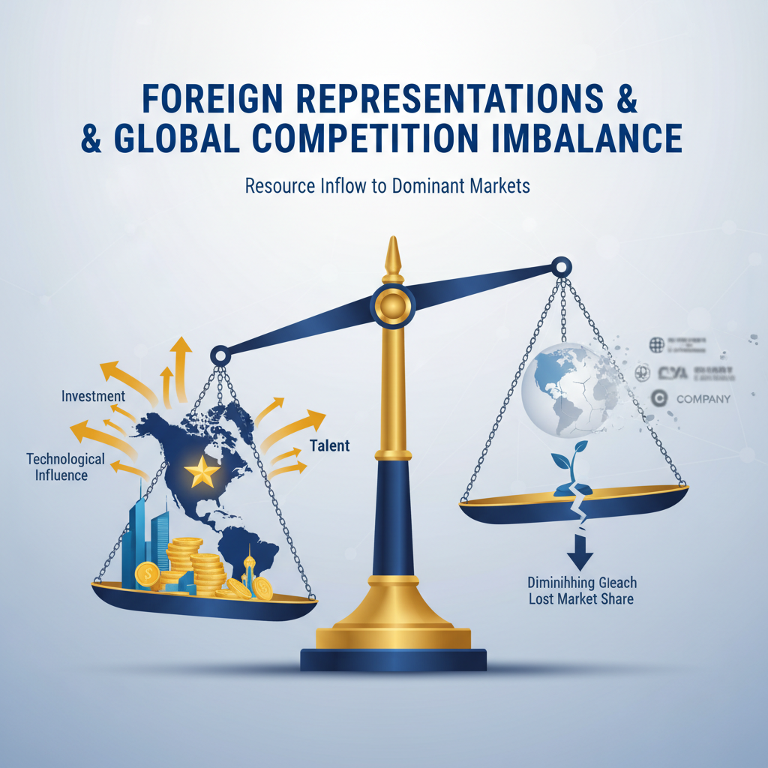5.1.2 Reduced Capacity for International Competition
Concentrating influence operations within the United States by embedding representation centers in Washington or strategically selected state capitals inevitably reshapes an organization’s external posture. The same assets that secure legislative insertions, executive program access, and regulatory interpretation shifts domestically must be continuously engaged to defend these positions (1). Over time, the operational bandwidth consumed by congressional monitoring, agency liaison work, state-level coalition management, and public affairs alignment erodes the capacity to engage meaningfully in international arenas. What begins as tactical necessity, to capture procedural openings at home, matures into a structural commitment that constrains global agility. This reduced capacity manifests first in resource diversion. Organizations maintaining proximity advantages within U.S. governance allocate substantial financial and human capital toward defensive maintenance of federal and regional gains, leaving fewer funds and fewer staff for exploratory or competitive ventures abroad (3). Each high-priority domestic cycle pulls teams inward: appropriations hearings for defense industrial base funding (4), BOEM consultations on offshore mineral leases (5), and export control licensing negotiations involving sensitive partners (2) all command immediate attention from specialists whose knowledge is often non-transferable outside the American policy context. The sunk costs in cultivating domestic procedural fluency, knowing exactly when a subcommittee will take technical testimony or how an agency prefers its impact assessments framed, reinforce institutional focus on internal horizons rather than steering capability outward. The opportunity cost is most visible when foreign competitors operate unburdened by equivalent domestic entanglements. Entities headquartered outside U.S. political cycles can redeploy lobbying and compliance budgets directly into market expansion across regions with looser governance constraints or faster liberalization trajectories. While American-engaged organizations are refining narrative adaptations for House committee sensibilities or synchronizing gubernatorial endorsements before federal lease finalizations, rivals may already be concluding deals in resource-rich jurisdictions whose licensing regimes bypass lengthy public comment processes (5). By the time domestically tethered actors return attention to these arenas, local incumbents have cemented political goodwill and contractual precedence. The temporal dynamics of domestic engagement further constrain outward competition. Sudden policy events in Washington, tariff introductions under national security framing (3), emergency export control tightening affecting high-tech components (2), redefinitions of vessel classifications altering logistics economics (5), require immediate reaction, pulling strategic planners away from ongoing international negotiations. These compressed timelines undermine the continuity necessary for relationship-building abroad; momentum in foreign markets depends on sustained presence and iterative confidence-building, both incompatible with recurrent interruptions to address home-front developments. Sectoral interdependencies in U.S.-based strategies aggravate this narrowing effect. Defense manufacturers embedding themselves into appropriations dialogues around submarine construction support must also sustain readiness displays for executive branch industrial resilience programs (4). Energy exporters leveraged into coastal state infrastructure plans tied to mineral corridors face overlapping demands from regional environmental boards, municipal councils, and federal regulators, all requiring customized engagement sequences if project viability is to be preserved (1). Maintaining coherence across these domestic vectors leaves minimal margin for multi-sector consortium participation abroad or coordinated lobbying within supranational trade frameworks. Cultural alignment work inside American political environments also competes directly with the cultural adjustments required for international influence. Messaging crafted to suit district-level values, employment growth statistics, local industry preservation narratives, cannot be ported wholesale into markets where decision-makers prioritize different symbolic currencies such as technological leadership or integration into transnational value chains (3). The cognitive load absorbed by constantly recalibrating communication strategies to fit local U.S contexts diminishes organizational responsiveness to distinct foreign audience cues. Even structural advantages obtained domestically can impede international mobility. For example, securing protective clauses under federal trade policy that privilege certain mineral exports might tie production schedules rigidly to compliance with related reporting or operational standards (5). Altering those schedules to meet rapid-turnaround orders from overseas buyers may trigger review obligations or expose entities to enforcement risk under U.S statutes, a deterrent that less regulated competitors sidestep entirely when courting global clients. Compounding this are legal exposure considerations inherent in operating within strict U.S transparency frameworks. Lobbying disclosure regimes, export licensing reviews under EAR and ITAR protocols, and detailed procurement compliance audits all consume organizational bandwidth simply to maintain lawful standing while pursuing domestic goals (2). Foreign competitors functioning outside these systems can iterate contracts, investments, and joint ventures much faster because their primary administrative overhead revolves around transactional law rather than continuous governance compatibility checks. The interplay between national-scale priorities and regional integrations reinforces this inward pull. Governors’ endorsements used to sway congressional outcomes on energy exports require months of cultivation via state-level offices embedded deeply enough to interpret community priorities accurately (1). Replicating such depth of engagement internationally would demand parallel structures abroad; few organizations can sustain both without diluting effectiveness given finite resources. Instead they opt to consolidate influence domestically, with predictable attrition in global footprint competitiveness. This concentrated emphasis inevitably affects competitive positioning metrics over longer arcs. Reduced deal velocity abroad means fewer footholds established against internationally mobile rivals; lagged entry compresses profit potential once a sector matures in foreign jurisdictions; protective gains at home rely increasingly on sustaining favorable political climates within one country’s governance system rather than diversifying risk across multiple regulatory environments. From an analytical perspective, the same procedural mastery enabling decisive impact inside U.S policy corridors becomes structurally counterproductive when it monopolizes capacity needed for parallel competitive engagement under different rulesets elsewhere. Thus while embedding representation centers close to Washington’s power hubs ensures maximum access to influence vectors essential for shaping American political and commercial landscapes, which remains indispensable for success within those boundaries, it also sets in motion an adaptive cycle prioritizing national and regional interests over international challenges. With each budget line item allocated toward maintaining domestic alliances, monitoring legislative windows, preparing agency-compatible submissions, and aligning narratives with localized culture (3), less remains available for projecting competitive force globally. Into this vacuum step competitors who configure their growth plans unimpeded by such constraints, leveraging absence from U.S-centric cycles as freedom to pursue emerging opportunities while domestically anchored actors maintain their strongholds at home but cede ground abroad (1).

5.1.3 Economic Implications for Domestic Industries
Domestic industries in the United States experience measurable economic consequences when organizations channel substantial resources into influence operations anchored within national and regional markets. The concentration of strategic effort into proximity-based advocacy enhances the capacity to shape legislative, executive, and regulatory frameworks to serve domestic market interests, but this comes at the expense of flexibility to pursue and adapt to global opportunities. As outlined previously in Section 5.1.2, the reallocation of financial and human capital toward protecting domestic advantages fundamentally alters competitive positioning, both internally and in relation to foreign rivals. The primary economic effect on domestic industries arises from the structural enmeshment between political influence tactics and market conditions. Securing favorable terms through mechanisms such as appropriations riders for defense contracts directly impacts industrial supply chains by stabilizing demand for local production over extended horizons (4). For manufacturers involved in submarine component fabrication or other long-lead projects, these policy victories translate into predictable revenue streams, which in turn justify sustained investment in workforce training and infrastructure expansion. This feedback loop fortifies industry resilience at home while simultaneously hardening market entry barriers against outside competition, particularly international firms lacking equivalent access to U.S. decision-making nodes. Regional industries benefit similarly when state-level advocacy synchronizes with federal objectives. Coastal energy exporters lobbying governors for supportive statements during BOEM’s mineral lease consultations (5) not only secure operational rights but legitimize associated infrastructure investments such as port facility upgrades or logistics corridor reinforcement. Such projects generate multiplier effects locally: construction sector growth, expanded service markets, and increased municipal revenues from business activity. These economic gains are tangible outcomes of proximity-enabled political engagement; however, they also deepen reliance on continued political favor, making sectors vulnerable to shifts in regional priorities or changes in administration that divert attention or funding elsewhere (1). The emphasis on defending these entrenched positions diverts resources away from international initiatives that might diversify revenue sources or technological innovation inputs. For example, a technology manufacturer engaged heavily in U.S.-centric export control negotiations around sensitive semiconductor components involving UAE partnerships (2) invests heavily in compliance assurance frameworks tailored to satisfy American regulators. While domestically beneficial, ensuring licensure continuity and keeping production pipelines open, such investment limits capital available for exploring emerging tech clusters abroad where less stringent transfer protocols could enable faster scaling. Economic implications also extend into how domestic industries adapt their operational strategies under persistent influence maintenance regimes. Continuous engagement with regulatory agencies like BIS or state commissions enforcing governance transparency standards (7) requires allocating internal audit capabilities and legal review teams specifically for ongoing compliance. These functions represent fixed overhead that many foreign competitors avoid or manage with fewer constraints due to lighter domestic governance expectations within their jurisdictions. The competitive delta becomes visible when rivals reinvest savings from reduced regulatory burdens directly into innovation cycles or aggressive pricing strategies targeting the same international customers American firms might otherwise pursue. Trade policy adjustments influenced via representation centers create another layer of domestic impact. Tariffs justified through national security narratives (3) protect certain segments of manufacturing by raising import costs on foreign competitors; yet they also shift downstream cost structures within allied sectors, sometimes increasing input prices for industries reliant on affected materials. Actors embedded in federal advocacy networks can attempt to mitigate negative spillovers by securing exemptions or alternative sourcing provisions during early tariff list compilation phases, but success demands focus on intricate negotiation with policymakers that reduces room for concurrent overseas market-seeking activities (1). In defense-linked commercial ecosystems, alignment with federal program priorities such as Title III of the Defense Production Act positions firms advantageously for grant funding or long-term procurement cooperation (4). Economic certainty here drives local supply chain development and supports high-skill job creation concentrated in specific regions, an outcome politically attractive for legislators whose constituencies benefit directly. Yet this alignment also ties corporate strategy closely to maintaining political relationships and meeting evolving readiness criteria determined within U.S.-specific contexts; it does not inherently translate into adaptability for bidding processes structured differently under foreign military procurement regimes. Domestic industries further experience the economic consequence of opportunity cost where capital is absorbed by ongoing narrative refinement rather than exploratory ventures abroad. Crafting messages aligned with American cultural symbols such as sovereignty over resource management or resilience against foreign supply chain dependency (3) ensures continued policy protection but narrows communication bandwidth available for conducting relationship-building across culturally distinct markets beyond U.S. jurisdiction. Infrastructure-heavy sectors exemplify this dynamic well. Energy exporters investing in LNG terminal expansions tied to critical mineral export capability may prioritize influencing coastal state legislatures and relevant federal agencies over negotiating investments in developing region ports offering favorable trade conditions without equivalent environmental compliance layers (5). The immediate economic gain domestically, increased throughput capacity feeding protected export channels, is offset by the forfeiture of potential early-mover advantages internationally where competitors free of U.S.-centered obligations can lock down transport rights unopposed. From an analytic standpoint, embedding representation centers as instruments of influence yields clear domestic economic benefits: tariff insulation, appropriation-based industrial support programs, infrastructure development catalyzed by politically secured approvals, and regulatory accommodations enhancing operational margins inside the country (1). These benefits accumulate into market fortification that deters external disruption, but they also form a strategic anchor limiting outward mobility. In summary, the economic implications for domestic industries include heightened stability through sustained demand supported by favorable policies; localized growth via infrastructure alignment; strengthened supply chain resilience under protected statuses; increased overhead related to continuous compliance monitoring; constrained agility due to opportunity costs; and a competitive edge domestically paired with diminished reach internationally as rivals exploit openings beyond American governance cycles (3). The calculus becomes one of weighing assured home-market primacy against diversified exposure, a decision shaped heavily by resource allocation patterns established once representation centers commit fully to embedding within U.S political and regulatory ecosystems.

5.2 International Consequences

5.2.1 Opportunities for External Competitors
The inward orientation created when American firms and allied organizations embed themselves deeply into domestic governance cycles yields an increasingly visible strategic opening for external competitors. These actors, often operating without the procedural burdens or cultural adaptation costs inherent to U.S.-centric influence operations, can allocate a greater share of resources toward agile market entry in geographies where regulatory barriers are lower and the velocity of policymaking is faster. While incumbent organizations in the United States dedicate substantial personnel to maintaining legislative footholds, tracking congressional markups, lobbying appropriations committees for sector-specific funding, and aligning narratives with district-level priorities, they necessarily divert capacity from scouting and securing positions in foreign jurisdictions (1). This asymmetry enables foreign-based competitors to occupy market space before U.S.-anchored entities even begin substantive engagement abroad. One advantage for these external actors lies in their freedom from the tight synchronisation demands that bind domestic operatives to congressional timetables, agency comment periods, and state commission reviews. Without having to monitor BOEM vessel classification hearings or respond within days to BIS amendments affecting export controls on sensitive technologies (2,5), competitors can keep their strategic focus squarely on emerging opportunities, in sectors such as critical minerals extraction in Africa, high-tech manufacturing hubs in Southeast Asia, or LNG infrastructure expansion linked to newly liberalised energy markets. The headroom created by absence from U.S. procedural maintenance allows them to marshal capital quickly, form local alliances unencumbered by distant lobbying compliance regimes, and adapt offerings to regional operational norms without waiting on internal approvals bound up in American legal frameworks. The global trajectories pursued by these competitors often exploit the very constraints U.S.-based organizations face domestically. For example, when Washington insiders concentrate effort on securing Title III Defense Production Act funding for specific industrial capacities (4), foreign naval suppliers may cultivate parallel contracts with allied militaries whose procurement processes run independently of American influence channels. In infrastructure-heavy industries, state-level advocacy inside the U.S., whether aimed at port expansions tied to mineral exports or workforce development programs for defense manufacturing, absorbs time and budget that could otherwise be deployed toward competitive bidding on equivalent projects financed by multilateral development banks abroad (1). Each cycle devoted internally means another missed tender internationally. Trade policy developments further accentuate this gap. Tariff protections engineered through national security narratives may stabilise certain domestic sectors but simultaneously incentivise offshore buyers to diversify sourcing away from tariff-affected American exports. External suppliers positioned outside such protectionist zones can respond rapidly, aligning price points below tariff-inclusive rates and locking down supply contracts while American producers are still engaged in defensive lobbying at home to preserve exemptions or secure offset agreements beneficial only within U.S. borders. The relative absence of stringent political culture alignment work is another enabling factor for competitors. Domestic advocacy demands fine-tuned messaging adjustments, embedding job creation statistics into proposals for one congressional committee while deploying sovereignty-framed rhetoric tailored to another’s ideological predispositions (3). External competitors targeting markets outside the U.S. bypass this constant recalibration; they craft campaigns suitable for their intended regions’ decision-making patterns without the overhead of daily cultural retuning mandated by the volatile currents of Washington politics. Regulatory agility compounds the advantage. While U.S.-based actors await the outcome of Federal Register publication cycles before operational plans can proceed, possibly years between relevant rulemakings, non-U.S. competitors navigate shorter approval timelines abroad. They implement new mining methods without facing prolonged environmental comment windows like those common under BOEM’s leasing processes (5), enabling them to bring product streams online well ahead of American rivals encumbered by local consultation obligations and litigation risks tied into federal compliance regimes. State-capital-focused advocacy within America also presents exploitable blind spots. An entity concentrated on aligning with governors’ endorsements or negotiating intricate tax abatements through regional commissions may lack current intelligence on shifting procurement standards or investment incentives offered overseas (7). Without continuous watch over these international signals, opportunities pass unacknowledged until occupied decisively by rivals who operate fully outside U.S-centric monitoring systems. This effect parallels situations observed under export control tightening: when BIS narrows licensing scope around strategic partners such as UAE-linked semiconductor ventures (2), compliant domestic actors endure review delays affecting delivery capacity abroad, creating room for competitors already positioned within alternative supply chains free from comparable control friction. The absence of reciprocity obligations into complex cross-domain coordination further liberates external players. While embedded representation centers must continually interlace defence sector lobbying with mineral export arguments (4) or align state-level endorsements with federal trade committee testimonies (1), outsiders simply push mono-focused campaigns toward singular objectives within chosen territories. A mining consortium seeking entry into a South American concession zone need not consider how its vessel classification will interact with naval procurement funding bills, it concentrates solely on fulfilling host-government terms and mitigating local competitive risks. From an economic standpoint these openings persist because entrenched domestic influence requires high upkeep relative to outward projection capability (3). Every hour allocated toward cultivating subcommittee relationships in Washington translates into opportunity hours absent from negotiating foreign bilateral trade agreements or participating in joint ventures targeting non-American consumer bases. This cumulative tilt reshapes competitive geographies over time: dense concentration of U.S.-based advocates defending national advantages on one side; opportunistic international operators accelerating their growth trajectories without interference from counterparts locked into inward-facing policy maintenance loops on the other. In practical terms, sophisticated external competitors turn these conditions into structured strategy: deploy capital flexibly across jurisdictions with rapid cycle governance; embed locally where their presence won’t be diluted by multitiered compliance burdens; adopt scalable messaging aligned solely with target-region priorities; neutralise American competitive potential by occupying supply chain roles that would require lengthy domestic alignment processes if pursued via U.S.-dependent routes (1). By moving unobstructed through openings formed when domestically anchored actors commit disproportionate energy inwardly, foreign entrants not only achieve initial market presence but frequently entrench themselves structurally before any reactive penetration attempt can dislodge them, converting proximity gaps inside America into positional dominance outside it.

5.2.2 Influence on Global Market Dynamics
The tendency for U.S.-based organizations to embed deeply within domestic political and regulatory systems reverberates through global market structures, reshaping competitive balances and altering the pace at which different actors can claim or defend international positions. As observed in Section 5.2.1, the operational immersion required to succeed inside U.S. legislative cycles, agency rule-making windows, and state-level policy alignments consumes a disproportionate share of strategic bandwidth. This inward prioritization both strengthens the hand of domestic industries, by securing favorable laws, executive orders, and regulatory interpretations, and simultaneously leaves open channels abroad for competitors unencumbered by comparable procedural obligations (1). Such dynamics can shift not only bilateral engagements but also multilateral alignment patterns in high-value sectors. Global market actors respond differently depending on whether they are entrenched in U.S.-centric governance or operating without that tether. For firms tied into Washington influence processes, defending appropriations language for defense manufacturing supply chains (4) or sustaining BOEM offshore lease advantages (5) delivers immediate commercial stability at home but tends to slow outward expansion. These delays matter because many international markets, especially those in resource-rich emerging economies, operate on compressed timelines for project approvals compared to the multi-year cycles common in U.S. statutory change. Competitors active in these theatres can implement extraction projects, logistical corridors, or technology transfer deals before domestically focused U.S players have completed their latest cycle of congressional hearings and agency consultations. In some cases, this asymmetry accelerates regional demand pivots away from American suppliers entirely. Tariff protections framed under national security narratives (3) potentially shield domestic manufacturing short-term but prompt overseas buyers to diversify supply chains toward providers outside protected zones. External competitors benefit doubly, they avoid tariff cost hikes when selling into third-country markets and can present themselves as stable long-term partners unimpacted by politically driven price fluctuations stemming from U.S trade policy changes. Over time that reliability builds market share in ways difficult for U.S-embedded companies to dislodge once political conditions shift internally. The restricted outward mobility faced by U.S.-anchored organizations also impacts strategic technology markets subject to export controls. Licensing revisions under EAR targeting sensitive partnerships, such as advanced semiconductors involving UAE entities, require sustained attention to compliance negotiations (2). While American firms invest months ensuring continued legal operation within those frameworks, foreign producers outside the regime may capture contracts with buyers eager to avoid license uncertainty altogether. In highly time-sensitive technology races, this capacity for uninterrupted delivery allows external competitors not just entry but iterative advantage: reinvesting profits into R&D cycles unhindered by extended compliance lags. Global market dynamics consequently reflect a dual-speed environment: one track marked by slow-moving but substantively entrenched American actors; another defined by faster-cycling, procedurally lighter rivals. Critical mineral supply illustrates this clearly. Inside the U.S., vessel classification disputes under maritime law must be resolved through blended advocacy across agencies and congressional subcommittees (5), locking significant corporate capacity into domestic resolution work. Abroad, operators free from such constraints push polymetallic nodule exports through permissive jurisdictions with minimal procedural friction, bringing product streams online faster and often cheaper into shared international marketplaces. This bifurcation is reinforced when U.S-embedded companies prioritize sectoral integration at home over diversified risk abroad. Coalitions linking defense procurement narratives with energy infrastructure upgrades (4) are politically potent internally; they secure funding streams and legal protection domestically yet offer little direct leverage in non-U.S jurisdictions where local policymakers structure value propositions differently. The internal coalition-building consumes resources that could otherwise be committed to new alliance formation abroad, alliances that external competitors pursue aggressively while American counterparts remain committed to maintaining cohesion among domestic stakeholders. Foreign rivals adapt quickly by mapping where American influence patterns generate blind spots internationally. If Washington-based advocates concentrate on coordinated governor endorsements feeding federal decision points (1), competitors target jurisdictions unaffected by that linkage, for example African mining ministries or Southeast Asian port authorities, filling relationship vacuums with sustained presence until contractual commitments lock out later challengers. This is especially visible in infrastructure finance circles where multilateral development bank-funded projects proceed according to local institutional rhythms rather than foreign legislative calendars; absent early engagement from American firms distracted domestically, rival consortia solidify terms before any redirection of attention occurs. Even allied markets adjust around these dynamics. Partners who rely on timely inputs from American manufacturers, for instance naval allies sourcing submarine components, may hedge their procurement with alternate suppliers if legislative unpredictability or executive reprioritization slows delivery tied to U.S-embedded processes (4). Competitors stepping into these allied relationships gain not just transactional wins but long-term interoperability footholds potentially displacing American technical standards in joint operations. From an economic modelling standpoint, the interplay between inward resource focus and external opportunity capture produces uneven growth trajectories across global sectors influenced by U.S-engaged actors versus freer rivals (3). Markets where speed-to-contract is paramount trend increasingly toward non-U.S suppliers; sectors valuing standardisation under strong governance remain bound closely to American players but risk ceding frontier expansions. In macro terms this creates a feedback loop: internal fortification of domestic positions through embedded representation centers bolsters home-market resilience while progressively capping growth potential relative to opportunistic international operators whose procedural liberty allows them greater manoeuvrability. Consequently global market dynamics shift toward multipolar supply ecosystems less dependent on singular U.S output advantages than earlier decades. While established reputation, technological leadership, and institutional know-how keep American actors competitive in certain regulated domains, their slower strategic mobility relative to externally positioned competitors redistributes opportunity space internationally (1). The question for embedded entities becomes whether defending domestic predominance outweighs conceding emergent positions abroad, a calculus shaped not only by sectoral economics but by structural realities embedded within the very governance architectures that grant them influence at home yet bind their reach globally.

5.2.3 Potential Changes in Diplomatic Engagement
Diplomatic engagement patterns are likely to evolve as a direct consequence of the inward concentration of influence operations within U.S. governance systems. When organizations commit substantial resources to maintaining proximity-driven advocacy in Washington or key state capitals, they not only deepen their operational entanglement with domestic decision-making but also shape the contexts in which U.S diplomacy interacts with foreign stakeholders. The strategic emphasis on protecting national and regional markets means that diplomatic outreach may increasingly be calibrated to safeguard these internal gains rather than to capitalize on emergent external openings (1). This recalibration has implications for both the tone and scope of formal diplomatic engagements, whether conducted at the governmental or corporate level. For companies and industry coalitions closely aligned with federal priorities, existing diplomatic channels might be repurposed primarily to defend domestic policy frameworks abroad. Defence-related manufacturers who have secured appropriations for industrial base resilience (4) could find themselves working through State Department commercial sections or embassy trade missions mainly to ensure foreign procurement opportunities do not undermine U.S supply chain stability. Such missions may focus less on expanding market horizons and more on reinforcing allies’ alignment with procurement standards that mirror American legislative intent, thereby serving as indirect extensions of domestic political victories. In sectors where regulatory agencies hold decisive interpretive authority, such as BOEM’s role in offshore mineral leasing (5) or BIS’s export control licensing for sensitive technologies involving UAE-linked partners (2), diplomatic negotiations may shift toward managing compliance synchrony across borders. Engagement with foreign ministries could increasingly centre on harmonizing definitions, safety standards, and operational practices so that external actors cannot exploit divergences between U.S rules and local frameworks. This defensive diplomacy aims to neutralize competitive threats from jurisdictions offering looser compliance regimes, effectively exporting domestic regulatory culture into allied agreements. The cultural framing adapted for domestic political audiences also plays a role in shaping outward diplomatic discourse. Narratives emphasizing sovereignty over resources or resilience against foreign supply chain dependency (3) may be carried into bilateral meetings, influencing how potential joint ventures are presented to counterpart governments. While these themes bolster consistency between home and abroad, they can limit flexibility in adapting offers to regions where different symbolic currencies, such as integration into transnational networks or technological leadership, dominate policy priorities. The result is a narrowing of diplomatic repertoire that aligns closely with internal messaging but risks alienating interlocutors whose strategic self-image diverges from American domestic rhetoric. State-level political integrations further influence diplomatic posture, particularly when governors’ endorsements or regional commission resolutions are leveraged in federal discussions before becoming part of international dialogues (1). Organisations embedded within these subnational systems may seek to translate state-level successes into case studies showcased during trade delegations or bilateral economic forums. However, because such examples are optimised for U.S contexts, including localized community benefit framing, they might require careful adaptation to resonate internationally without appearing parochial or protectionist. Trade measures such as tariffs introduced under security-based justifications (3) demonstrate another axis through which domestic focus reshapes outbound relations. Diplomatic exchanges tied to such measures often revolve around defending their necessity or negotiating carve-outs for close allies, rather than exploring liberalisation possibilities more broadly. Competitors not subject to these reciprocal obligations may pursue trade expansions unimpeded while American diplomacy remains concentrated on preserving politically critical protections at home. In global market terms, as explored earlier, this creates room for faster-moving counterparts to occupy territory while U.S actors engage diplomatically in maintaining status quo advantages. Export control regimes linked to defence cooperation agreements likewise impose forward-looking constraints on diplomatic messaging (2). Licenses affecting sensitive military technologies require sustained bilateral trust; diplomats and corporate envoys must continuously reassure counterparts about safeguarding against diversion risks even when geopolitical tensions mount. Representation centres feeding into this process provide technical documentation and compliance narratives tailored for agency reviewers domestically; these outputs often frame the basis of talking points used overseas. The binding effect is twofold: it maintains license viability but ossifies international engagement around defensive assurances rather than opportunity expansion. The prolonged interaction cycles inherent in such coordinated diplomacy reduce agility for pivoting toward unanticipated openings beyond established partner networks. For example, an LNG exporter closely involved in securing coastal infrastructure approvals from multiple state authorities (5) may carry those coalition relationships into negotiations with allied nations dependent on similar energy corridors, but lack parallel readiness for engaging markets outside those corridors due to preexisting commitments woven intricately around domestic stakeholder consensus.
U.S.–Middle East relations present another layer of constraints on diplomatic agility when domestic priorities intersect with contentious regional strategies. As noted in presidential security strategy discussions, there appears little appetite for imposing reforms externally in environments like Iran unless conditions emerge organically; this stance tempers the scope of overt engagement while keeping defensive channels active (10). Such positioning feeds directly into the broader pattern described above: outbound diplomacy becomes cautious and protection-oriented, staying anchored in internal calculations rather than venturing deeply into riskier initiatives abroad.
From an operational standpoint, potential changes in diplomatic engagement will likely emphasise thematic coherence with internal advocacy goals over exploratory breadth abroad. Embedded presence in Washington enables instant feedback loops between federal decision-makers and international envoys, ensuring outbound messages reflect up-to-the-minute procedural realities inside U.S institutions. However, this same integration reinforces a gravitational pull toward using foreign relations primarily as protective instruments for internal market structures rather than adaptable vehicles for expansion into wholly new arenas (1). Competitors operating without such entwined mandates retain more freedom to reframe their diplomatic agendas opportunistically according to shifting global demand patterns. Consequently, organisations pursuing intensive influence domestically must weigh the stabilising benefits of diplomatically extending home-market protections against the opportunity costs of reduced mobility across diverse geopolitical theatres (3). Over time this balance could reshape their role within international ecosystems, from wide-ranging actors exploring frontier deals wherever conditions permit, to entrenched guardians of domestically anchored value chains engaging externally mainly when alignment serves internal interests already defined through U.S political circuits.

5.3 Strategic Exploitation of Reduced U.S. International Interest

5.3.1 Market Penetration by Competitors
Market penetration by competitors in the context of reduced U.S. international engagement tends to develop along predictable vectors that exploit the structural inward orientation created when American organizations concentrate their influence operations domestically. As discussed in Section 5.2.1, the intensive investment required to sustain proximity-driven advocacy in Washington or major state capitals channels financial and human resources into defending national and regional market positions. This narrowed focus, while maximising procedural leverage inside U.S governance, inherently reduces operational flexibility for pursuing global expansion, leaving exploitable gaps in high-growth foreign markets (1). Competitors outside the U.S., whether foreign corporations or allied-but-independent industry actors, capitalise on these gaps by redirecting their own resources toward arenas where entry barriers are lower, regulatory approval cycles are shorter, and incumbent American players have yet to establish a sustained operational presence. Free from the continuous requirements of congressional relationship maintenance, state-level political alignment, and agency compliance negotiations under frameworks such as BOEM or BIS (2,5), these entities maintain strategic agility for opportunistic deployment of capital and expertise into markets that demand rapid response. The speed advantage is often decisive. In sectors like offshore mineral extraction, where classification disputes under U.S maritime statutes can take months or years to resolve due to overlapping agency jurisdictions (5), foreign operators working under less procedurally dense regimes move forward with leases and commence production cycles while American firms remain bogged down in domestic resolution processes. By the time these U.S.-anchored companies resolve internal matters through coordinated congressional lobbying and federal agency briefings (1), rivals may have cemented relationships with host-country regulators, secured exclusive extraction rights, and begun delivering product streams competitively priced due to lower compliance overheads. Energy infrastructure illustrates similar vulnerabilities. Domestically engaged exporters advocating for LNG terminal expansions invest heavily in aligning federal approvals with coastal state legislative endorsements (5). In contrast, non-U.S competitors channel resources directly into emerging ports across liberalising energy economies, negotiating terms without needing to balance multi-tiered domestic political cultures (3). This absence of internal governance friction allows them to lock in throughput capacity long before American actors redirect attention abroad. Consequently these competitors benefit from first-mover status embedded within local industrial strategies that can be difficult for later entrants to displace. In defence-linked industries, especially those tied to procurement cycles such as submarine construction programs supported under Title III of the Defense Production Act (4), domestic contractors expend continual effort ensuring inclusion in appropriations bills and meeting evolving readiness benchmarks. Foreign defence suppliers unbound by U.S-centric legislative rhythms pursue procurement opportunities with allied militaries whose decision frameworks operate independently from Washington’s timelines. The resulting international contracts not only generate immediate revenue but also standardise allied forces around technical specifications provided by non-U.S suppliers, potentially diminishing interoperability advantages long relied upon by American defence exporters. Trade policy adjustments further magnify penetration potential. Tariff protections designed through national security narratives (3) shield targeted domestic industries but simultaneously drive overseas buyers toward alternative sourcing arrangements beyond U.S supply chains. Competitors situated outside protected zones offer stable pricing unimpacted by tariff fluctuation; they present themselves as reliable partners amid market uncertainty induced by American policy changes (1). Securing these contracts during periods when U.S suppliers remain focused on defending domestic exemptions or negotiating offsets delivers to rivals both immediate sales volumes and downstream customer loyalty resistant to later displacement. Export controls targeting sensitive technology flows, such as advanced semiconductors involving UAE-affiliated ventures, represent another domain where competitors seize advantage (2). Licensing reviews under EAR protocols can consume months of American firms’ operational attention; potential buyers unwilling to risk disruption turn instead to suppliers outside restrictive regimes for continuity of delivery and development support. The gap widens when those external suppliers reinvest freed resources into rapid iteration cycles, enhancing product competitiveness further while American producers concentrate on compliance assurance narratives aimed at satisfying domestic regulatory culture rather than scaling globally unique offerings rapidly. An underlying enabler for this market penetration lies in freedom from constant cultural adaptation demanded inside U.S political ecosystems. Domestic advocates must fine-tune messages continually for different audiences, embedding district-level job creation statistics for congressional hearings while presenting sovereignty-framed resource independence arguments elsewhere (3). Foreign competitors focus their communication strategies entirely on host-market priorities without diverting narrative bandwidth toward simultaneous domestic recalibrations. This simplification accelerates campaign rollout and allows deeper engagement with local stakeholders unmediated by conflicting rhetorical obligations across multiple governance levels. These conditions encourage external actors to systematise penetration strategies:
- Target jurisdictions unaffected by current U.S bilateral focus, ensuring absence of entrenched American presence.
- Exploit approval processes with inherently shorter timelines than comparable U.S regulatory sequences.
- Leverage stable trade frameworks avoiding tariff volatility linked to U.S national security measures.
- Align technical standards solely with local policy priorities rather than balancing compatibility with complex American legislative intent.
In practice this results in incremental exclusion of domestically tethered firms from segments they once considered within reach globally. The feedback loop becomes self-reinforcing: successes domestically breed further inward commitment; inward commitment yields strategic absence abroad; absence enables competitor entrenchment; entrenchment complicates future displacement efforts even if international engagement capacity is restored later (1). Over time such patterns reconfigure competitive landscapes, weakening traditional dominance of American-origin organisations in certain transnational domains while expanding zones of influence controlled by actors whose operational geographies remain unconstrained by the governance architectures central to U.S market success at home but limiting abroad.

5.3.2 Advancing Growth Plans in Emerging Markets
Building upon the structural openings created when U.S.-based organizations concentrate their resources on defending domestic footholds, competitors seeking to expand into emerging markets often deploy strategies deliberately calibrated to exploit that reduced international attention. By avoiding the procedural burden inherent in sustaining influence within American legislative, executive, and regulatory cycles, these actors gain not only operational agility but also the capacity for sustained engagement in geographies where policy change is rapid and often more negotiable (1). This freedom from Washington’s dense governance rhythms allows concentrated investment in market penetration campaigns tailored exclusively to local political economies, sidestepping the constant recalibration required when appealing simultaneously to varied domestic constituencies. In practical terms, when American firms remain occupied with securing appropriations for defence-related manufacturing (4), contesting vessel classifications under BOEM’s offshore mineral leasing framework (5), or negotiating export control licences involving sensitive UAE-linked technologies (2), competitors can initiate end-to-end project development abroad with minimal interruption. A mining consortium operating in West or East Africa, for example, may engage directly with host ministries to secure rights to critical mineral deposits, moving from exploration approval to commercial extraction within timelines unachievable under U.S regulatory contexts. The absence of multi-layered domestic compliance obligations ensures each capital deployment aligns tightly with revenue objectives rather than being delayed by overlapping jurisdictional reviews or statutory comment periods. In emerging energy markets, similar advantages materialise. While U.S-linked LNG exporters channel considerable time into synchronising coastal state legislative endorsements with federal infrastructure approvals (5), competitors advance port construction partnerships in Southeast Asian or Latin American economies by working through single-tier government investment boards. Concentrating decision authority within fewer points of contact accelerates feasibility assessments and eliminates the parallel necessity of tailoring proposals to fit divergent political cultures at both state and federal levels, a friction unique to American-engaged actors deeply embedded in U.S political ecosystems. The tempo gap between domestically anchored entities and outward-focused competitors allows the latter to dominate supplier rosters early in new market cycles. First-mover status carries compounding benefits: entrenched relationships with local regulators resistant to displacement; alignment with national industrial strategies before foreign competition appears; and control over logistics pathways that become default channels for regional exports when production scales up. Over time these positions morph from opportunistic wins into structural dominance, hardening against future challenge even if U.S actors later seek entry once domestic pressures ease. Trade policy volatility inside the United States further incentivises buyers in emerging markets to prefer suppliers beyond tariff reach (3). Competitors can lock in pricing stability over multi-year contracts without exposure to sudden cost escalations tied to national security–based import duties or retaliatory measures affecting U.S-sourced goods. When domestic advocacy teams are preoccupied defending exemptions or mitigating downstream industry impacts through congressional negotiation (1), foreign entrants forge reputational capital around reliability, an intangible yet potent discriminator for procurement officers faced with balancing cost efficiency against long-term supply certainty. Export control regimes also create exploitable openings: licensing delays under EAR frameworks affecting dual-use or high-tech components reduce American delivery velocity (2). Competitors situated outside restrictive jurisdictions step into these gaps by offering equivalent technologies certified under alternative regimes, reassuring buyers via compliance documentation aligned with local standards rather than U.S-dictated constraints. Even where technical parity is not exact, continuity of supply outweighs marginal performance differences during early adoption phases, particularly in markets prioritising speed-to-operation over incremental capacity improvements. A critical enabler underpinning competitor growth planning lies in message discipline matched precisely to target-market priorities. Freed from the constant need to oscillate between district-level economic framing and national security rhetoric demanded inside U.S advocacy circuits (3), outwardly focused organisations develop singular narratives integrated into every point of stakeholder contact abroad. This coherence strengthens branding efforts, reduces communications overhead, and accelerates trust accrual among local decision-makers, trust that often proves decisive when competing contract bids enter final evaluation stages. Growth plans leverage this advantage through phased sequencing designed for depth rather than breadth: initial anchor projects establish operational credibility; follow-on investments broaden sector exposure while cross-linking supply chains; eventual consolidation moves bind infrastructure footprints irrevocably into national economies so that replacement by late-entering challengers becomes politically improbable. Sector-specific tactics reflect similar exploitation patterns already evidenced under conditions described previously in Section 5.3.1. Defence contractors outside the U.S influence structure bid aggressively on procurement packages in regions upgrading marine assets or aerial fleets, embedding their technical standards as default operational baselines before American interoperability advocacy takes shape abroad (4). Energy firms deliver turnkey infrastructure integrating resource extraction with domestic transport solutions unavailable to competitors segmented by internal lobbying silos for disparate congressional committees and federal agencies back home (5). Technology producers sign exclusivity agreements linked directly into national digital transformation agendas without concern for conflicting export control stipulations from multiple internal stakeholders, as often confronts U.S-based peers balancing BIS compliance alongside trade committee optics focusing on geopolitical sensitivities (2). Financing models also skew toward competitor advantage: funds earmarked domestically by American firms for campaign contributions, coalition coordination, procedural alignment consultancy fees, or agency-focused legal reviews represent capital unavailable for equity participation abroad. Competitors redirect equivalent budget lines toward high-yield joint ventures or majority stakes in strategic assets inside emerging markets, a conversion multiplying returns faster than incremental gains from marginal policy shifts defended domestically (1). The result is an acceleration curve wherein market share expansion correlates directly with absence from procedural-heavy governance systems like those of the United States; timelines compress as engagements abroad progress unimpeded by recurring detours back into legislative overhead maintenance. The aggregated outcome reshapes industry maps rapidly: zones historically receptive to American commercial culture reorient toward suppliers offering quicker integration cycles; infrastructural dependencies align away from U.S logistical networks; technical specification defaults migrate toward standards set independently of Washington-driven policy ecosystems. Without parallel expansions abroad by domestically engrossed actors, competitor-led growth plans fill voids at full tempo, transforming temporary opportunity into entrenched position across multiple sectors simultaneously (3). In essence, advancing growth plans in emerging markets hinges on leveraging comparative freedom from stateside influence maintenance obligations into aggressive deployment across jurisdictions capable of absorbing foreign partnerships swiftly. It is this operational liberty, and the disciplined exploitation thereof, that translates reduced U.S international presence into long-run strategic gain for global competitors prepared not merely to enter but rapidly entrench themselves while incumbents remain anchored within America’s demanding vectors of influence (1).

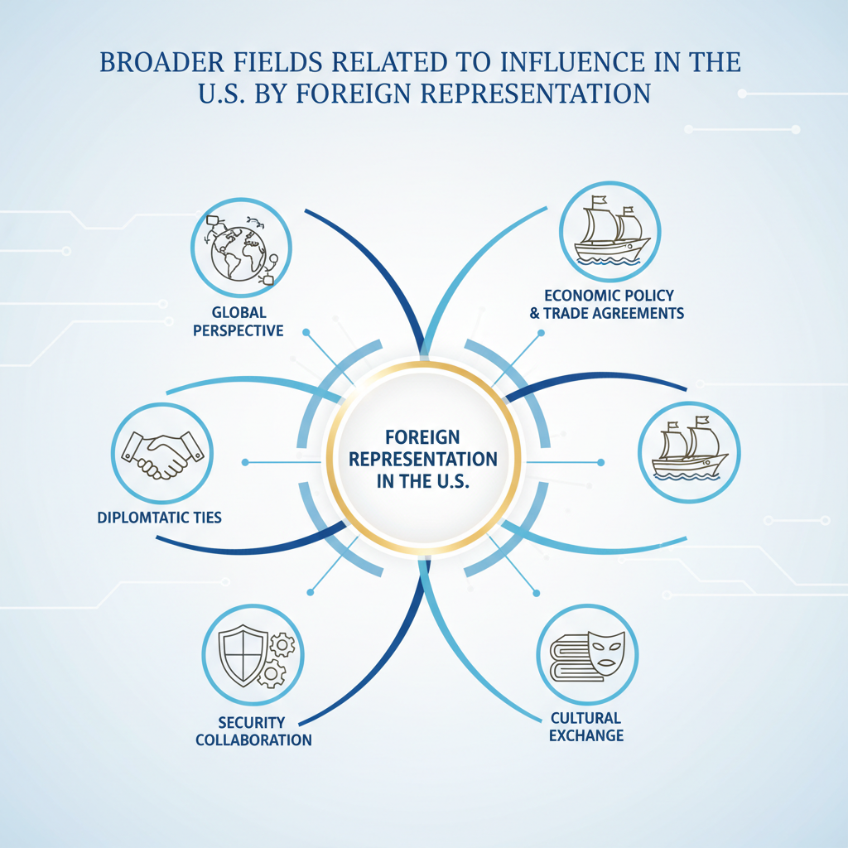

6 Broader Fields Related to Influence in the U.S.

6.1 Role of Media in Shaping Public Opinion

6.1.1 Local Media as Policy Catalysts
Local media outlets often operate as amplifiers and accelerators for policy initiatives, bridging the formal channels of legislative or regulatory engagement with public sentiment that can decisively influence outcomes. Their catalytic role is not simply about reporting information; it involves shaping narratives in ways that embed organizational objectives into the conversational frameworks most accessible to policymakers and constituents alike. Organizations maintaining proximity to decision-making centers, particularly through representation offices in Washington or strategically positioned state capitals, are best placed to synchronize their policy advocacy with local media cycles (1). This capability is critical because timing and narrative framing determine whether a policy proposal gains momentum before entrenched opposition consolidates. Local media coverage has a pronounced effect on how district-level stakeholders perceive complex issues. A technically dense debate, such as BOEM’s interpretation of vessel classification rules under offshore mineral leasing statutes, remains abstract until reframed into tangible benefits like community job creation or regional economic revitalization (5). By aligning advocacy materials with media narratives emphasizing these local gains, organizations can convert procedural matters into familiar stories that resonate politically. Policymakers absorbing constituent concerns through such coverage often find themselves pre-inclined toward supportive stances even before formal testimony is presented, as the public narrative has already defined what “helpful” policy looks like within that locale. Representation centers exploit this dynamic by coordinating op-eds, press releases, and targeted interviews to coincide with key procedural milestones, committee hearings, agency comment closings, or governor endorsement announcements. Such orchestration ensures that policymakers encounter coherent messaging across both formal briefings and informal public discourse channels. For instance, when lobbying for Title III Defense Production Act funding to enhance industrial base resilience (4), parallel release of human-interest stories in local papers detailing anticipated workforce training benefits primes regional legislators to view the allocation as a communal investment rather than an abstract budgetary line item. The trust capital built through consistent local media presence is not easily replicated from outside these geographic contexts. Relationships cultivated over time between representation staff and regional reporters yield early opportunities to introduce favorable framings before rival narratives take hold. In contested policy spaces like export controls affecting sensitive foreign-linked technology transfers (2), crafting stories around domestic capacity expansion and allied security collaboration can counteract fear-based opposition narratives well before they appear in legislative debates. Here, local media serves as a pre-legislative battleground where public sentiment can be steered toward receptivity by reframing inherently complex compliance discussions into clear benefit arcs aligned with community identity. These benefits emerge most starkly when considering the political culture’s susceptibility to localized storytelling, as observed across multiple governance layers (3). Messages delivered via trusted local outlets carry greater legitimacy than purely external communications, especially in sovereignty-sensitive environments where resistance to perceived outside imposition is high. Recasting corporate or foreign-backed initiatives as regionally originated endeavors supported by external expertise mitigates potential backlash rooted in autonomy concerns. Representation centers embedded near both federal and state hubs can direct local journalists toward highlighting the community-led aspects of proposals timed with policymaker decision calendars. Moreover, local media acts as a procedural accelerator during periods of compressed timelines, a phenomenon frequent in agency rule-adoption phases or emergency executive actions (1). Publication of opinion pieces or news features just ahead of agency hearings can create constituent pressure strong enough to sway interpretive leeway in final rules, particularly when officials face scrutiny over whether they have adequately considered public input. This interplay is especially relevant when dealing with technical sectors like critical mineral extraction under maritime transport constraints (5), where public narratives emphasizing economic independence dovetail perfectly with national security framings sought in congressional committee rooms. Coordination between media strategies and lobbying efforts necessitates precise sequencing: premature exposure risks galvanizing opposition too early, while delays squander opportunities to influence framing before formal positions solidify among decision-makers. Organizations must maintain agile editorial pipelines capable of responding to emerging policy signals picked up via embedded monitoring teams inside Washington and relevant state capitals. The ability to adjust story angles rapidly, for example shifting from an economic focus toward environmental stewardship after detecting heightened regulatory sensitivity, depends on continuous proximity-driven intelligence flow (1). State-level dynamics also play into the catalytic power of local media. Governors’ supportive statements on infrastructure or resource extraction projects directed at federal agencies gain added weight when echoed across constituent-focused publications (5). These stories often migrate upward into national discourse through syndication or re-citation in congressional discussions, creating an integrated narrative chain from local newsrooms all the way to Capitol Hill committee records. However, sustaining such locally aligned media activism absorbs considerable organizational bandwidth, a recurring theme in domestically concentrated influence strategies, and limits parallel investment into international communication campaigns (3). Competitors free from such domestic anchoring can use equivalent resources for penetrating emerging markets abroad while U.S.-based actors commit cycles toward defending national narratives across fragmented regional contexts at home. Ultimately, leveraging local media as a policy catalyst means turning proximity into narrative dominance: embedding advocacy points within culturally resonant storylines timed precisely for procedural inflection moments, using trusted journalistic platforms as informal extensions of formal lobbying arenas (1). While doing so strengthens immediate prospects for domestic policy success by enveloping decision-makers in aligned discourse within their constituencies, it deepens the strategic bias toward inward defense of existing markets, thereby perpetuating the trade-off that constrains global expansion agility outlined earlier in Section 6.1.1’s preceding analytical threads. This structural reality makes mastery over localized narrative environments both a decisive asset in U.S political influence and a defining limit on parallel international opportunity exploitation.

6.1.2 National Media Narratives
National media narratives operate as a structural overlay on policy discourse, setting interpretive frames that extend well beyond the immediate locality of decision-making and into the broader cultural and political fabric influencing federal outcomes. While local outlets shape constituency-level sentiment in ways described earlier, national platforms define the lexicon through which campaigns, legislative debates, and regulatory actions are presented to the country as a whole. Organizations with a representation center in Washington gain not only proximity to legislative and executive actors but also access to the national media ecosystem that routinely interfaces with those actors, thereby offering them opportunities to synchronize their advocacy objectives with overarching storylines broadcast across print, television, and digital networks (1). This synchronization is more than communicative convenience, it is an influence vector in itself. National narratives possess agenda-setting power that can determine whether an issue is elevated into a matter of “national interest” or relegated to a niche technical concern. When a topic such as offshore mineral leasing transitions from being described in specialist terms to occupying primetime commentary, framed perhaps as part of a national strategy on resource independence, it reshapes how congressional committees and executive agencies prioritize their attention (5). Representation centers embedded close to federal institutions can feed data, talking points, and context directly into journalists’ networks covering the political beat, increasing the chance that their preferred framing becomes dominant during these shifts. For industries tied into significant appropriations cycles, defense manufacturing connected to submarine construction funds under Title III of the Defense Production Act (4), national media coverage transcends public relations. It creates perceived stakes for national security, essentially reinforcing arguments made inside committee rooms by giving them a mass audience. Faced with extensive coverage linking specific spending packages to strategic readiness against geopolitical threats, legislators may find it politically costly to oppose funding measures aligned with such narratives. This feedback loop tightens further when agencies themselves adopt terminology circulating in major outlets, lending official legitimacy to rhetorical themes initially seeded by advocacy teams. Because national newsrooms often rely on high-profile analysts and think tank affiliates for context pieces, representation centers cultivate sustained relationships with such intermediaries. These flows of information are carefully managed so that expert commentary reflects marketing objectives stripped of overt corporate branding but rich in sector-specific relevance, a form of indirect lobbying conducted through opinion shaping rather than direct petitioning (1). In export control debates involving sensitive bilateral technology ventures like UAE-linked semiconductor collaborations (2), organisations can benefit when respected analysts echo licensing safeguard arguments consistent with their own compliance positions. Once embedded into high-circulation outlets, these viewpoints inform not just policymakers but allied foreign observers tracking American discourse through internationally syndicated content. However, achieving influence via national media requires careful narrative calibration around prevailing political culture trends. Language anchored in sovereignty themes or resilience against foreign dependency resonates strongly during high-tension geopolitical periods (3), aligning easily with both public mood and congressional rhetoric. Conversely, during moments when economic efficiency or environmental sustainability dominate debate cycles, advocacy must pivot toward those motifs swiftly or risk being sidelined as culturally out-of-step. Representation teams seated within Washington can monitor these shifts more effectively than external actors by interacting regularly with reporters who themselves attend committee hearings and federal briefings; these interactions reveal which angles have traction across multiple stakeholders simultaneously. Unlike local media work, where messages often emphasize regional employment benefits or infrastructure upgrades, national media engagements must anticipate cross-sector linkages likely to emerge when stories reach broad audiences. A feature story on maritime law adjustments under the Jones Act (5) might begin as an economic analysis but spill over into defence logistics discussions once national commentators connect vessel classification rulings to naval readiness planning. Representation centers exploit such interconnectivity by preparing multi-point narratives capable of surviving thematic migration across editorial desks: what begins as an employment statistic can evolve seamlessly into a security proof point without losing coherence. The temporal dimension is equally critical. National narratives often crystallize around breaking developments, executive orders altering procurement priorities overnight or sudden trade policy announcements under tariff authority (3), leaving narrow windows for inserting perspective before stakeholders form lasting positions. Proximate advocates can deploy coordinated responses within hours: op-eds penned by former agency officials sympathetic to their cause; background briefings offered to influential correspondents; curated data packets timed for weekend political talk shows known to shape Monday morning legislative caucus agendas. From an operational standpoint, this mode of engagement intensifies domestic commitment patterns already observable across other influence domains. To maintain continuous narrative presence within national discourse requires editorial readiness teams attuned both to procedural calendars and breaking news rhythms. Each cycle absorbs resources that might otherwise be allocated toward building equivalent media footholds abroad where competitors unbound by U.S.-centric obligations fill coverage gaps relevant to international buyers or regulators. The result is a reinforced inward weighting: domestic industries gain resilience through aligned public perception at scale, yet global agility diminishes as external communication pipelines receive less investment. National media also plays an indirect regulatory role by influencing how oversight bodies gauge public acceptability of certain policy actions. Agencies conscious of high-visibility coverage may adjust technical guidance or enforcement posture, not necessarily due to statutory change but because widespread public framing alters perceived mandates (1). For instance, BIS considering export license scope under EAR could temper conditions if national discourse paints overly restrictive rules as counterproductive to allied cooperation on security-critical technologies (2). Representation centers positioned near both the policymaking apparatus and newsroom infrastructure can catalyse this effect deliberately. The ability of national narratives to interact dynamically with regional inputs adds another layer of complexity for representation offices coordinating across jurisdictions. A governor’s endorsement featured prominently in state press gains multiplied force if picked up by leading national outlets before arriving formally in committee records (5). This orchestration loops back into lobbying strategies where local endorsement serves dual functions: swaying federal actors via constituent appeal while fortifying nationwide narrative lines running parallel in mainstream coverage. Ultimately, mastery over national media engagement offers organizations embedded within U.S governance systems both a formidable amplifier for policy positions and an anchor tying strategic communications firmly to domestic defence of market advantages. The breadth of audience reach allows integrated advocacy involving legislative sponsors, agency policymakers, regulators, and constituents all consuming similar frames, streamlining message discipline across channels. Yet this same breadth magnifies the resource draw required for constant maintenance: each reframing effort designed for headline traction diverts bandwidth from cultivating alternative story architectures abroad where rivals operate freely without balancing multiple internal narrative commitments. In the long arc of competitive positioning, organisations must decide whether securing dominance within America’s overarching narrative environment compensates sufficiently for inheriting corresponding limitations on global expansion capacity, a calculus bound tightly into the operational realities driving role allocation inside modern representation centers (3).

6.1.3 Digital Platforms and Influence Campaigns
Digital platforms have reshaped the mechanics of influence campaigns in the United States, functioning as high-speed conduits for political and commercial messaging while retaining many of the strategic imperatives associated with more traditional media engagement. Unlike the legacy rhythms of national broadcast ecosystems, contemporary online architecture offers instantaneous distribution, precision audience segmentation, and the ability to iterate narratives in real time across geographically dispersed constituencies. For organizations intent on shaping decisions within congressional committees, executive agencies, or regulatory bodies, these capabilities promise reach and adaptability unmatched by older channels. However, their effectiveness in producing tangible policy outcomes still hinges on the same foundational condition seen throughout other influence vectors: continuous proximity to decision-making hubs such as Washington, D.C., in order to align digital momentum with procedural opportunities in federal and state governance. The acceleration provided by social media algorithms changes both scale and tempo of influence operations. Campaigns can now saturate targeted segments, committee jurisdictions, agency stakeholders, or key districts, using tailored content that reinforces pre-existing advocacy work conducted in closed-door briefings or public hearings. This method mirrors historical printed pamphleteering but at vastly higher velocity; a report seeded internally within an agency can be matched by externally visible social posts designed for constituents whose representatives hold votes critical to advancing a proposal (1). The tactical advantage lies in synchrony: when digital narratives crest just ahead of procedural actions like committee markups or rulemaking comment closures, they frame the context in which decision-makers interpret formal submissions and testimony. Embedded representation centers remain vital for ensuring that such online activity does not drift into detachment from procedural reality. A remote campaign may generate impressive engagement metrics but fail to impact statutory language if uncoordinated with actual calendared events inside Congress or meetings within agencies like BOEM (5). Local teams, versed in domestic cultural codes and governance rhythms, are able to monitor impending shifts, a sudden inclusion of a leasing clause in an appropriations rider, or a pending reclassification notice under maritime law, and cue digital amplifications precisely when those shifts are still malleable inside official processes. Without such embedded oversight translating procedural nuance into timing guidance for online dissemination, even well-crafted campaigns risk becoming mere symbolic gestures rather than instruments of change. Digital advocacy also alters how narratives travel vertically between regional markets and national arenas. Content originating from a state capital, highlighting local job creation tied to infrastructure projects, can be positioned on national channels to generate supportive pressure that reaches Washington policy circles. Representation staff coordinate with social media managers so that this localized thematic material is formatted appropriately for broader audiences without losing authenticity grounded in regional priorities. This integration ensures governors’ endorsements or state commission resolutions feed directly into national discourse via retargeted content streams timed alongside federal deliberations, reinforcing multi-level lobbying strategies already underway offline. The precision targeting inherent in platform-based campaigning introduces micro-segmentation strategies able to sidestep generic nationwide appeal in favor of concentrated persuasion efforts toward individuals who exert disproportionate sway over institutional outcomes. Congressional aides known to prepare briefing materials for subcommittee chairs can be exposed repeatedly to professionally produced explainer clips contextualizing policy proposals within their assigned portfolio areas; similarly, mid-level agency engineers drafting compliance templates might encounter industry-backed data visualizations circulated through professional networking platforms (1). These tailored exposures deepen cognitive familiarity before formal consultations occur, a subtle conditioning effect augmenting direct advocacy engagements conducted face-to-face inside Washington offices. Yet this capacity brings its own demands: maintaining message fidelity across fragmented platform ecosystems requires constant alignment between online narratives and offline positioning inside federal venues. Proximity enables rapid cross-checks when political atmospheres shift suddenly, for example, after late-night amendments alter bill scope during markup sessions, or when export control determinations narrow permissible deal terms involving sensitive technology partners (2). An embedded presence ensures immediate recalibration of digital content streams so they neither contradict fresh procedural realities nor miss fleeting alignment windows where federal sentiment momentarily favors a proposal’s advancement. Operationally, social platforms offer speed but can carry volatility risk if narratives are not managed carefully within prevailing political culture (3). Algorithms amplify emotionally charged framings which may resonate broadly but conflict with moderate language preferred within formal policy venues; representation offices must dampen or redirect such surges toward culturally acceptable registers that sustain credibility among lawmakers and agency heads controlling substantive outputs. Failure to do so risks alienating decision-makers even as public engagement numbers climb, a misalignment particularly costly when legislative majorities are narrow and floor votes hinge on cross-faction negotiation rather than unilateral partisan will. Digital campaigning also interacts dynamically with regulatory oversight patterns. Agencies are aware of online discourse during rulemaking phases; high-visibility debate can influence how aggressively compliance thresholds are set or how technical definitions evolve before codification (5). Coordinated campaigns encompassing both docket submissions and public-facing platform discussion enhance pressure points without breaching formal consultation etiquette, but require careful choreography anchored by inside knowledge on where interpretive flexibility exists within the agency’s process culture (1). Representation centers give advocates access to those informal signals: offhand remarks hinting at openness to alternative performance metrics can guide how infographics or explainer threads are constructed for public consumption parallel to internal lobby briefs. From a broader strategy viewpoint, as established across related domains, the investment required for maintaining high-functioning digital influence operations that seamlessly mesh with domestic procedural calendars inevitably draws resources inward toward U.S.-focused objectives. Staff cycles consumed by calibrating message timing for committee agendas or adjusting metadata keywords around emergent agency rule drafts mean less operational energy remains for architecting equivalent campaigns abroad where competitors free from American governance entanglements act quickly into liberalising markets (3). These rivals leverage absence from U.S-centric maintenance routines as agility: while domestically bound actors fine-tune targeting parameters for subcommittee influencers on Capitol Hill, external competitors saturate policy spaces overseas before any responsive entry occurs from American firms anchored at home. In some cases, logistical realities tied to federal auditing requirements may also intersect indirectly with digital advocacy efforts; understanding how institutional knowledge is preserved within complex oversight frameworks could influence campaign continuity strategies when dealing with defense-related or compliance-heavy subject matter (11). Thus digital platforms serve simultaneously as force multipliers for proximity-enabled advocacy and as structural anchors binding strategic attention inward when paired with embedded representation centers in Washington or analogous hubs. They transform messaging speed and precision yet depend entirely on localised procedural fluency to convert narrative dominance into substantive changes across legislative text, executive directive implementation, or regulatory interpretation cycles. Mastery over their mechanics demands accepting the inherent trade-off between defending entrenched positions domestically through tightly integrated online-offline campaigns and preserving mobility internationally where opportunity windows often open, and close, on rhythms altogether different from those orchestrated inside American political infrastructure (1).

6.2 Legal and Regulatory Compliance

6.2.1 Lobbying Disclosure Requirements
Lobbying disclosure requirements in the United States operate as a formalized transparency mechanism intended to record and publicize the activities of entities seeking to influence federal or state decision-making. For organizations aiming to effectively participate in U.S. political and commercial arenas, understanding these obligations is not optional, it defines the permissible boundaries of advocacy and ensures continued access to policymakers across legislative, executive, and regulatory domains. These requirements are anchored in statutes such as the Lobbying Disclosure Act (LDA) at the federal level, supplemented by state-specific frameworks varying in scope and detail. The rules demand registration of lobbying entities, periodic reporting of contacts with covered officials, disclosure of issues lobbied upon, and expenditure reporting associated with such activities. Non-compliance risks legal penalties as well as reputational damage that may erode relationships built painstakingly over years. Failure to accurately report activity can harm both procedural credibility and substantive policy objectives. Policymakers rely on the transparency provided by these reports to assess who is attempting to shape their votes or regulatory decisions. If an organization appears opaque, either by omission or misstatement, it can trigger increased scrutiny, potentially leading to exclusion from key policy dialogues or invitations to testify before committees being withheld. Representation centers in Washington are purpose-built to manage this compliance environment through in-house expertise capable of formatting disclosures according to statutory demands while aligning them tactically with ongoing advocacy operations. This ensures that required transparency does not inadvertently expose politically sensitive strategies prematurely while still meeting legal obligations (1). Operationally, effective compliance demands granular tracking systems mapping each interaction between organizational advocates and government officials. This involves logging meetings with congressional staffers during bill markup stages, conversations with agency analysts during pre-notice consultations on rulemaking (5), or attendance at non-public briefings where legislative priorities are informally signaled ahead of formal release dates (4). Each logged instance must be linked back to specific policy issues or legislation codes for accurate quarterly reporting under LDA norms. For organizations heavily embedded in multiple sectors, defense procurement, offshore mineral extraction, high-tech export controls, these tracking systems become complex cross-referenced databases capable of distinguishing which personnel engaged on which matter under differing jurisdictional rules. While disclosure fulfills legal transparency functions, it also acts indirectly as a narrative tool within political culture. Publicly accessible reports allow stakeholders, and opponents, to frame an organization’s actions either positively as engaged citizenship or negatively as undue influence from external actors (3). Here proximity again plays a determinative role: representation centers located within Washington can anticipate how forthcoming disclosures will likely be interpreted by journalists, watchdog groups, and rival coalitions. This anticipation enables preemptive narrative framing through media relations strategies that contextualize filed lobbying data within acceptable public discourse themes such as job creation for domestic industries or contributions to national security resilience (2). By embedding compliance into broader communications planning, organizations reduce the risk that raw disclosure data is used against them rhetorically. There is also a competitive dimension embedded within disclosure regimes. External competitors operating beyond U.S borders often escape equivalent transparency requirements; they lobby foreign governments without mandated public reporting of meetings or expenditures (1). While this grants them tactical opacity abroad, U.S-based advocates must work under a spotlight that reveals not only their chosen policy targets but also the resources committed to those engagements. This asymmetry can be strategically exploited by rivals who monitor publicly available LDA filings for insights into American actors’ focus areas and adjust their own campaigns accordingly in regions where U.S players appear absent due to heavy domestic entanglement. As outlined earlier in Section 6.2.1, domestically anchored commitments divert operational energy inward, enabling faster-moving competitors overseas. State-level lobbying disclosure frameworks add another layer of complexity for organizations running multi-jurisdictional advocacy operations across regional markets aligned with federal activity. Coastal states influencing BOEM leasing processes may require periodic filings different from federal templates, sometimes demanding more immediate updates during legislative sessions focused on infrastructure or maritime law revisions (5). Representation centers operating parallel offices at state capitals must synchronize these state filings with federal reports so that messaging remains consistent while satisfying local procedural codes designed around regional political cultures (3). Misalignment between levels, for example reporting different positions on vessel classification criteria federally than regionally, can erode credibility and weaken advocacy traction inside both spheres. Given these challenges, integration between legal compliance teams and government relations units is vital. Regulatory engagement described earlier relies on trust capital with agency staff; incomplete or inconsistent disclosures risk undermining such trust if agency partners perceive misrepresentation about past contacts (7). Similarly in defence manufacturing sectors dependent on long-term appropriations planning (4), lawmakers may hesitate to support projects if they suspect undisclosed lobbying related to competing initiatives; transparent yet strategically presented filings reassure stakeholders that engagement follows agreed norms. From an operational strategy standpoint, many representation centers build compliance readiness cycles directly into monitoring systems for legislative and regulatory timelines. Anticipating filing deadlines allows them to align high-value advocacy events just inside reporting quarters so disclosure documents feature favorable narratives when they reach public view. A well-timed governor’s endorsement letter supporting a mineral export corridor project could appear alongside expenditure figures contextualizing travel costs for stakeholder engagement rather than being buried amid less compelling entries, a subtle but meaningful shaping of perception possible only through deliberate alignment between lobbying activity planning and disclosure schedule management. In some areas, especially defense-related initiatives, the visibility generated by disclosure intersects with congressional oversight dynamics around unfunded priorities lists (UPLs). When large-scale programs appear as unfunded needs rather than line items in budget requests, the accompanying narrative may shift toward urgency or political symbolism rather than routine appropriation debate (12). This interplay can amplify the stakes for how information is presented publicly since committee deliberations often weigh perceived transparency against classified or partially withheld details tied to national security considerations. Ultimately, mastering lobbying disclosure requirements is less about mechanically satisfying legal provisions than about integrating those provisions into a broader influence architecture rooted in proximity-driven situational awareness (1). Properly handled, these filings serve as both compliance necessities and strategic assets reinforcing legitimacy while preemptively countering oppositional framing. Poorly managed, or delegated entirely without integration into the advocacy core, they become liabilities exposing tactical focus areas at ill-chosen moments or inviting adversarial use of transparency data against hard-won domestic advantages. For U.S-focused actors already contending with opportunity costs linked to diminished international agility due to heavy domestic commitments (3), treating disclosure regimes as active components of influence rather than passive burdens can help sustain competitive positioning internally even as global rivals exploit openings abroad created by those same inward commitments.

6.2.2 Transparency and Accountability Measures
Transparency and accountability measures in the United States function both as safeguards for democratic legitimacy and as operational constraints that any organization seeking influence must integrate into its strategy. For entities maintaining a representation center inside Washington, D.C., or a strategically chosen state capital, compliance with these measures is not merely about avoiding legal liability, it is about sustaining access to decision-making forums and preserving credibility with legislative staff, agency officials, regulatory bodies, and wider stakeholder audiences who monitor such disclosures closely (1). The linkage between procedural openness and influence viability becomes apparent when examining how policymakers respond to entities whose activities are perceived as opaque. An incomplete or inconsistent public record of lobbying, contributions, or regulatory input can rapidly erode trust even among previously aligned allies. Operationally, transparency entails systematic documentation of interactions across all governance layers. Meetings with congressional offices during markup phases must be recorded in sufficient detail to meet disclosure law requirements without undermining tactical advantage (4). Similarly, communications with agencies like the Bureau of Ocean Energy Management (BOEM) regarding technical refinements in offshore mineral leasing criteria must be captured within reporting frameworks, whether federal or state-specific, so that compliance timelines are observed precisely (5). This disciplined capture extends to cross-sector engagements; for example, if an advocacy team lobbies simultaneously on defense procurement issues tied to shipyard workforce funding and on export control licensing for advanced semiconductor projects linked to UAE-backed ventures (2), the disclosure architecture must map these parallel tracks accurately to preserve internal coordination and withstand external scrutiny. Accountability aligns closely with transparency but takes an additional step: it demands demonstrable adherence to declared objectives and policies over time. When a representation center declares in public filings that it advocates for industrial resilience under Title III of the Defense Production Act, oversight actors, legislative committees, inspectors general, watchdog NGOs, may later evaluate whether the organization’s activities produced outcomes consistent with those stated aims (3). Failure to close that loop invites accusations of misrepresentation or opportunism. Maintaining alignment requires periodic internal audits that cross-reference disclosed positions against project deliverables so that external reviews reinforce rather than undercut influence credibility. Mechanically integrating transparency into day-to-day advocacy means adopting robust tracking systems capable of generating accurate disclosures across multiple jurisdictions without delaying tactical engagement. State capitals add complexity: governors and legislative committees influencing federal processes may have their own accountability rules governing the timing and content of outside submissions (7). Missteps here risk contaminating the entire advocacy pipeline; an unnoticed breach at state level can cascade upward if federal actors perceive discrepancies between local reporting and national statements, even in unrelated issue areas. From a strategic view, embedded offices use transparency not simply defensively but also proactively to frame narratives favorably before opponents do. Public reports can be contextualized through media relations so that lobbyist registration entries or expenditure tallies appear as evidence of constructive civic participation rather than vested-interest intervention (1). For example, planned disclosure showing high engagement costs related to BOEM consultations may be paired with press releases highlighting environmental stewardship commitments embedded within project proposals, a move designed to blunt critiques from rivals positioning themselves as sustainability champions. Yet this necessity creates a resource gravity pulling ever more operational energy toward domestic disclosure and accountability maintenance cycles. Specialist compliance staff, narrative coordinators for framing public records, legal teams ensuring statute alignment, all absorb focus that could otherwise drive exploratory ventures abroad (3). Competitors free from U.S.-style high-transparency regimes can invest equivalent budgets directly into new-market penetration strategies (Section 6.2.1). The asymmetry becomes most visible when American actors miss foreign tender opportunities while finalizing quarterly filings intended to satisfy overlapping federal and subnational accountability statutes. In sensitive sectors under heightened oversight, defense supply chains, critical minerals extraction maritime rules, high-tech exports involving geopolitical sensitivities, the rigour of accountability expectations increases further. Legislative sponsors may demand post-engagement reports demonstrating not just lawful conduct but realised benefits tied precisely to appropriations or regulatory concessions granted (4). Export control administrators under EAR protocols may require periodic proof that licensed technology transfers remain compliant amid evolving foreign partnerships (2). Each fulfilment cycle binds personnel into ongoing evidence compilation tasks coextensive with domestic market defence priorities, a structural feature reinforcing inward focus over international adaptability. Strategically adept representation centers build feedback loops connecting operational transparency data directly into government relations goals: disclosure tracking feeds analytics predicting potential points where accountability narratives might be challenged; rapid-response units adapt messaging preemptively so official records remain congruent with prevailing cultural framings valued by U.S political audiences (3). Such integration prevents reactive crisis management when hostile coalitions attempt to weaponize transparency against entrenched market positions, a risk magnified by public accessibility of lobbying and compliance filings. In certain cases this vigilance mirrors military-affiliated oversight frameworks in which performance is evaluated against stated educational or operational objectives over extended periods, practices seen in programs like JROTC where instructor performance accountability intersects with statutory mandates on unit composition (13). Ultimately, organisations operating inside America’s influence ecosystems must treat transparency and accountability measures as active instruments shaping their legitimacy rather than passive hurdles obstructing their campaigns (1). Properly synchronised with proximity-enabled monitoring of legislative calendars, agency rule-making rhythms, and state-level policy sequences, these measures become part of a coherent engagement narrative projecting reliability both internally and outwardly. Yet sustaining this coherence enforces continued domestic prioritisation: every successful execution cements internal market predominance while incrementally constraining external growth agility, creating open terrain internationally for rivals unconstrained by equivalent procedural cultures to advance faster toward their own expansion plans.

6.3 Economic Leverage and Resource Strategy

6.3.1 Energy Sector as a Policy Lever
Within the United States, the energy sector occupies a uniquely potent position as both an economic driver and a policy lever for influencing legislative, executive, and regulatory decisions. Its strategic weight stems from the overlap of domestic energy security imperatives, industrial growth objectives, and geopolitical considerations embedded in trade and defense frameworks. Entities seeking to shape outcomes in this domain must first develop a nuanced grasp of how energy debates integrate into broader political narratives, particularly those surrounding critical minerals extraction, offshore resource management, and infrastructure development for transport of oil, LNG, or emerging renewable sources. Proximity to Washington is decisive here; without an embedded representation center capable of aligning sectoral arguments with prevailing federal priorities, advocacy risks missing the narrow procedural windows that turn technical proposals into codified policy (1). Energy policy discussions at the federal level intertwine with national security rhetoric and economic independence strategies. Mining and offshore exploration activities regulated by agencies such as BOEM are framed not only in terms of revenue potential but also as safeguards against reliance on foreign supply chains (5). This framing creates dual avenues for influence: aligning resource development projects with congressional committee interests that prioritize resilience, and synchronizing technical data submissions during agency comment periods to embed favorable operational definitions before rule finalization. For example, vessel classification under maritime law for mineral transport, if aligned strategically with Jones Act compliance pathways, can shield domestic operators from foreign competition while cementing infrastructure investment patterns beneficial to long-term market control. Such alignment demands precise timing relative to both legislative calendars and agency rulemaking cycles, reinforcing why representation capacity inside Washington is essential for converting sectoral expertise into durable commercial advantage. Executive branch engagement magnifies the energy sector’s leverage potential through direct presidential initiatives or statutory tools like the Defense Production Act Title III. Orders focusing on building domestic capacity for critical materials or energy infrastructure can trigger accelerated funding programs and procurement commitments (4). Representation offices tuned into agency follow-through processes post-directive can provide readiness evidence early enough to secure inclusion in priority lists before budget allocations are locked. This positions organizations not only to benefit commercially but also to frame themselves as contributors to nationally endorsed resilience strategies, a portrayal that shields their projects from later political challenge. Trade policy intersects sharply with energy as a policy lever when tariff measures or export controls recalibrate international flows of commodities or technology components related to extraction and processing (3). U.S.-linked LNG exporters or oil producers caught in these shifts must navigate both protective measures designed to bolster domestic markets and retaliatory actions from trading partners seeking alternative suppliers. Advocacy grounded in Washington can influence the scope of these measures by inserting sector-specific exemptions or flexible compliance stipulations during policy drafting phases at agencies like BIS (2), ensuring continued access to key foreign markets despite overarching restrictions. This requires intimate familiarity with the intersecting mandates of trade committees, energy-focused legislative caucuses, and security advisors weighing geopolitical risk factors alongside export economics. At state levels, especially coastal capitals where governors hold consultative authority over offshore leasing proposals (5), integration between local economic agendas and federal strategies becomes central to shaping outcomes. Representation centers coordinating directly with these governors’ offices can steer formal recommendations toward operational parameters advantageous for industry actors, while parallel media campaigns emphasize job creation, infrastructure investment, and environmental stewardship tailored for regional audiences (1). These endorsements can then be fed upstream into congressional hearings or agency dockets as legitimizing input supportive of expediting project approvals federally. The layering effect, local advocacy reinforcing national positioning, amplifies influence far beyond what federal-level lobbying could achieve unaided by regional resonance. The cultural dimension underpinning energy policy influence is significant. In sovereignty-sensitive contexts within U.S political culture (3), promoting domestic control over energy resources plays into entrenched preferences against external dependency. Corporate narratives tying offshore mineral exploitation or LNG terminal expansion directly to reduced reliance on politically unstable foreign suppliers find ready reception among legislators and agency heads concerned with strategic autonomy. Representation teams capable of sustaining these narratives consistently across hearings, briefings, and regulatory submissions preserve alignment even when broader political atmospheres shift focus, for instance toward environmental protection amid public pressure spikes, by integrating sustainability protocols into existing independence frameworks without diluting core operational advantages. Operationally, leveraging the energy sector’s policy significance requires continuous monitoring across multiple governance domains: congressional committee schedules handling appropriations impacting port upgrades; BOEM’s release dates for mapping data identifying high-yield lease blocks; BIS amendments adjusting export license categories relevant to component shipments; state commission sessions revisiting environmental compliance baselines for new infrastructure projects (1). The synchronization challenge here is acute: missing any one procedural point can delay implementation or create vulnerabilities competitors might exploit domestically or internationally. Embedded representation allows simultaneous oversight across these points while coordinating responsive action in real time, whether mobilizing coalition letters ahead of House subcommittee markups or releasing district-targeted press statements that prime constituent support on issues under imminent vote consideration. However, sustained use of the energy sector as a domestic policy lever compounds inward resource allocation pressures already evident in U.S-centric influence strategies (Section 4.3.1). Staffing devoted full-time to defending established lease terms, securing tariff exemptions for fuel exports, or maintaining compliance positions under evolving maritime classifications inevitably limits capacity available for seeking comparable footholds abroad (3). Competitors operating outside American governance loops exploit this asymmetry by advancing rapidly into emerging markets offering faster approval cycles, fewer compliance obligations, and pricing flexibility unhampered by U.S trade politics, as seen in LNG developments across Southeast Asia that proceed while American firms focus intensively on sustaining home-market privileges through federal lobbying (5). Ultimately, mastery over this sector’s influence potential depends not solely on technical proficiency but on embedding that proficiency within proximity-enabled advocacy architectures designed to operate fluidly across legislative chambers, executive program initiation points, regulatory interpretation phases, and regional integration junctures (1). Doing so converts resource control into an enduring instrument of commercial survival domestically, a power base defended vigorously through continual narrative reinforcement tied to economic independence themes, but leaves open questions about balancing such intensive inward commitment against the agility required for competitive engagement in global energy markets where rivals move quickly into spaces unobserved or underserved by U.S-bound actors.

6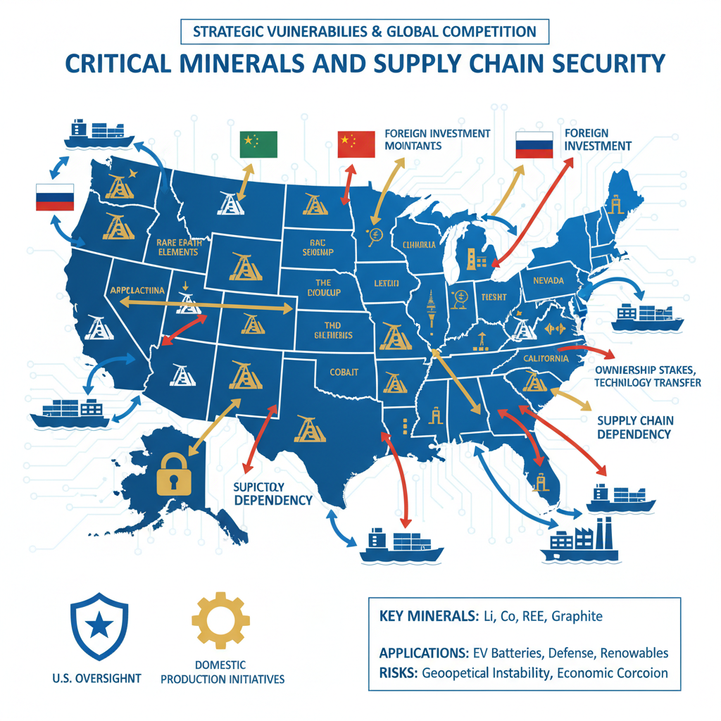

3.2 Critical Minerals and Supply Chain Security
Critical minerals occupy a strategic position in both economic planning and national security discourse within the United States, creating a dual-layer policy environment that organizations must navigate adeptly to exert influence. These resources, ranging from rare earth elements to cobalt, nickel, and other industrial inputs, are indispensable for advanced manufacturing, defense systems, renewable energy infrastructure, and high-technology components. Their secure sourcing, processing, and transport constitute not just commercial opportunities but vulnerabilities with implications for military readiness and technological competitiveness (5). Entities that understand the vectors of influence surrounding critical minerals policy can shape legislative clauses, executive directives, and regulatory frameworks in ways that protect domestic supply chain integrity while simultaneously advancing sectoral market positions. Advocacy effectiveness hinges on aligning technical proposals for mineral exploration or processing with prevailing national narratives about independence from foreign supply chains. Lawmakers and agency administrators have increasingly adopted resilience framing for these resources, emphasizing reduced reliance on strategic competitors’ exports, and reward proposals that integrate localized economic benefits into national security goals (3). Representation centers embedded in Washington enable stakeholders to feed sector-specific intelligence directly into committees overseeing natural resource legislation or defense procurement planning. By delivering evidence of how domestic mineral projects strengthen industrial sovereignty, such centers ensure resonance with protectionist currents embedded in political culture. The regulatory component significantly shapes operational viability. Agencies like the Bureau of Ocean Energy Management (BOEM) control leasing rights for offshore reserves; their determinations on eligible operators and vessel classifications directly affect cost structures under statutes such as the Jones Act (5). Amendments or clarifications to these rules influence whether extraction costs remain competitive against foreign-sourced alternatives. Embedded representation staff can anticipate shifts in classification criteria by maintaining continuous contact with agency technical teams prior to official notice periods. This proximity allows them to submit data-informed adjustments during early consultation stages rather than reacting after final rules constrain operational flexibility (1). Legislative cycles provide another avenue where critical minerals intersect directly with defense-linked appropriations. Submarine construction programs or other advanced systems require specialty metals whose procurement stability influences readiness timelines (4). Advocacy coordinated around appropriations markups can insert provisions directing funds toward domestic industrial base expansion, including mineral refining capacity, by framing these investments as resilience measures that meet both military specifications and civilian manufacturing needs. Integration between committee lobbying and alignment with executive programs like Title III of the Defense Production Act ensures continuity from statutory intent through agency implementation steps. Export control regimes add complexity by tying permissible trading of refined critical minerals to national security reviews administered under frameworks such as the Export Administration Regulations (EAR) (2). When foreign partnerships are involved, particularly those linking U.S. producers with entities in geopolitically sensitive states, licensing conditions must reconcile diplomatic caution with commercial imperatives. Representation centers positioned near licensing authorities can present safeguard protocols early in review processes, thereby mitigating risks of denial while maintaining policy compliance. Without this level of proactive immersion inside Washington’s decision apparatus, organizations risk reactive defensiveness after controls are enacted, losing strategic contracts abroad to competitors operating outside restrictive jurisdictions. State-level politics often function as amplifiers for federal mineral policy outcomes. Governors adjacent to offshore mineral blocks possess consultative authority under federal statutes (5); supportive positions from these offices can materially influence BOEM’s final lease determinations by embedding regional endorsement in federal records. Local representation aligned with state economic development agendas ensures governors receive tailored impact analyses connecting mineral exploitation projects to job creation and infrastructure upgrades valued by constituents. These endorsements flow upstream into congressional hearings as legitimizing evidence for aligned industry measures. Cultural adaptation remains an ever-present necessity when advocating around critical minerals policy. In autonomy-focused climates, external investment into resource sectors may face initial skepticism; reframing such initiatives as domestically led projects supported by international expertise satisfies sovereignty-sensitive preferences while retaining capacity advantages derived from global cooperation (3). Representation staff grounded in these cultural nuances craft messaging consistent across committee testimonies, agency filings, and regional media outputs so that public perception aligns positively before formal decisions emerge. Operational strategies reinforcing secure critical minerals supply chains extend beyond extraction rights into logistics infrastructure, refining capacity, and integration with allied distribution networks. Port facility enhancements or dedicated transport corridors tied to mineral exports may attract multi-sector support if marketed as dual-use assets benefiting both commercial throughput and naval resupply capabilities (5). Coordinated advocacy bundles defense infrastructure language together with energy export narratives, a tactic demanding cross-domain expertise able to package proposals that meet procedural thresholds across multiple committees simultaneously. However, sustaining this multifaceted engagement deepens inward resource commitment much like patterns observed previously in Section 6.3.1. The monitoring of granular procedural calendars, from agency docket closings to appropriations deadlines, consumes organizational bandwidth that could otherwise target global resource ventures less encumbered by extensive compliance regimes (3). While domestic entrenchment delivers formidable control over policy shaping within U.S borders, it also leaves scope internationally for agile competitors free from such governance cycles to secure concessions swiftly in emerging mining jurisdictions abroad. In sum, mastering influence across the interconnected legislative mandates, regulatory frameworks, trade controls, and cultural narratives tied to critical minerals demands the full suite of proximity-enabled capabilities discussed throughout this thesis: situational awareness sharpened by physical presence inside relevant hubs; procedural literacy sufficient to exploit narrow advocacy windows; narrative agility aligning technical imperatives with dominant political frames; and coalition management spanning federal committees through state capitals (1). For organizations prepared to accept the implicit trade-off between sustained domestic market defence and constrained global mobility, the critical minerals sector offers unmatched leverage over supply chain security debates, a leverage amplified precisely because such resources straddle commercial profitability and national strategic readiness alike (4).

6.3.3 Infrastructure Investments as Influence Tools
Infrastructure investments can serve as durable levers in shaping political and commercial decision-making within the United States, particularly when deployed strategically in conjunction with advocacy operations anchored at a representation center. Organizations that understand the vectors of influence in U.S. governance recognise that physical assets, ports, energy terminals, transportation corridors, industrial parks, carry immediate economic weight while also embedding long-term dependency relationships with policymakers, regulatory agencies, and local constituencies (1). These investments do not merely create operational utility; they become political artifacts around which legislative support, regulatory approval, and appropriations decisions coalesce. A central function of infrastructure investment as an influence tool is its ability to generate measurable regional economic impacts that align with lawmakers’ district priorities. Projects like LNG terminal expansions or port modernisations tied to mineral export capacity deliver job creation figures that legislators can publicise during campaigns and appropriations debates (5). This creates reciprocal incentive structures, political actors see tangible benefits in defending or advancing projects whose continuation validates their performance to constituents. Representation centers monitor these dynamics closely to time advocacy interventions during budget markups or infrastructure bill consolidations so commitments made by policymakers are reinforced by visible construction milestones or operational outputs. Where federal priorities overlap with state agendas, infrastructure becomes a unifying mechanism. A coastal port upgraded for mineral shipment may simultaneously fulfil Navy logistical requirements; framed correctly before congressional committees and defence acquisition offices, the project appears indispensable to both commercial throughput and strategic readiness (4). This dual-use narrative allows advocates to pull resources from separate funding streams while ensuring cross-domain policy reinforcement. Federal agencies such as BOEM can be influenced during leasing consultations if regional infrastructure readiness supports accelerated development timetables; governors’ endorsements premised on such readiness carry weight upstream in final determinations (5). From an executive branch perspective, substantive infrastructure aligned with presidential directives under programmes like the Defense Production Act Title III reinforces statutory goals related to domestic capacity and resilience (4). An organization demonstrating shovel-ready industrial upgrades in sectors deemed critical can secure early place within priority lists for grants or procurement guarantees. Representation centers translate technical project plans into agency-compatible documentation well before submission deadlines, ensuring capital spending intersects neatly with performance benchmarks set administratively after high-level directive issuance (1). Regulatory engagement benefits similarly from strategically positioned infrastructure because it tangibly frames compliance narratives. A firm operating a modernised port meeting robust environmental standards can present itself as a baseline-proof operator when agencies consider tightening procedural thresholds for offshore resource handling (5). Such facilities become demonstrative assets, embodied arguments for why certain operational models merit favourable interpretation under maritime law classifications or export licensing conditions (2). Regulators inclined toward visible proof of feasibility often adopt parameters already tested in high-capacity sites built under monitored compliance regimes. On the trade and export control side, infrastructure linked directly into supply chain security discussions elevates influence beyond sectoral confines. Storage capacity expansions for critical minerals interconnected with refining plants show U.S.-based policymakers a closed-loop system able to insulate national production from geopolitical disruptions (3). Representation teams leverage this presentation in EAR licensing talks or tariff exemption negotiations by emphasising how infrastructural investment directly supports national resilience framing central to legislative discourse on security independence (2). At the state level, large-scale investments confer immediate bargaining capital over local regulatory boards and commissions charged with approving environmental or zoning permits (7). By embedding projects within narratives of community benefit, advocates can secure smoother passage through regional compliance gates, especially important when those approvals are prerequisites for parallel federal actions. Governors endorsing such development bring constituent-aligned pressure into Washington’s decision circuits; representation centers orchestrate this flow so local endorsements arrive at committee rooms contemporaneous with related hearings (1). There is an evident cultural dimension: domestically controlled infrastructure taps into sovereignty-sensitive themes prevalent across American political culture (3). Whether ports ensuring export independence or manufacturing hubs producing defence components without foreign reliance, physical investments manifest rhetoric about self-sufficiency into tangible artefacts legislators can champion publicly. This resonance enhances protective policymaking around the asset, approvals are defended more vigorously against competing interests once an institution exists physically within a district’s borders. However, leveraging infrastructure as a political influence tool intensifies inward resource allocation patterns already seen in connected sectors (Section 6.3.2). Maintaining construction schedules aligned with policy windows demands constant coordination between engineers, public affairs teams, lobbyists, and regulatory specialists, all anchored domestically to ensure congruence between site progress and advocacy milestones (1). Capital locked into reinforcing U.S.-based facilities constrains liquidity for international ventures; organisational bandwidth devoted to integrating these projects into legislative narratives leaves less scope for scouting opportunities abroad where approvals could be faster or costs lower absent stringent compliance cultures. Competitors outside U.S governance ecosystems exploit this disbalance by advancing equivalent projects overseas unimpeded by multi-tiered procedural synchronisation demands. Yet when calibrated precisely against federal and state timelines, infrastructure investments create compounded influence effects that are difficult to rival domestically: legal frameworks adapt around their existence; appropriations flow toward their maintenance; regulatory baselines take cues from their operational design; trade positions reference them as proofs of capacity under protective regimes; diplomatic engagements abroad may cite them as demonstration of domestic self-reliance tied to allied commitments (4). The strategic calculus remains whether this inward fortification offsets opportunity costs calculated across absent foreign ventures, a choice defined not solely by market arithmetic but by recognition that in U.S political-commercial interplay, few instruments offer as sustained an anchor on policymaking priorities as visible, capital-intensive assets embedded inside key geographic jurisdictions where legislative votes are won and regulatory discretion is exercised daily.

7 Sustainability of Influence Strategies

7.1 Long-Term Relationship Building

7.1.1 Maintaining Trust with Policymakers
Maintaining trust with policymakers requires a structured and ongoing engagement that goes beyond transactional lobbying. It is not enough to deploy persuasive arguments in isolated meetings; trust is the result of consistent, credible interaction reinforced over time through alignment of organizational behavior with the expectations and procedural norms of those who control legislative, executive, and regulatory levers. Representation centers based in Washington, D.C., become indispensable to this process by situating staff within immediate reach of informal policy dialogues, subcommittee working sessions, and agency consultations where reputational capital is either built or eroded (1). Trust rests on perception as much as on fact, policymakers assess whether an actor’s communications are reliable, whether commitments made in previous sessions have been followed through operationally, and whether positions remain consistent even when political atmospheres shift. Proximity enables continuous reinforcement of credibility signals. A representation office can respond rapidly when policymakers request additional data during committee markups or agency rulemaking phases, demonstrating preparedness that reassures them about future interactions. For instance, if BOEM seeks clarification on vessel classifications affecting offshore mineral leasing (5), delivering technically precise responses within hours shows capability and respect for procedural deadlines, both factors that deepen trust. Similarly, during defense appropriations cycles linked to industrial base resilience programs under Title III of the Defense Production Act (4), an organization’s ability to present coherent readiness metrics aligned with prior claims reinforces the image of a dependable partner capable of meeting statutory objectives without unexpected shortfalls. Aligning advocacy content with prevailing political narratives enhances receptivity while protecting established relationships. In sovereignty-sensitive climates where external dependency is viewed warily (3), positioning resource extraction or energy infrastructure projects as domestically led initiatives, even if backed by external expertise, preserves trust among legislators attentive to constituent perceptions. This cultural calibration requires daily situational awareness achievable only through embedded presence; local cues from congressional aides or agency analysts often signal subtle shifts in committee sentiment before official agendas reflect these changes. Adjusting messaging accordingly ensures policymakers feel understood within their own ideological context, strengthening relational bonds. Accountability plays a major role in sustaining trust over extended timelines. Public oversight mechanisms such as lobbying disclosure requirements demand accuracy and completeness (1). Missteps here jeopardize not just legal standing but long-nurtured rapport: an incomplete filing that fails to mention relevant export control discussions with BIS concerning UAE-linked semiconductor ventures (2) could lead policymakers to suspect deliberate concealment or sloppy management. Representation centers integrate compliance tracking directly into their advocacy planning so filings corroborate verbal claims made to decision-makers; this congruence solidifies confidence that the organization operates transparently. Consistency across multiple domains of engagement is equally important. Many federal actors coordinate with state-level officials when shaping policy; misalignment between positions presented federally and those recorded regionally undermines credibility. For example, if a coastal governor’s endorsement on mineral leasing terms is used in congressional testimony but state filings reflect different operational priorities (5), legislators may question the reliability of the advocate’s narrative. Representation teams avoid this by synchronizing messages across jurisdictions, ensuring every interaction contributes to a coherent trust profile. Delivering tangible outcomes tied to prior commitments strengthens long-term relationships markedly. If an organization has promised support for workforce training tied to naval shipyard contracts (4) during appropriations hearings, demonstrating actual program implementation before subsequent budget reviews validates previous advocacy efforts. Policymakers measure such follow-through against other stakeholders whose commitments remained rhetorical; consistent deliverables elevate a partner into a trusted category within the policymaker’s mental hierarchy. Trust also benefits from being safeguarded during politically volatile moments. Sudden policy shifts, introduction of national security tariffs impacting critical minerals (3), rapid reclassification under maritime law changing cost structures for operators (5), or emergency amendments tightening export controls on high-tech components (2), can prompt reactive lobbying surges prone to overselling solutions or contradicting earlier stances. Representation offices located close to these events temper responses within culturally acceptable frames, protecting relational stability by avoiding contradictory messaging borne of haste. At the executive agency level, where mid-level managers often draft key policy language later adopted formally, sustained interpersonal rapport is essential for inclusion in pre-publication deliberations (1). This access depends on prior interactions marked by respect for procedural boundaries and readiness to provide constructive technical input rather than opportunistic demands. Policymakers at this tier are more likely to extend informal invitations for consultation when past collaborations have yielded mutually acceptable adjustments without contentious public disputes. Yet devoting resources toward nurturing these domestic trust networks, whether in committees, agencies, regulatory boards, or state governments, inevitably binds organizations more tightly into national and regional market defence cycles discussed earlier in Section 6.3.2. While this consolidation ensures resilient influence within U.S borders, it reduces flexibility for international competition where rivals operate unrestrained by similar proximity-maintenance obligations (3). Competitors abroad may advance faster into liberalizing markets while domestically anchored actors spend cycles reinforcing already strong ties at home. Strategically managing trust therefore involves balancing depth against breadth: embedding sufficiently to benefit from immediate feedback loops and procedural accommodation while not allowing domestic entrenchment to foreclose timely pursuit of global opportunities. In practice this means formalizing relationship maintenance protocols inside representation centers, scheduled review meetings with key contacts, transparent reporting systems linking commitments to delivered outputs, adaptive messaging frameworks responsive to cultural currents, so every engagement incrementally builds reputational equity with policymakers across governance levels (1). By institutionalising these practices an organisation can secure durable partnerships crucial for influencing complex policy landscapes internally while preserving enough operational elasticity to re-engage internationally where competitive openings demand rapid mobilisation.

7.1.2 Continuous Cultural Adaptation
Continuous cultural adaptation within the U.S. political and commercial environment demands far more than an initial orientation to prevailing values and rhetorical styles, it requires a sustained, iterative process of recalibrating engagement strategies in response to subtle shifts in sentiment, symbolism, and interpretive priorities among policymakers, regulators, and the public. As outlined previously in Section 7.1.1, maintaining trust relies heavily on consistent alignment with these dynamics, but long-term influence also depends on an organization’s ability to detect and integrate changes that may emerge quickly or gradually depending on the political climate (1). Political culture at the federal level is not monolithic; it oscillates along partisan lines, reacts to global events, and often reframes key narratives through legislative debate or executive pronouncements. A representation center embedded in Washington ensures immediate exposure to these oscillations, allowing for rapid adaptation of advocacy frames. Staff who engage daily with congressional aides or mid-level agency analysts pick up early signals, such as a committee chair’s shift from emphasizing industrial job creation toward environmental safeguards, that indicate where narrative emphasis must pivot (5). Translating technical arguments into language compatible with such pivots is essential; for instance, offshore mineral development proposals might need reframing so they incorporate sustainability protocols without undermining cost-efficiency claims. Missing these cues risks making organizations appear tone-deaf or disconnected from emergent policy currents.
At the state level, cultural adaptation takes on different contours. Each capital has a distinctive political personality shaped by local economic drivers, ports, energy corridors, defense manufacturing hubs, that determine resonance points for advocacy (4). Here continuous adaptation may involve reinterpreting federal objectives in ways that match regional identity narratives. In autonomy-sensitive states reminiscent of sovereignty-focused contexts abroad (3), project pitches must be couched as locally driven initiatives supported by external expertise rather than federally imposed programs. Representation centers interfacing at both tiers mediate between these varying norms to ensure coherent yet flexible messaging across jurisdictions. Cultural adaptation also means tracking how external factors alter domestic self-perceptions. Geopolitical conditions, sanctions regimes affecting critical minerals sourcing (5), tightened export controls on technology components under EAR frameworks involving UAE partnerships (2), or protective tariffs framed as national security measures (3), can heighten sensitivity to themes of economic independence and resilience. Advocacy operating in this milieu must adjust tone and content to mirror heightened protectionism without alienating trade-oriented constituencies who may be wary of excessive isolationism. The balance is often delicate: overt nationalism can secure support from certain factions while alienating others whose cooperation is needed for cross-sector initiatives.
Representation centers use embeddedness to blend procedural timing with symbolic calibration, integrating cultural cues directly into policy interventions. For example, lobbying submissions timed ahead of appropriations markups might highlight workforce impacts if legislators are campaigning heavily on employment issues; in years where fiscal restraint dominates discussion, those same submissions may stress return-on-investment metrics and efficient resource use instead. Such agility requires continuous monitoring not only of official agendas but also media narratives feeding into policymaker priorities. Public affairs functions play a complementary role by amplifying culturally adapted messages through local and national media outlets to reinforce alignment across audiences (1). A vessel classification dispute under maritime law affecting mineral shipments might be framed in local press as protecting regional jobs and commerce while being presented nationally as safeguarding industrial capacity against foreign dependence (5).
Both convey operational benefits but each is crafted to conform with the prevailing sentiment of its intended audience. Continuous adaptation further extends into interpersonal rapport management within influence networks. Messaging consistency matters for trust maintenance, yet repetition without responsiveness can dull engagement effectiveness. Interlocutors accustomed to nuanced dialogue expect advocates to adopt emerging thematic threads quickly; a House member shifting focus toward renewable energy integration will anticipate industry partners realigning proposals accordingly, even when those partners have traditionally emphasised fossil fuel logistics. Failure to match this evolution creates openings for competitors who demonstrate greater cultural agility. This process consumes significant organizational bandwidth and reinforces domestic entrenchment because it requires persistent in-person presence inside governance venues where sentiment shifts first appear. The iterative modification of advocacy materials, compliance narratives, coalition talking points, and public communications all bind resources into defending current market positions against erosion from changing cultural climates (3). Consequently, opportunities abroad, where competitor firms face fewer demands for constant domestic recalibration, may be pursued less vigorously or too late to secure advantageous entry.
Sector-specific considerations intensify adaptation requirements. In defense-linked industries reliant on appropriations cycles for shipbuilding contracts (4), shifts toward fiscal conservatism demand lobbying emphasis on efficiency gains and multi-use asset production; during heightened geopolitical tension periods, cultural appeal skews toward readiness expansion regardless of budgetary strain. Energy exporters advocating LNG terminal growth must pivot between independence-themed rhetoric during foreign supply disruptions and climate adaptation narratives when federal environmental review processes tighten under BOEM oversight (5). Technology sectors affected by export controls need sophistication in blending compliance guarantees with innovation leadership framings that ease fears over capability loss while meeting legislative scrutiny thresholds (2). Organizations mastering continuous cultural adaptation institutionalize feedback loops between their representation centers’ monitoring activities and strategic decision-making bodies. Daily intelligence gathered informally from policymakers informs immediate content adjustments; quarterly trend analysis guides structural positioning across legislative agendas; long-term cultural mapping predicts areas where public sentiment could push policy unexpectedly toward or away from existing operational strengths.
The necessity of this sustained flexibility underscores a central strategic trade-off: deep responsiveness domestically increases durability against cultural misalignment but amplifies inward resource allocation at the expense of global positioning agility. In certain instances, adaptation must also account for bilateral dynamics beyond U.S. borders, for example, considerations around expanding defense cooperation under agreements such as those governing Greenland require sensitivity to allied perceptions while advancing American security aims (14). Competitors unbound by U.S.-centric obligations can deploy comparatively static yet locally optimized messaging abroad while U.S.-embedded actors continue cycling through domestic adaptation routines (1). Thus continuous cultural adaptation remains both a vital instrument for influence success inside the United States and a defining factor limiting concurrent expansion into international markets, a dual reality shaping competitive landscapes over extended strategic horizons.

7.1.3 Institutional Memory and Knowledge Transfer
Institutional memory and knowledge transfer emerge as integral components in sustaining influence within the United States, particularly for organizations that have invested in establishing representation centers in Washington, D.C., or other strategically relevant federal hubs. The procedural fluency and cultural literacy described in Section 7.1.2 are not static achievements; they are cumulative assets developed over repeated cycles of legislative monitoring, agency consultation, and regulatory engagement (1). Without robust mechanisms to capture, preserve, and disseminate this accumulated intelligence, even well-established advocacy positions risk erosion when personnel turnover alters relational continuity or procedural expertise within the representation center. Institutional memory operates on several levels. At its most basic, it refers to accurate records of tactical engagement, tracking which congressional aides respond positively to specific framing strategies during committee markups, which agency analysts have historically been open to alternative technical interpretations, or which state-level offices consistently coordinate with federal actors on shared priorities like offshore mineral leasing (5). More sophisticated layers involve synthesizing these episodic data points into patterns: understanding that certain public narratives (job creation tied to naval shipbuilding under Title III (4)) gain traction only at particular stages of appropriations cycles or during heightened geopolitical tension, while others (energy independence framing during BOEM lease consultations) resonate more predictably across diverse political climates (3). Knowledge transfer ensures these insights remain actionable beyond the tenure of any single staff member. Representation centers must institutionalize methods for onboarding new personnel so they can step immediately into ongoing campaigns with minimal loss of momentum. This requires codified documentation of prior engagements, not mere lists of meetings held but analytical breakdowns of outcomes achieved and procedural pathways navigated. For instance, if an export control licensing effort linked to UAE semiconductor ventures succeeded due to early insertion of compliance safeguards acceptable to BIS reviewers (2), future teams benefit from knowing which safeguards were persuasive and why they aligned with prevailing agency priorities at that moment. Absent such detail, successor advocacy may fail by repeating ineffective tactics or missing critical timing cues embedded in agency workflow patterns. Effective institutional memory systems also map cross-domain interdependencies discovered through operational history. A successful lobbying push around vessel classification flexibility under maritime statutes may have originated in technical docket submissions yet ultimately depended on reinforcing narratives deployed simultaneously via national media channels highlighting industrial base resilience (1). Storing this integrated view allows future strategists to rebuild similar multi-pronged efforts without reconstructing from scratch the coalition sequencing or content distribution tactics originally employed. Such integration is particularly important for sectors where domestic positions must be defended intensively against shifting interpretations, critical minerals supply chain policy being a prime example where legislative clauses, agency classification rules, and trade controls mutually affect commercial viability (5). In practice, knowledge transfer can take multiple forms: secure digital repositories holding briefing materials and legislative analyses; relational databases linking stakeholders to specific policy outcomes; scheduled debrief sessions after major advocacy milestones where lessons learned become part of communal organizational knowledge; mentoring structures within representation centers pairing veteran operatives with incoming staff to accelerate familiarization with both formal procedural nuance and informal cultural signals picked up via daily embedded presence (1). These systems should be designed not merely for archival value but for active retrieval, capable of surfacing relevant precedent quickly when new bills are introduced or fresh rulemakings announced. The importance of embedding such systems intensifies under the resource constraints inherent in heavy domestic engagement. As noted throughout earlier discussions, organizations anchored deeply in U.S.-centric influence cycles devote substantial energy toward protecting national and regional market advantages at the expense of international ventures. Institutional memory mitigates some opportunity cost by making domestic defense more efficient; if staff can deploy historically validated tactics without redundant trial-and-error exploration each cycle, time saved might be reallocated, however minimally, to scouting international opportunities before competitors consolidate them abroad. Yet absent rigorous knowledge transfer practices, personnel churn resets strategic depth repeatedly, forcing renewed learning curves that perpetuate inward focus and prolong vulnerability to external competitive advances. Cultural elements form a critical subset within institutional memory worth emphasizing separately. Understanding how specific political culture cues influence receptivity, for example sovereignty-framed arguments resonating strongly during national security tariff debates (3), is not merely anecdotal wisdom but operational intelligence whose preservation supports future adaptability. When shifts occur, environmental stewardship gaining bipartisan prominence in offshore development contexts, a documented record showing how past adaptations were executed enables quicker recalibration without undermining trust cultivated over years among policymakers who value message consistency balanced with contextual relevance (5). Institutional memory also holds substantial defensive value regarding transparency regimes like lobbying disclosure requirements (1). Knowing precisely how past filings were framed to satisfy statutory demands while preserving tactical confidentiality shields current operations from inadvertently revealing sensitive strategy details prematurely. Likewise, maintaining continuity in disclosure narratives reinforces credibility among policymakers accustomed to seeing congruence between reported activities and verbal engagements, credibility that erosion from inconsistent reporting could jeopardize irreversibly. From a structural standpoint, knowledge transfer mechanisms should extend beyond purely internal channels when appropriate alliances exist. Industry coalitions operating across multiple sectors often face similar policy touchpoints, critical minerals actors intersecting with defense procurement advocates over infrastructure projects benefiting both naval logistics and mineral export capacity (4). Sharing historical insight on stakeholder reactions or procedural bottlenecks across coalition members enhances collective adaptability while distributing the cognitive load required for constant domestic cultural recalibration (3). However such sharing must be balanced against competitive sensitivities; robust internal governance should dictate what categories of institutional experience are transferable externally without compromising proprietary advantage within the representation center’s immediate operational scope. Ultimately, well-maintained institutional memory functions as a force multiplier for proximity-enabled advocacy, allowing each procedural window seized today to inform how similar windows will be engaged tomorrow while reducing inefficiencies endemic to high-turnover environments inside Washington’s demanding policy circuit (1). The quality of knowledge transfer systems determines whether these lessons persist as active levers shaping subsequent engagements or fade into isolated recollections accessible only through informal oral transmission prone to distortion over time. In influence strategies defined by compressed timelines and high resource intensity domestically, investing in systematic preservation and transmission infrastructures is a prerequisite for sustaining competitive positioning at home, and potentially recovering enough strategic agility to reenter select global arenas before rivals irreversibly occupy them following prolonged American absence from those fronts (3).

7.2 Adaptive Policy Engagement

7.2.1 Responding to Shifts in Political Leadership
Responding effectively to shifts in political leadership requires an operational posture that couples continuous situational awareness with the procedural agility already emphasized by embedded representation centers. Changes at the top tiers of legislative, executive, or regulatory bodies inevitably cascade through subordinate structures, reordering priorities, altering interpretive baselines for statutory mandates, and reframing cultural narratives that had previously underpinned successful advocacy. Organizations based in Washington, D.C., or other federal capitals are uniquely positioned to observe these transitions as they unfold, often catching signals through informal channels before policy shifts manifest formally. By remaining within immediate physical reach of decision-making hubs, these entities can pre-emptively adjust their engagement strategies rather than be forced into reactive positions after new leadership solidifies its agenda (1). Leadership turnover in Congress, for example the replacement of a committee chair overseeing BOEM’s domain, can redirect emphasis from resource exploitation toward environmental safeguarding almost overnight (5). Advocates prepared for such reorientation will have pre-developed alternative narrative frameworks embedding sustainability protocols alongside economic independence claims; these can be deployed immediately to preserve influence potential without appearing resistant to legitimate public concerns. Similarly in defense procurement contexts, a change in subcommittee leadership may shift the conversation from industrial base expansion to efficiency audits (4). Maintaining access under such conditions depends on having ready-to-present data proving cost-effectiveness and multi-use benefits of existing programs, a pivot requiring both technical readiness and cultural sensitivity. Executive branch transitions often carry even greater procedural acceleration. Newly inaugurated presidents commonly issue early executive orders reprioritizing sectors like critical minerals extraction or altering export control thresholds for sensitive technologies involving strategic partners such as UAE-linked ventures (2). Representation centers with entrenched agency relationships can engage implementing departments during transition briefings, inserting sector-specific readiness metrics into initial review packets before competing interests crowd the agenda space. Conversely, organizations lacking proximity must await public release of executive priorities and then scramble to retro-fit proposals into narrow application windows, a delay that forfeits first-mover advantages within newly prioritized programs and leaves openings for rivals unencumbered by similar domestic obligations. At the regulatory level, leadership changes among boards or commissions recalibrate enforcement zeal and interpretive latitude. A newly appointed commissioner at a financial services oversight body may escalate scrutiny over governance transparency (7); firms anticipating this shift who have prepared enhanced compliance reporting aligned with regional political culture can position themselves as model operators, preserving favorable treatment while competitors struggle under stricter audit demands. Likewise, new appointees at agencies tasked with maritime law enforcement can adopt more restrictive readings of vessel classifications (5), directly affecting cost structures for offshore mineral exporters. Embedded advocates able to respond with technical clarifications framed to satisfy both legal compliance and current policy symbols retain operational viability where less adaptive players incur delays or redesign expenses. Rapid adaptation hinges on institutional mechanisms capable of re-aligning messaging across multiple domains simultaneously: legislative talking points recalibrated for altered committee philosophies; executive-focused proposals rephrased for compatibility with incoming administration’s thematic priorities; regulatory filings reformatted according to revised guidance styles favored by new chairs or directors (1). Such multi-channel synchrony is difficult without permanent representation centers staffed by personnel cross-trained in domestic cultural fluency and procedural mastery, they function as integration nodes ensuring no single leadership change produces misalignment elsewhere along the policy chain. In practice, responsiveness begins well before formal leadership transitions occur. Monitoring electoral landscapes for congressional seat risks tied to district economic trends allows pre-positioning of advocacy materials that match potential successors’ likely orientations (3). Within executive agencies, retirement announcements or nomination hearings offer predictive cues about incoming leaders’ operational philosophies; representation staff use these moments to seed favorable technical concepts into pre-transition briefing ecosystems via trusted analysts or coalition intermediaries. Timing is paramount, once leadership consolidation occurs and agendas are publicly declared, insertion points narrow considerably as schedules fill with implementation activities rather than exploratory consultations. Strategically integrated media relations also play a role in navigating leadership changeovers. National outlets present incoming leaders’ stated goals in ways that ripple through public discourse; aligning organizational narratives with these frames magnifies compatibility perceptions among decision-makers newly attuned to broad cultural currents (1). Local press can simultaneously reinforce continuity for constituents affected by specific projects, such as port expansions linked to mineral exports, creating grassroots endorsement pipelines transferable into legislative justification records regardless of individual political affiliation (5). It must be acknowledged that this level of preparedness absorbs considerable organizational bandwidth domestically. Resources devoted to mapping potential shifts across all relevant governance layers detract from capacity available for pursuing external market opportunities, a structural trade-off consistent with earlier observations regarding inward resource gravity (3). Competitors absent from U.S.-centric maintenance loops remain freer to deploy equivalent planning budgets toward forecasting foreign leadership changes, securing early participation in liberalizing markets abroad before American actors redirect attention externally post-transition. Nonetheless, failing to respond adeptly to domestic leadership shifts carries immediate operational risk: contracts tied to appropriations may be cut if program narratives no longer align with new budget philosophies; export licenses can lapse when reclassified components fall outside revised security tolerances; regulatory exemptions won through prior relationships may dissolve under different interpretive attitudes. Mitigating these risks demands embedding foresight functions inside representation centers, dedicated teams tasked specifically with scenario modelling for probable leader-driven policy pivots; liaison officers cultivating rapport not only with current officeholders but also emerging influencers likely to ascend into key roles; procedural strategists ensuring rapid re-alignment of compliance pathways consistent with altered enforcement priorities (1). Operational resilience thus derives from an organization’s ability to integrate proximity-enabled intelligence collection with decisively flexible execution grounded in both cultural adaptability and procedural precision. By institutionalizing these capabilities within their Washington base, or comparable strategic federal hub, entities maintain relevance amid cyclical realignments in America’s decision infrastructure while accepting that each successful domestic adaptation deepens entrenchment internally, limiting equivalent agility for external engagements that global competitors may execute unfettered in parallel theatre (3).

7.2.2 Adjusting to Economic Cycles
Adjusting to economic cycles within the United States requires an operational philosophy that blends macroeconomic awareness with the procedural and cultural fluency already discussed in Section 7.2.1. Economic expansion, recessionary pressures, inflationary surges, and sector-specific contractions each recalibrate the context in which political and commercial decisions are made. Organizations maintaining representation centers in Washington, D.C., or in strategically selected federal capitals must integrate these macro shifts into influence strategies if they intend to preserve relevance across legislative, executive, and regulatory arenas (1). The cyclical nature of economic conditions alters policymaker appetites for certain proposals. In a growth phase, congressional committees may be inclined to support expansive infrastructure projects tied to mineral export corridors or LNG terminal upgrades (5), as employment and revenue projections harmonize with political narratives celebrating prosperity. Advocates can press for larger appropriations linked to defence industrial base expansion under Title III of the Defense Production Act (4), leveraging optimistic fiscal outlooks to argue for multi-year commitments without encountering substantial pushback on cost grounds. Conversely, during contraction or budget deficit periods, committees may scrutinize expenditures more tightly; here influence vectors shift toward demonstrating cost efficiencies, phased funding schemes, or multi-use asset viability that align with austerity messaging. Representation centers positioned proximally can pivot messaging rapidly between these frames. For instance, an offshore mineral development firm lobbying BOEM on vessel classification criteria under maritime statutes (5) might emphasize long-term revenue multipliers during boom conditions but shift toward immediate compliance cost containment when recession signals increase legislative caution on capital-intensive ventures. Similarly, export control licensing efforts involving sensitive technology partners such as UAE-backed semiconductor projects must reflect prevailing macroeconomic imperatives: framing transactions as net contributors to domestic industrial resilience during downturns mollifies protectionist impulses while still satisfying BIS’s security review protocols (2). Economic cycles influence agency enforcement posture and interpretive latitude as well. In high-employment environments, agencies may demonstrate greater openness to regulatory flexibility, allowing operational definitions that favour expansion under environmental compliance norms, provided public sentiment supports continued growth. During contractions, the same agencies could tighten enforcement under the guise of safeguarding jobs through domestic market prioritization, making proximity critical for detecting interpretive changes before they are codified into guidance documents. Representation teams embedded locally can convene immediate meetings with technical staff to adjust submissions accordingly and pre-empt unfavourable policy crystallisation. Trade policy is particularly sensitive to economic cycle phases. A surging economy encourages tariff relaxation or bilateral negotiation to secure resource inputs at competitive rates; downturns often prompt protective measures justified by national security rhetoric (3). Stakeholders advocating on energy exports or critical minerals must anticipate these swings, embedding contingency clauses in agreements so supply chain commitments remain viable across policy reversals driven by macro indicators. Here the proximity advantage allows advocates to use backchannel communications with trade committee aides when shifting cycle dynamics threaten existing terms; written case briefs backed by district-level impact projections can be delivered while debates are still fluid inside subcommittee rooms (1). Adjusting also requires deep integration with state-level agendas shaped by local economic conditions. A coastal governor facing a regional recession may elevate port expansion funding requests tied to mineral exports into top-tier legislative priorities; representation offices connecting federal policymakers with these state narratives can lock in multi-jurisdictional support for associated infrastructure bills (5). In contrast, surplus-based state budgets might encourage experimental partnerships in technology sectors, creating windows for high-tech export licensing framed within innovation leadership rather than purely defensive compliance narratives (2). From a cultural standpoint, economic cycles modulate dominant symbols within U.S political discourse. Prosperity phases embolden themes of global integration and competitive reach; recessions redirect attention toward sovereignty-sensitive frames emphasising independence from foreign supply chains (3). Adjusting effectively entails preserving message consistency while reweighting symbolic emphasis to fit current atmospheres without alienating coalitional allies cultivated over prior cycles. Operationally, this adaptation consumes resources proportionate to domestic entrenchment levels. Maintaining readiness for cycle-induced shifts means constant monitoring of macroeconomic indicators alongside procedural calendars, Federal Reserve rate changes feeding into appropriations committee agenda adjustments; employment reports influencing agency workload prioritisation; commodity price trends altering legislative appetite for resource exploitation bills (5). Representation centers often develop integrated intelligence dashboards correlating these datasets with pending decision opportunities across Congress and executive bodies so advocacy campaigns can be recalibrated in step with both economic metrics and procedural opening points (1). However, this inward focus inevitably constrains external mobility. The commitment needed to defend policy gains against cyclical reinterpretation domestically reduces capacity for sustained presence abroad, a recurring strategic trade-off identified throughout U.S-centric influence operations (3). While competitors free from such maintenance burdens direct equivalent analytical capacity toward forecasting foreign cycle patterns and positioning themselves globally ahead of turnarounds, domestically bound actors remain preoccupied with local recalibration drills dictated by American political-economic rhythms. Risk management becomes inseparable from opportunity capture in this environment. Cyclical downturns raise threat profiles for funding withdrawals or tightened licensing norms; upswings create risk through potential complacency that invites legislative amendments removing favourable clauses inserted under earlier scarcity conditions. Embedding preventative planning in representation center workflows mitigates this volatility: scenario modelling pairs advocacy content banks ready for deployment across multiple permutations of economic indicator sets, ensuring policy engagement remains resilient regardless of directional shifts in macro trends (1). Ultimately, adjusting to economic cycles inside the United States crystallises why understanding local influence vectors, and embedding within proximity access points, is indispensable for shaping policy outcomes effectively. Proximity enables real-time alignment between macroeconomic realities and procedural engagements across governance layers; it transforms technical readiness into actionable leverage timed precisely against fluctuating fiscal appetites and cultural frames prevalent among decision-makers. Yet every successful domestic cycle adjustment strengthens inward orientation, a reality that both fortifies U.S market position and limits parallel capacity for global expansion where competitors act unconstrained by the dense maintenance demands intrinsic to American influence ecosystems.

7.2.3 Integrating Technological Innovations in Advocacy
Integrating technological innovations into advocacy operations has become indispensable for organizations aiming to influence political and commercial decisions in the United States. In contexts described earlier in Section 7.2.2, where cyclical economic shifts alter legislative appetites and regulatory enforcement patterns, technology serves as both a stabilizing element and an agility multiplier for representation centers embedded in Washington or other strategic hubs. These centers, by virtue of their proximity, are uniquely positioned to deploy tools that convert situational awareness into tactical advantage, yet they must also acknowledge that such integration deepens domestic commitment at the expense of international responsiveness (1). Digital tracking systems for legislative and regulatory timelines sit at the core of technological integration. Algorithms parsing congressional calendars, agency docket announcements, and state-level decision bulletins can flag procedural openings faster than manual monitoring alone (5). A representation center leveraging these tools is able to queue advocacy materials aligned with relevant committee or agency styles precisely when submission windows are most receptive. This includes preparing technical inputs for BOEM on vessel classification well before public notification periods open, or delivering export license safeguards to BIS ahead of potential tightening related to sensitive partners like UAE-linked semiconductor operations (2). Automating this detection layer ensures continuity across high-turnover staff cycles, becoming part of the institutional memory essential for sustained influence (4). Advanced data analytics further enhance advocacy precision by linking macroeconomic indicators with micro-level procedural opportunities. Machine learning models trained on historical legislative behaviour can forecast which committees are likely to respond positively to specific framing, whether independence narratives tied to critical minerals extraction (3) or dual-use infrastructure proposals connecting mineral export corridors with naval resupply capabilities (5). By integrating these predictive insights into daily operational workflows inside a representation center, advocates can tailor both content and timing, increasing congruence between their proposals and prevailing policy currents. Collaboration platforms and secure information-sharing environments allow multi-domain coordination without compromising sensitive strategic data. For example, when an appropriations push for submarine industrial base funding intersects with regulatory interpretations impacting offshore mineral logistics (4), internal networks ensure that defense sector lobbyists and energy industry advocates work from synchronized talking points. Cloud-based document control tied to legislative milestones prevents discordant messaging, a risk heightened when operating across multiple policy arenas concurrently (1). Such cross-cutting coherence is vital given cultural differences across committees and agencies; automated version control ensures every output remains aligned with U.S political culture expectations while still adaptable for regional specificity. In public affairs, technological innovation manifests as sentiment analysis systems scraping national and local media to detect shifts in narrative alignment or opposition emergence. If local coverage begins reframing an LNG terminal project from job creation toward environmental scepticism, representation staff can recalibrate outward messaging while embedding compliance assurances in submissions awaiting agency review (5). Machine-assisted media monitoring compresses the feedback loop between discourse change and advocacy response, critical in sovereignty-sensitive climates where external perception impacts legislative receptivity (3). Moreover, targeted digital campaigns coordinated through sophisticated ad-buy algorithms enable precise constituency influence. Embedding geotargeted narratives around mineral lease support directly into districts represented on key resource committees amplifies constituent pressure coinciding with committee deliberations (1). These campaigns are choreographed alongside offline engagements: constituent-facing social media posts sync with in-person briefings by advocates inside Washington offices so messaging consistency strengthens policymaker trust. Regulatory engagement benefits considerably from virtual modelling technologies used to demonstrate feasibility under proposed compliance benchmarks. Simulations showing environmental performance of upgraded port facilities handle complex datasets within BOEM’s evaluative frameworks (5); presenting such models during comment periods appeals to technical reviewers seeking tangible proof over abstract claims. Enhanced visualizations also travel well across agencies where mid-level staff draft technical appendices influencing final rule language, embedding persuasive evidence early mitigates later reinterpretation risks. From a defensive perspective, blockchain-based audit trails fortify transparency measures central to lobbying disclosure requirements (1). Immutable logs corroborating reported interactions reduce vulnerability to accusations of misreporting while supporting narrative framing that positions the organization as a standard-bearer for compliant advocacy practices. Integration here not only satisfies statutory demands but feeds directly back into relationship maintenance with policymakers prioritizing transparency. Technological integration also supports long-term relationship continuity through centralised stakeholder databases enriched with behavioural metadata, tracking interactions at granular levels such as preferred briefing formats or thematic leanings over time. For legislators involved in defense procurement oversight (4), automatic prompts before appropriations cycles remind advocates what historical claims were well-received and what deliverables have been promised but remain outstanding, a reinforcement mechanism preserving reputational equity established through previous cycles. However, adopting these innovations accelerates inward gravity within U.S-centric operations. Extensive investment in IT infrastructure tuned specifically to American procedural rhythms further binds organizational resources domestically; global adaptability diminishes as analytic bandwidth focuses tightly on optimising home-market influence vectors rather than surveying foreign opportunities unbound by similar governance structures (3). Competitors unconstrained by Washington’s synchronisation requirements may instead deploy broadly applicable technologies toward agile penetration of emerging markets abroad, securing footholds while U.S-focused actors refine data models calibrated solely for domestic political ecosystems. The strategic calculus therefore lies not only in selecting which technologies enhance real-time responsiveness within American policy channels but also in determining how much resource allocation toward such tools constrains broader positioning internationally. For organizations whose competitive survival depends foremost on controlling domestic legislative outcomes, whether securing protective clauses under maritime law or defending export license viability amid shifting security doctrines, deep integration is justified despite opportunity costs overseas. Yet those seeking balanced global engagement must weigh whether embedding advancements primarily into U.S representation workflows risks ceding too much terrain abroad where competitors act unchecked by American compliance burdens. Ultimately, seamlessly joining technological innovations with proximity-enabled advocacy transforms representation centers from reactive lobbying units into adaptive intelligence nodes capable of influencing statutes, directives, and rules at formative stages (1). It reinforces immediate political traction inside Washington’s corridors at the cost of narrowing outward projection capacity, a trade-off mirroring the structural realities threaded throughout U.S-focused influence strategies where continual defence of national and regional markets consumes strategic oxygen rivals use freely to advance growth plans elsewhere.

7.3 Risk Management in Influence Operations

7.3.1 Mitigating Political Backlash
Mitigating political backlash in the United States requires organizations to anticipate and manage both the procedural and cultural fault lines along which opposition typically emerges. Such backlash may stem from perceptions of overreach, misalignment with prevailing public sentiment, conflicts with entrenched policy priorities, or mistrust arising from transparency concerns. For entities aiming to shape political and commercial decisions effectively, deep familiarity with the U.S. vectors of influence is essential not only to advance proposals but also to protect hard-won policy positions from reversal when political climates shift unfavorably (1). The embedded representation center becomes the operational pivot here, enabling real-time monitoring of emerging criticisms in legislative bodies, executive agencies, regulatory frameworks, and state-level arenas. One central defensive strategy lies in preemptive narrative framing that neutralizes contentious elements before they are magnified by opposing coalitions. This involves identifying components of an initiative most likely to attract ideological challenge, such as maritime law adjustments under BOEM that could be portrayed as undermining domestic build requirements (5), and integrating counter-arguments directly into early communications with policymakers. Proximity allows advocates to detect rhetorical trial balloons floated by rivals within committee markup sessions or agency briefings; these signals can trigger recalibration before narratives solidify publicly. For example, when promoting infrastructure investments related to mineral exports, positioning them as dual-use assets that enhance naval supply chains provides a security frame difficult for opponents to assail without appearing contrary to national defense interests. Maintaining relational capital with policymakers further mitigates backlash risk. Sustained trust built through consistent delivery on commitments (Section 7.1.1) reduces susceptibility to sudden policy withdrawal prompted by external pressure. If legislators have observed tangible follow-through, such as enacted workforce training programs tied to appropriations wins in defense manufacturing (4), they are more inclined to defend those projects when criticism arises, framing them as proven district or national assets rather than speculative ventures vulnerable to cuts. Operational transparency plays a dual role: meeting statutory disclosure requirements and positioning openness as an organizational strength in public discourse. Timely and accurate lobbying activity reports (1) prevent adversarial actors from exploiting perceived information gaps to suggest manipulative intent. Coupling these filings with strategically released narratives, such as environmental compliance successes during mineral lease developments, provides ready-made context that diffuses skepticism among media outlets and oversight bodies. Similarly, agencies under pressure from watchdog groups may temper regulatory re-interpretations if their records show consistent constructive engagement by stakeholders who respect procedural integrity (7). Cultural adaptation also underpins backlash prevention. In sovereignty-sensitive atmospheres (3), external investment initiatives must be reframed as locally driven collaborations rather than top-down impositions. Within states heavily politicized around autonomy and resource control, aligning advocacy language with community-led benefit themes fosters resilience against accusations of foreign encroachment or corporate domination. An embedded office tracking cultural sentiment can adjust this framing dynamically, for instance shifting port expansion discussions toward regional economic pride during election cycles where protectionist rhetoric rises sharply. Regulatory engagement channels require similarly tailored defensive planning. Licensing bids involving sensitive technologies like semiconductors linked to UAE partnerships operate at heightened risk of cancellation if export control scrutiny intensifies (2). Mitigation depends on embedding technical safeguards within licensing proposals from the outset, ensuring compliance margins wide enough to absorb mid-process tightening without project derailment. Proximity inside Washington facilitates immediate negotiation when review criteria adjust unexpectedly; representatives can present modifications addressing security concerns before denial narratives gain political traction. Balanced coalition management helps distribute potential backlash load across multiple supportive factions, making it harder for opposition to target singular points of vulnerability. For example, combining defense sector suppliers lobbying for shipyard funding with energy exporters advocating port upgrades, both benefiting from the same infrastructure project, creates diversified stakeholder endorsement that opponents must counter in multiple policy circles simultaneously (5). Representation centers orchestrate this synergy so messaging remains coherent across committees while tailored per audience cultural cues sustain authenticity. Media relations provide another vital buffer against backlash escalation. Early dissemination of highly visible job creation statistics tied to contested projects shapes constituent perception before rivals can frame initiatives negatively in local or national outlets (1). In moments of legislative sensitivity, such as tariff introductions impacting critical minerals, the deployment of region-specific success stories primes public opinion toward protective support for policies already associated positively with community welfare (3). This makes it politically costly for opponents to dismantle such measures without risking electoral repercussions. Timing remains critical: mitigation mechanisms lose potency once opposition narratives dominate discourse around a bill, directive, or regulatory decision. Embedded monitoring detects inflection points where committee debates introduce hostile interpretations; rapid-response teams can then initiate quiet one-on-one counter-lobbying or public reaffirmation campaigns reinforcing original policy value propositions well before vote counts solidify against them. Geopolitical conditions necessitate contingency mapping for international linkages present in domestic proposals, a defence-oriented shipbuilding contract containing foreign subcomponent suppliers might become a target amid security disputes unless protective clauses are visible within procurement narratives (4). Embedding alternative sourcing options into discussion materials assures policymakers wary of vulnerability that corrective pathways exist should foreign collaboration become contentious. Resource allocation discipline prevents overextension that leaves gaps in defensive posture; organizations heavy with domestic entrenchment must still maintain capacity reserves specifically earmarked for backlash countermeasures (3). Without this guard-band, emergent political hostility can overwhelm an advocacy apparatus already saturated by routine influence maintenance tasks. Developments within U.S. naval defense illustrate how shifts in strategic priorities complicate advocacy: evolving interpretations of missions such as ballistic missile defense have altered the Navy’s programmatic language over time, reflecting both changing threat assessments and new technological horizons (15). Awareness of these programmatic shifts allows advocates engaged in maritime-related infrastructure or procurement debates to preemptively align proposals with current doctrinal emphasis instead of relying on outdated assumptions that might invite resistance on capitol floors.
Ultimately mitigation efficacy depends on synchronizing procedural fluency with situational awareness drawn from constant proximity inside U.S governance ecosystems (1). This synchronization allows defenders not just reaction speed but informed preemption, embedding resilience against foreseeable opposition directly into legislative drafting choices, agency rule-shaping dialogues, and culturally tuned public narratives before adversaries initiate full-scale pushback campaigns capable of eroding entrenched domestic advantages secured through sustained representation efforts at America’s decision-making centers.

7.3.2 Navigating Regulatory Uncertainty
Navigating regulatory uncertainty in the United States demands an approach that is both procedurally sophisticated and deeply embedded within the federal policy environment. The operational reality for companies and organizations is that statutes are often crafted with broad language, leaving interpretive discretion to agencies whose enforcement posture can shift rapidly based on political leadership changes, macroeconomic conditions, or emergent public sentiment. This variability introduces risk into strategic planning, particularly for market actors reliant on stable compliance trajectories to justify capital allocation and long-term contracts. As emphasized in Section 7.3.1, proximity becomes a decisive asset: without a representation center in Washington, D.C., organizations are forced into reactive postures, often learning of regulatory reinterpretations only after they have been communicated through public channels, at which point corrective advocacy faces hardened institutional positions (1). The complexity arises from overlapping layers of authority and implementation. A single operational area, such as offshore mineral extraction, might be subject to BOEM leasing rules (5), environmental impact standards imposed by EPA guidance, maritime transport limitations under Jones Act provisions, and state-level permit regimes. Adjustments within any one framework change the cost basis and deployment feasibility across the entire chain. Agencies can revise technical definitions, compliance benchmarks, or procedural timelines without new legislation simply by issuing updated guidance or reinterpretations of statutory language (1). Stakeholders without constant embedded monitoring miss early informal signals, for example, internal discussion drafts on vessel classification, that foreshadow official changes. Representation centers staffed with personnel fluent in agency practice can request clarifications directly from technical managers before revisions firm up, sometimes introducing alternative evidence that modifies the draft toward more favorable terms. Regulatory flux often emerges in response to technology shifts or geopolitical developments. Export controls under EAR involving sensitive bilateral ventures like UAE-linked semiconductor manufacturing illustrate how external variables trigger domestic review processes (2). BIS may decide to narrow permissible licensing scopes or adjust end-use conditions with little advance warning beyond insider networks. An organization embedded within Washington’s proximity can pre-position safeguard proposals timed for agency review committees prior to announcement, mitigating the business shock competitors experience when forced into retroactive compliance restructuring. In critical mineral policy, supply chain security narratives may lead agencies to fast-track certain leasing decisions while tightening others based on perceived vulnerabilities; only close observers able to track interdepartmental signals will exploit acceleration windows effectively without misallocating resources toward tracts likely to stall under heightened scrutiny. Multi-jurisdictional interplay multiplies uncertainty factors by creating procedural dependencies that vary according to regional politics and federal priorities. State governors adjacent to offshore projects have formal consultation rights; their positions influence BOEM determinations materially (5). A supportive state-level endorsement timed correctly can lock in an agency’s interpretation well before opposition narratives gain traction internally; conversely, unforeseen local resistance injects friction into federal processes even after preliminary approvals appear secure. Representation centers coordinating outreach across these layers reduce the risk of asynchronous messaging that might inadvertently weaken advocacy credibility when reviewed holistically by regulators tracking stakeholder alignment patterns (1). Another dimension is enforcement variability tied to leadership turnover inside agencies and commissions (7). A regulator newly appointed with a mandate emphasizing stricter oversight may recast previously routine filings into compliance-intensive exercises; conversely, leadership oriented toward facilitation might streamline approvals, but only for applicants prepared to demonstrate adherence to updated interpretive baselines swiftly. Having an embedded foothold allows organizations to align submission materials with those evolving priorities before instructions filter out broadly via official notices or secondary trade press reporting. Legislative oversight mechanisms also feed directly into regulatory volatility. Committees concerned about program efficacy may launch hearings prompting agencies to alter guidance mid-cycle; such alterations ripple immediately into compliance contexts already underway for market actors. Without representation staff capable of engaging both committee aides and agency directors during these pivot moments, businesses risk midstream operational disruption costly enough to affect competitive positioning domestically and internationally. In sectors like defense-linked manufacturing, where appropriations cycles bind production schedules closely to policy continuity, advocates must translate complex technical readiness data into policy terms satisfying both legislative accountability concerns and regulatory implementation feasibility without creating contradictions exploitable by opposing coalitions (4). Synchronizing regulatory navigation with public affairs strategy helps stabilize perception during uncertain phases. Agencies working under intense media glare often adjust how assertively they enforce rules based on constituent mood; reinforcing compliance narratives through targeted press engagement can ease adoption of favorable interpretations internally. During comment periods on environmentally sensitive leases, coordinated op-eds highlighting adherence to sustainability benchmarks convert potential opposition into qualified support, thus providing regulators political latitude for approving operations they might otherwise defer under contentious conditions. Operational readiness for shifts requires structured intelligence collection leveraging insider access: informal consultations revealing staff-level hesitations about technical criteria; coalition meetings where allied industries report early feedback from rulemaking sessions; subcommittee briefings hinting at forthcoming legislative input likely to alter agency interpretation downstream (1). The representation center acts as a processing hub where these snippets coalesce into actionable adjustments across engineering parameters, contract language, timeline forecasts, and narrative framing, aligned tightly with procedural windows still open for modification before final codification occurs. Heavy investment into sustained domestic regulatory vigilance produces predictable opportunity costs internationally (3). Resources locked into defending existing advantage against U.S.-specific uncertainties become unavailable for exploratory engagement overseas, giving competitors free from American procedural load greater agility in claiming emerging markets unburdened by dense governance cycles. Yet for sectors critically dependent on U.S market stability, defense systems meeting Title III capacity goals (4), mineral exporters reliant on BOEM leasing turns (5), tech partnerships navigating EAR constraints, the trade-off often skews toward fortifying domestic standing despite reduced outward mobility because regulatory drift at home poses existential threats if unmanaged proactively. In effect, navigating regulatory uncertainty means embedding within decision-making geographies sufficiently deep to convert unpredictability into managed variability: detecting change origins early; influencing interpretive outcomes before formalization; synchronizing multi-layer stakeholder inputs into coherent advocacy; coupling technical compliance adaptation with public narrative reinforcement; and maintaining institutional knowledge robust enough to anticipate iteration rather than react belatedly (1). It requires acknowledging that while such practices secure influence durability in volatile domestic frameworks, they also intensify inward strategic bias, narrowing bandwidth for global competition where rivals operate without analogous constraints but lacking equivalent leverage over U.S market-defining regulations critical to national and commercial trajectories alike.

8 Conclusion
The analysis presented highlights the intricate interplay between political and commercial influence within the United States, emphasizing the necessity for organizations to embed themselves physically and culturally within key decision-making centers, particularly Washington, D.C., and strategically chosen state capitals. This embeddedness facilitates real-time engagement with legislative bodies, executive agencies, and regulatory authorities, enabling advocates to shape policy outcomes effectively by aligning technical expertise with prevailing political narratives and procedural rhythms. The sustained presence within these hubs allows for coordinated advocacy across multiple policy domains, integrating legislative initiatives, executive directives, regulatory frameworks, and regional priorities into cohesive influence strategies.
However, this concentrated focus on domestic engagement entails substantial opportunity costs. Resources devoted to maintaining continuous access, managing compliance with transparency and disclosure requirements, and adapting messaging to shifting political cultures inherently limit the capacity for international competition and expansion. Competitors operating outside the U.S. governance ecosystem benefit from greater agility, facing fewer procedural constraints and cultural recalibration demands, allowing them to capitalize on emerging markets and regulatory environments with shorter approval cycles and less complex oversight. This dynamic creates a strategic tension between securing durable domestic footholds and pursuing global growth, with organizations needing to balance depth of influence within American political structures against breadth of engagement across diverse international arenas.
The role of media, both local and national, alongside digital platforms, emerges as a critical component in shaping public opinion and reinforcing advocacy efforts, providing narrative coherence that supports policy objectives while mitigating potential backlash. Infrastructure investments and sector-specific lobbying further anchor organizations within domestic political economies, translating economic contributions into political capital that sustains long-term influence but also deepens inward orientation. Continuous cultural adaptation and institutional memory are essential for maintaining trust and procedural fluency, enabling organizations to respond effectively to leadership changes, economic cycles, and regulatory uncertainties.
Ultimately, the strategic calculus involves accepting that intensive domestic engagement secures immediate and tangible advantages within U.S. markets but simultaneously narrows global maneuverability. Entities must weigh the benefits of proximity-enabled influence against the risks of diminished international responsiveness, recognizing that competitors unencumbered by such commitments may establish entrenched positions abroad. This balance shapes organizational geographies and competitive trajectories, underscoring the enduring importance of situational awareness, procedural expertise, and cultural alignment within American governance systems as both enablers and constraints in the broader landscape of political and commercial influence.

1. Author U. Understanding the rules of influence in the united states. 2023.
2. Service CR. The united arab emirates (UAE): Issues for u.s. policy [Internet]. 2026. Available from: https://crsreports.congress.gov
3. Service CR. Kuwait: Issues for the 119th congress [Internet]. 2026. Available from: https://crsreports.congress.gov
4. Author U. Navy virginia-class submarine program and AUKUS submarine (pillar 1) project: Background and issues for congress [Internet]. 2026. Available from: https://crsreports.congress.gov
5. Service CR. Critical minerals on the u.s. Outer continental shelf: The bureau of ocean energy management’s role and issues for congress [Internet]. 2026. Available from: https://crsreports.congress.gov
6. Author U. France crime, defence & security report [Internet]. 2024. p. 1–40. Available from: www.fitchsolutions.com/bmi
7. Author U. Crime, defence & security report [Internet]. 2022. Available from: www.fitchsolutions.com
8. Author U. South korea crime, defence & security report [Internet]. 2024. Available from: www.fitchsolutions.com/bmi
9. Author U. Russia-china natural gas trade [Internet]. 2026. Available from: https://crsreports.congress.gov
10. Author U. Protests in iran: Possible u.s. Responses and issues for congress [Internet]. 2026. Available from: https://crsreports.congress.gov
11. Author U. Defense primer: FY2023 department of defense audit results [Internet]. 2024. Available from: https://crsreports.congress.gov
12. Author U. Defense primer: Defense and intelligence unfunded priorities [Internet]. 2026. Available from: https://crsreports.congress.gov
13. Author U. Defense primer: Junior reserve officers’ training corps [Internet]. 2026. Available from: https://crsreports.congress.gov
14. Author U. Greenland, denmark, and u.s. relations [Internet]. 2026. Available from: https://crsreports.congress.gov/IN12643
15. Author U. Navy aegis ballistic missile defense (BMD) program: Background and issues for congress [Internet]. 2026. Available from: https://crsreports.congress.gov

